UIP Online System User Guide – Streamlined UIP Template

This user guide provides a walkthrough of completing the new Unified Improvement Plan (UIP) streamlined template via the UIP Online System. This guide applies to both the school and district templates, and any differences in functionality and/or features between the templates are highlighted. Reference this guide in conjunction with additional UIP resources and training to develop and submit a UIP.
Table of Contents
Getting Started
Homepages – For Schools and Districts
Assurances
Priorities & Targets
Root Causes & Strategies
Implementation & Actions
Visualize
Submitting a Completed Plan

Getting Started
Gaining Access to the UIP Online System
Users must be assigned to a UIP role in CDE’s Identity Management (IDM) system to access the UIP Online System. Every district should have a Local Access Manager (LAM) who is responsible for assigning UIP roles within IDM. To gain access to the system:
- Contact your district’s LAM to request that you be assigned to the UIP2 School Admin role in IDM. If you do not know your district’s LAM, use CDE’s Request Assistance form to contact them.
- Following the instructions in the UIP Online System Set Up & Management Guide, the LAM will assign you to the UIP2 School Admin role. District Admin and District User roles do not need to change their role to access the Streamlined UIP template. Users can only be assigned to one UIP role in IDM at a time and cannot be assigned to more than one school at a time. If users are assigned to more than one UIP role, they will receive an error when attempting to log into the system. If school level users need access to more than one school, they should be assigned to the District User role and will gain access to all schools in the district.
  - Users with the UIP2 School Admin role can view, edit, and submit UIPs for district review for a single school to which they are assigned.
  - Users with the District Admin role can view, edit, and submit UIPs for public posting for all schools and the district.
  - Users with the District User role can view and edit UIPs for all schools and the district. If a school staff member requires access to more than one school’s UIP, they can be assigned to a district-level role.
  - Users with an Accountability Contact role have the same access to UIPs as District Admins, but they can also view and submit the district’s Accreditation and Request to Reconsider form on additional pages of the UIP Online System.
  - At this time, there is no option for the School User role with the Streamlined UIP Template.

Logging in to the UIP Online System
Once assigned to a UIP role in IDM, users can log into the system via the UIP Online System webpage (bookmark this page!). Depending on their UIP role, users must select either the District or School log in button. Users must enter their CDE username and password, which are the same credentials used to access other systems managed through IDM (e.g., PIPELINE, RANDA). BROWSER NOTE: CDE recommends using Chrome or Firefox to access the UIP Online System.

Upon logging in, users with a school-level role will enter directly into the school’s current UIP template and can follow the rest of this guide to complete the UIP. District Admins, District Users, and Accountability Contacts will need to navigate through the administrative pages of the UIP Online System to access the UIP templates and should reference the District Admin Guide for additional information. To access the streamlined template, the user must select the UIP2 Home button on the overview details page.

Troubleshooting Login Issues
- If you forgot your CDE password, reset it using the Identity Management password reset form.
- Confirm that you are signing in using the correct button. School users cannot access the system through the District login, and vice versa.
- If you still cannot log in, confirm with your district’s LAM that you are only assigned to one UIP role in IDM.
- If needed, reach out to uiphelp@cde.state.co.us for additional troubleshooting support.

Homepage: Schools and District
Upon accessing the Streamlined UIP through the Online System the Homepage will open (refer to snapshot on page 5). On the Homepage, a series of tabs positioned at the top may be accessed for user navigation. These tabs serve as the guide throughout the new streamlined UIP template. They encompass all necessary elements, with no additional sub-tabs present within the entirety of the Streamlined UIP template. Each tab will have a page related to UIP elements using text boxes, dropdowns, checkboxes, and calendars.
- The Homepage provides an overview of pre-populated information customized to each school, outlining elements to be addressed in the plan. Additionally, various types of rollovers and buttons are strategically placed to support improvement planning. For instance, an information icon offers detailed insights upon hovering, while another button may offer additional resources (e.g., Print UIP, Generate Summary Report) or edit options. For example, in the system (school/district) contact field, click the “Add Additional UIP Contact” to add extra contacts. The “Edit” or “Delete” buttons let you change specific contacts as well. Adjacent to the system (school/district) contact information box, a progress monitor tool is visible. Adding or updating contact information on the UIP template will not make changes or additions to the Directory from Pipeline.
- Starting on the left side of the page, a text field is designated for a system (school/district) description. While some fields of this tab are pre-populated, the system (school/district) description is an optional manual input. Here, a short narrative can highlight important and unique information about the system covering aspects such as programming, grade levels served, and special offerings. Upon completion, click the ‘Save’ button to preserve recent inputs. This School/District Description will also be used for other reporting, including the School/District Profile in SchoolView.
- Located towards the lower right of the page, a series of resource buttons allows access to pertinent information and resources specific to each tab. These are found throughout the template on each tab. An “Upload Files” button allows for the submission of supporting plan files, for example, short cycle plans.
- At the bottom, customized “Plan Details” list planning requirements for the specific school/district UIP . These encompass elements like UIP submission deadlines, combined plan eligibility, UIP status (e.g., Submitted for Posting), and state and federal identifications.

A comprehensive overview of the homepage tab is detailed in the table and screenshots below.
Section | Section Location | Description | Important Notes
School or District Information | Left, top of page | Displays information for the school/district from CDE’s Directory / Data Warehouse | School or District information can be updated in the Directory collection in Pipeline.
School or District Contact Information | Center, top of page | Identifies UIP contact person(s) and related information | UIP contacts may be by adding, editing, or deleting contacts. Adding or updating contact information on the UIP template will not make changes or additions to the Directory from Pipeline.
Progress | Right, top of page | Progress check marks show the completion status of the three major tabs of the UIP including priorities and targets, root causes and strategies, and implementation and actions. | Progress status will change from a grey check mark to a green checkmark when changes have been made to the associated tabs.
Optional: School/District Description | Middle of Page | Optional text box for users to write a short description (3-5 sentences) of their school/district including the school’s focus, offerings, and any special programs. | This description may be used to introduce and provide additional context about the school/district in CDE public reports (e.g., School/District Profile on SchoolView).
Plan Details | Left, bottom of page | Serves as a reference for schools/districts and provides site-specific information to support the annual improvement planning process. This includes state and federal identification along with related requirements. | Users are not required to enter information in this section, as CDE pre-populates the identifications and plan requirements displayed in this box.
Resources | Right, bottom of page | Provides several related resources to support plan development, address questions, and allow for public plan posting. | Users are not required to enter any information in this section but will submit the school level UIP to district staff to review before publicly posting. Users can also upload or drop files to be included in the submission of a plan and provide feedback about the Streamlined UIP template to CDE staff.
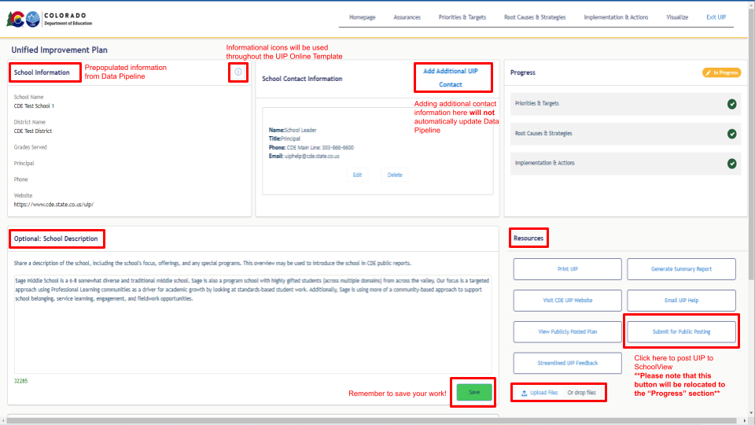
Assurances Tab
Transitioning to our Assurances tab, we introduce several planning elements that are required by the Colorado Department of Education. These elements serve to streamline the UIP process. Assurances are tailored to each school/district based on their specific context. Schools and districts are accountable for fulfilling these requirements. Though not mandatory for inclusion in the UIP, schools/districts may be required to provide related artifacts in support of monitoring. Districts/Institutes are responsible for ensuring compliance with all presented expectations for its UIP as well as each of its schools’ UIP. If a system cannot affirm the completion of any assurance, the plan includes an optional narrative to explain how the system plans to address the expectation (i.e. using the text field that follows the assurances). Additionally, the bottom of this screen reflects customized, site-specific pre-populated requirements that need to be addressed in the plan. These expectations are tailored to specific system attributes, programming, grants, and federal or state identifications. For example, READ Act requirements for K-3 serving schools. The screenshot below provides a snapshot of the appearance of the assurance tab. Please note the customized pre-populated requirements would be further down on the screen and aren’t visible in this screenshot.

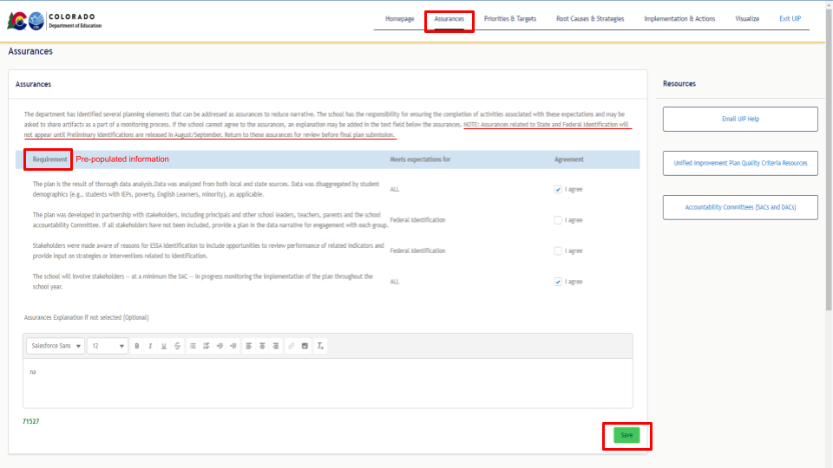
Priorities & Targets Tab
The third tab, named Priorities & Targets, is the plan location where Student Performance Priorities (SPP) for the school or district are identified. This includes the category, groups of students, and grades represented by the priority area. In addition, this tab allows for the inclusion of the related measures and targets for each priority area. Lastly, a text box is provided that allows the user to provide evidence and reasoning for the selection of the Student’s Performance Priorities.

The top of the tab includes a visual that shows the Student Performance Priorities and their relationship to identified Root Causes and Major Improvement Strategies. It is followed by a section that allows quick access to the data dashboards including enrollment and demographic, state accountability, and achievement and growth data (screenshot below).

After having identified Student Performance Priorities through comprehensive data analysis efforts, complete the text boxes (see screenshot on the next page) to capture prioritized efforts to improve student outcomes. SPPs will need a title, category, and selection of focused disaggregated groups and grade levels. Following entry of new information be sure to click on the “Save” button at the very bottom of the tab.

The screenshots below provide a snapshot of the Priorities & Targets tab.

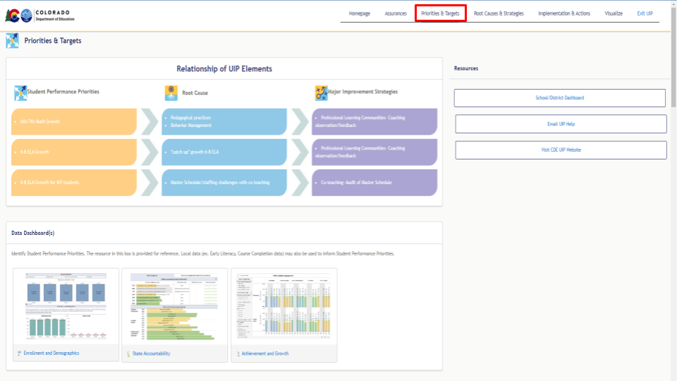
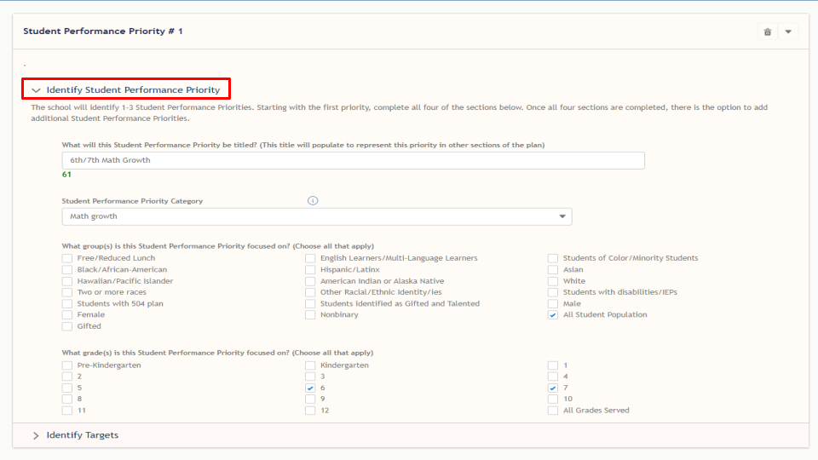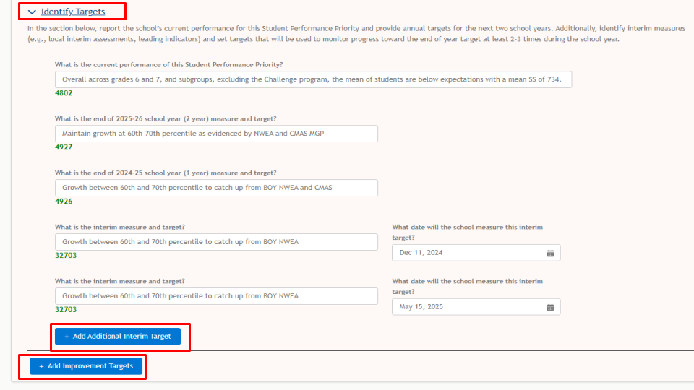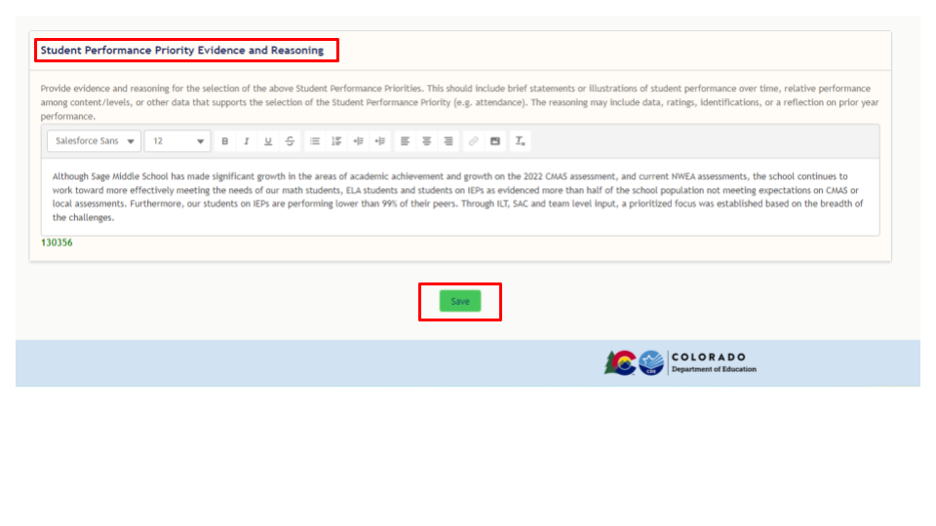
Root Causes & Strategies Tab
The fourth tab, called Root Causes & Strategies, reflects the next step in the planning process. For each Student Performance Priority (SPP) identified, systems will identify Root Causes that are driving priority areas. Root Causes require a title, description, category, and rationale. After Root Causes have been identified, the next step is to identify Major Improvement Strategies in the plan that will address those causes. Major Improvement Strategies will need a title, category, short description, associated Root Cause, evidence to support the detrimental impact of the Root Cause, as well as any financial resources used in support of the strategy. For each SPP, the plan requires the user to establish the relationship to the Root Causes, followed by the corresponding Major Improvement Strategies. Following entry of new information, be sure to click on the “Save” button at the very bottom of the tab.

The screenshots below provide a snapshot of the Root Causes & Strategies tab.
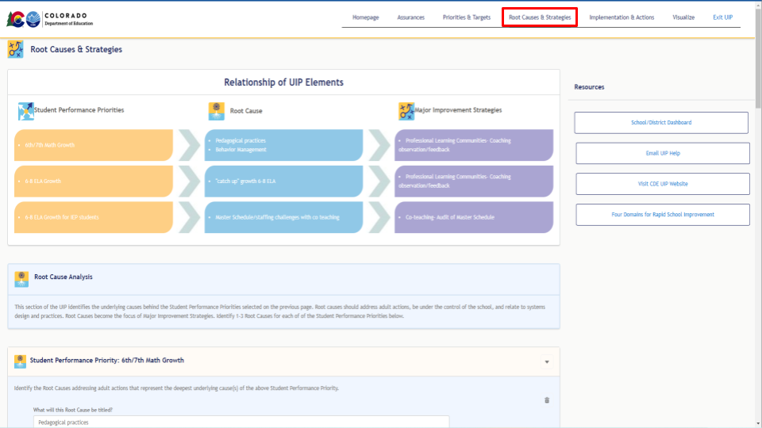
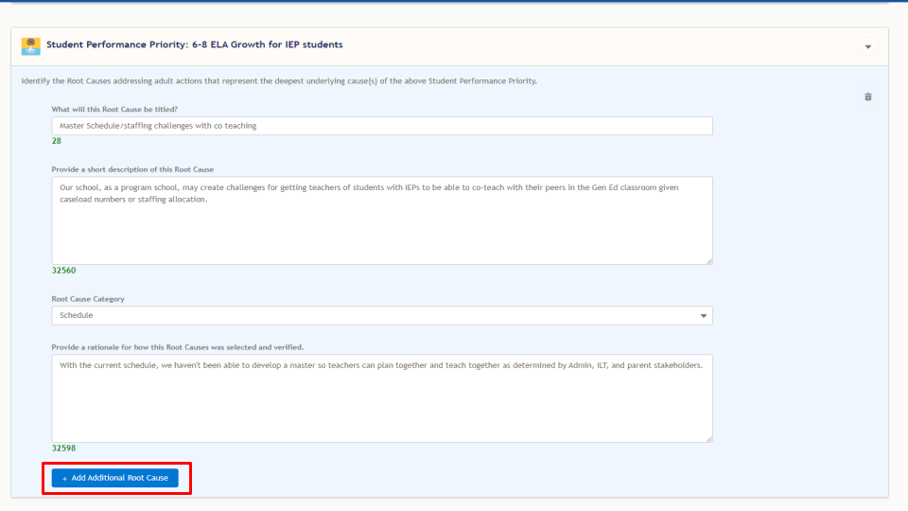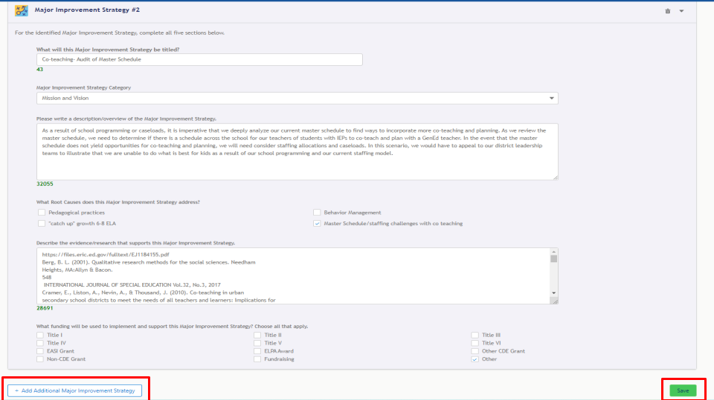
Implementation & Actions Tab
The fifth tab in the streamlined UIP template system is related to the Implementation and Actions associated with adopted Major Improvement Strategies. For each adopted strategy, complete the following: a) what improvement do you expect to see b) who will monitor this strategy, c) implementation milestones: what improvement will be made and how will it be measured and d) by what date? Next, develop the corresponding Action Plan that identifies action steps, responsible parties, along with start and end dates.

Alternatively, systems may upload an external action plan file. The Resources section of this tab includes an upload attachment function that allows the user to upload short cycle, or 90-day plans provided they include all necessary components and span the plan duration (e.g., two years using biennial flexibility).

Implementation Plans include a series of Implementation Milestones that measure the degree to which systems are being successful in implementing their Major Improvement Strategies. Implementation Plans, including Milestones, are developed to represent the duration of the strategy's timeline. Action Plans are utilized in detailing specific steps, responsible parties, start and end dates. Action Plans articulate the more nuanced steps taken within the system to meet the success criteria of each Milestone. As a result, the Action Plans and Action Steps are directly contributing to the success of Implementation Milestones leading to full implementation of the strategy thereby reducing Root Causes and ultimately improving student outcomes.

The screenshots below provide a snapshot of the Implementation & Actions tab.
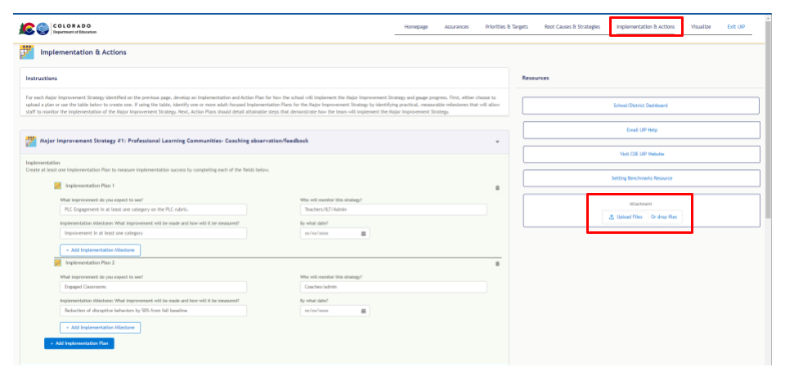
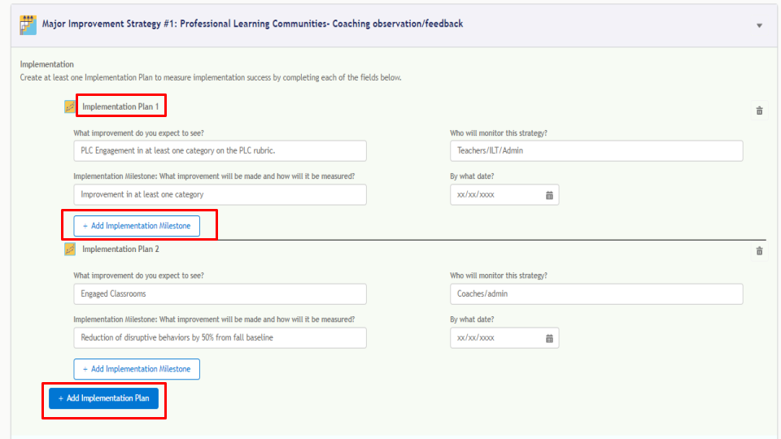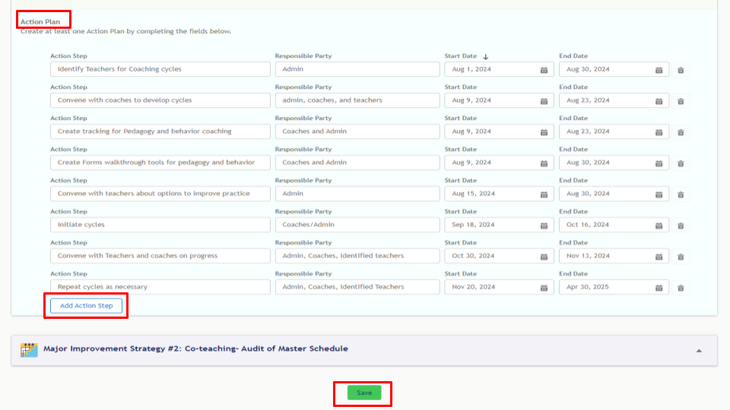

Visualize Tab
The Visualize tab provides an executive summary, offering a high-level overview of the UIP. It provides insights into Student Performance Priorities, Root Cause analysis, Major Improvement Strategies, and Assurances at the click of a mouse. Attachments can be viewed, and a PDF download option may be helpful for review by building leadership teams or accountability committees.

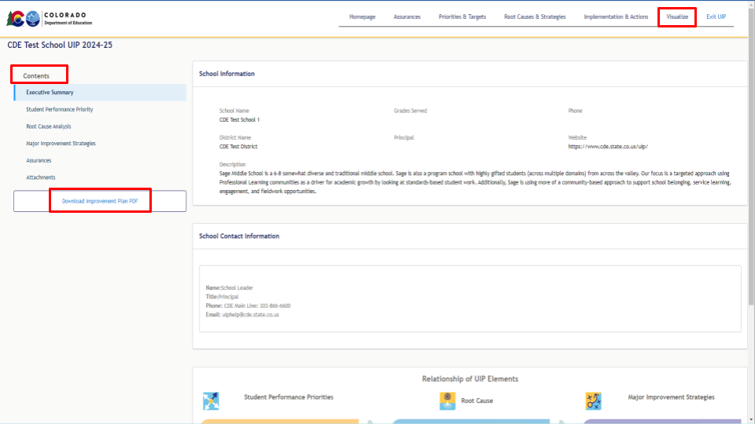

Submitting a Completed Plan
As schools and districts complete work on each section, mark the “Save” button at the very bottom of each page. Each time a tab is updated, the corresponding check box on the Homepage tab will turn green. This indicates the corresponding section is in progress.
For school UIP: Once the UIP is complete, if the school selects the “Submit for Public Posting” button, located in the Resources section on the Homepage, the district UIP contact(s) will be notified that the UIP is ready for review before submission to CDE. The UIP status will change to Ready for District Review. Once the district reviews/approves the school UIP for posting on the UIP Online System administrative page, the school’s UIP will be publicly posted to SchoolView and the UIP status will update to Submitted for Posting. Once the UIP has been publicly posted, if the school makes changes to the UIP, the UIP status will return to Ready for District Review and the district contact(s) will need to repost the UIP to SchoolView. SchoolView will show the last UIP version that was posted by district contact(s).
For district UIPs: Once the district UIP is complete and ready for CDE review, select the “Submit for Public Posting” button located in the Resources section on the Homepage. District UIPs are immediately available for public viewing on SchoolView. A plan may also be submitted for posting by navigating to the UIP Online System administrative pages and selecting the “Submit for Public Posting” button, refer to the District Admin User Guide for instructions.
