Student Name ____________________________________________ Date __________________

Feelings
Dear Parent:
We are learning that to infer means to come to a conclusion using both pictures, images,
and words. I hope you enjoy this activity with your child. This assignment is due ________________________. Thank you!

LET’S DO THIS

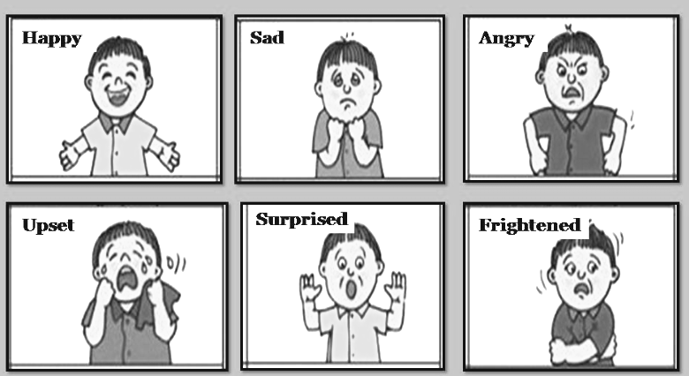

Talk with your child: We make faces to show the emotions that we feel.
See the pictures of a boy who is happy, sad, angry,
upset, surprised, and frightened.

Ask your child: Let’s play a guessing game.
Can you infer the feeling I am showing you?
Now, you make a face and I will infer your feeling.

Help your child use this sentence: I infer that you are
________________ because _______________.

For example, I infer that you are angry because your
face is getting red and you are frowning and glaring.

Repeat the game 3 more times.
LET’S DO THIS

Ask your child: Draw a picture of a face of a person with your favorite feeling.


Ask your child. Write one sentence about how the person in the picture is feeling.
Please help your child write the sentence, as needed.

__________________________________________________________________

Point to the words for your child to read the sentence to you.

Discuss with your child: Do you ever have the feeling that you drew in the picture?

What makes you have this feeling?

HOME-TO-SCHOOL COMMUNICATION

Dear Parent,

Please give your reactions to your child’s work on this activity.
Write YES or NO for each statement.
______ 1. My child understood the homework and was able to complete it.
______ 2. My child and I enjoyed the activity.
______ 3. This assignment helped me know what my child is learning in class.

Comment ________________________________________________________________________

Parent Signature __________________________________________________________________

Sampish, A., Wallace, R., Epstein, J., & Greenfeld, M. (2016). Teachers Involve Parents in Schoolwork (TIPS) Interactive Homework-Literacy K-3. Colorado Series. Baltimore: Center on School, Family, and Community Partnerships, Johns Hopkins University.

