Student Name ____________________________________________ Date ________________

What’s Cooking?
Dear Parent,
We are learning how to give someone clear directions to do or make something. I hope you enjoy this activity with your child. This assignment is due ____________________________.
Thank you!

LET’S DO THIS

- Tell your child: Some people like peanut butter and jelly sandwiches.

- Ask your child: Let’s say a friend came to visit and asked for a peanut butter
and jelly sandwich.

Act out the steps to make the sandwich without using words.

- Ask your child: Color the diagram to show the first 2 steps to make
a peanut butter and jelly sandwich.
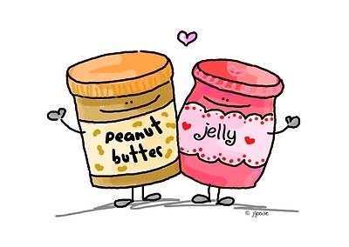

How to Make a Peanut Butter and Jelly Sandwich

 |  | 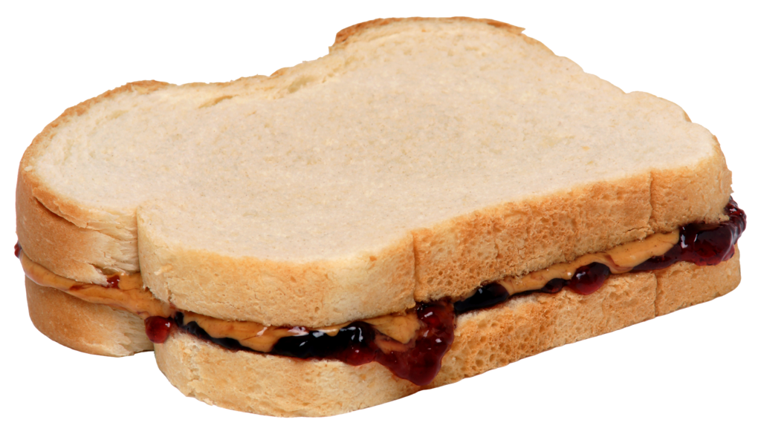

Step 1 Step 2 Ready to Eat!

- Ask your child: Tell me the steps to make the sandwich ready to eat.

EXTENSION

When it is a good time, ask your child to make a peanut butter and jelly sandwich
(or a favorite sandwich) and enjoy it together.

LET’S FIND OUT

Ask your child: What is one sport or game that you like to play?

Tell me the steps in how to play that game or sport.

Now, tell your child one game, sport, or other activity that you like,
and how to do that activity.

Discuss with your child:

Why is it important to know the steps to make a sandwich
or play a game?

HOME-TO-SCHOOL COMMUNICATION

Dear Parent,

Please give your reactions to your child’s work on this activity.
Write YES or NO for each statement.
______ 1. My child understood the homework and was able to complete it.
______ 2. My child and I enjoyed the activity.
______ 3. This assignment helped me know what my child is learning in class.

Comment ________________________________________________________________________

Parent Signature __________________________________________________________________

Sampish, A., Wallace, R., Epstein, J., & Greenfeld, M. (2016). Teachers Involve Parents in Schoolwork (TIPS) Interactive Homework-Literacy K-3. Colorado Series. Baltimore: Center on School, Family, and Community Partnerships, Johns Hopkins University.

