Student Name ______________________________________ Date _____________

Go Fish
Dear Parent,
We are learning to identify uppercase (capital) and lowercase letters and match them. I hope you enjoy this activity with your child. This assignment is due ___________________________. Thank you!

This activity requires each student to receive a deck of
MATERIALS

Go Fish Alphabet Cards from the teacher.

LET’S DO THIS

- With your child: Point to and read the letters on the alphabet chart together.
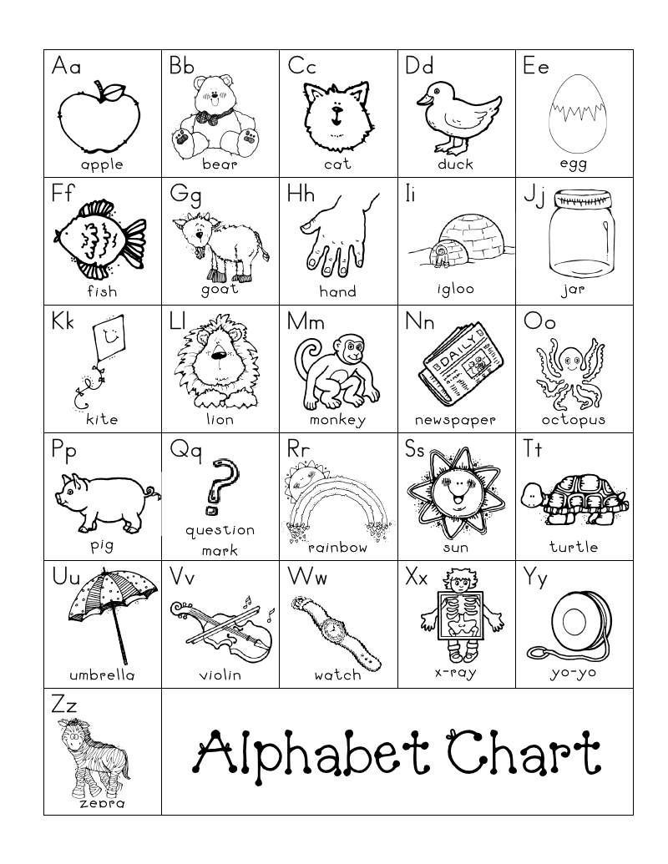

LET’S FIND OUT

1. Mix up or shuffle the Go Fish Alphabet Cards.

- Give your child 3 cards and yourself 3 cards. Put the rest of the deck face down on the table.

- Look at your cards. Ask your child if he or she has a letter that matches one of yours. For example, if you have a lowercase ‘a’, then you would ask your child for an uppercase (capital) ‘A’.

- If your child has a match, collect the card and place the matched pair of cards on the table. Continue your turn as long as there is a match. If your child does not have a match, s/he will say, “Go Fish.” Then, you take the top card from the deck and add to your hand.

- Now, your child takes a turn asking you for a letter. For example, if your child has an uppercase ‘B’, then, s/he will ask you for a lowercase ‘b’. Your child will collect the matched pair and put it on the table. If you do not have a letter to match, you say, “Go Fish” and your child will take the top card from the deck.

- Continue playing until there are no cards left in the middle or someone has no cards in hand. The winner of the game has the most matched pairs.

EXTENSION

Invite more family or friends to play Alphabet Go Fish with you.

Or, try a new game using the cards.

With your child: Take turns selecting a card from the deck.
Find something at home that begins with that letter.

HOME-TO-SCHOOL COMMUNICATION

Dear Parent,

Please give your reactions to your child’s work on this activity.
Write YES or NO for each statement.
______ 1. My child understood the homework and was able to complete it.
______ 2. My child and I enjoyed the activity.
______ 3. This assignment helped me know what my child is learning in class.

Comment ________________________________________________________________________

Parent Signature __________________________________________________________________

Sampish, A., Wallace, R., Epstein, J., & Greenfeld, M. (2016). Teachers Involve Parents in Schoolwork (TIPS) Interactive Homework-Literacy K-3. Colorado Series. Baltimore: Center on School, Family, and Community Partnerships, Johns Hopkins University.

