Student Name____________________________________ Date_______________

What Caused That?
Dear Parent,
We are learning how cause and effect change the plot of a story. I hope you enjoy this activity with me. This assignment is due _______________________________.
Sincerely,
___________________________
Student Signature

THINGS TO REMEMBER
- Cause and effect is the relationship between two things or events where one causes the other to happen.
- Cause is why something happens in a story.
- Effect is the result of the prior action.
- Example:
I reached under my desk to pick up my pencil. (CAUSE)
Then, I lost my balance and fell out of my chair (EFFECT)

LET’S DO THIS

- Work with a family partner. Who is working with you? _____________________

Read the story below to your family partner.

Discuss what happens in the story and what results from actions that are taken. .

What Caused the Crash in the Kitchen?
One day my mom was making dinner in the kitchen. Suddenly, I heard a loud crash and the sound of dishes breaking.
I ran to see what happened. My mom was sweeping up the mess.
I asked, “What happened?” She said, “I was standing on the step stool to get dishes from the top shelf of the cabinet. As I reached up, the cat ran by and surprised me. Then, my foot slipped and I dropped the dishes.”
My mom told me to put on shoes so that I wouldn’t step on the broken dishes and cut my foot. I put on my shoes and helped her finish cleaning up the broken dishes. What a crazy evening!

LET’S FIND OUT

- Discuss the story with your Family Partner. Find 3 cause and effect relationships.

You can use key words to report cause and effect relationships in a story.

For a cause, use words such as because or since.

For an effect, use words like then, as a result, or therefore.

- Complete the chart below to show what you found. The first one is done for you.
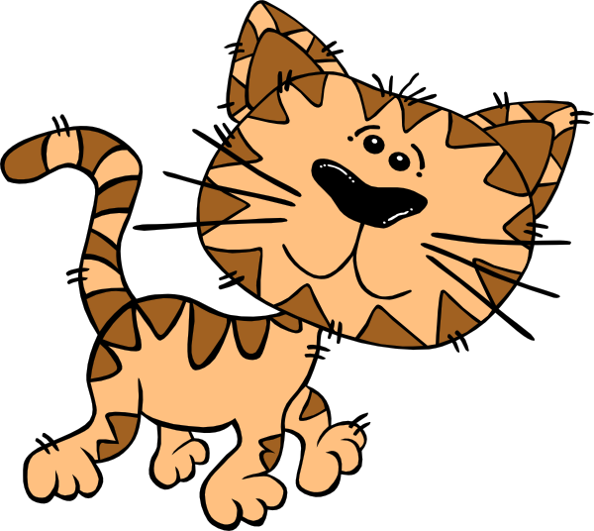


What Caused the Crash in the Kitchen?
Cause | Effect
Because dishes were on a high shelf | as a result, mom had to stand on a step stool
Because | then,
Because | therefore,

Now, with your family partner, share events that happened to you today.
Together, listen for 2 cause and effect relationships. List them in the chart below.

Something That Happened Today

Cause | Effect
Because | as a result,
Because | then,
HOME-TO-SCHOOL COMMUNICATION

Dear Parent,

Please give your reactions to your child’s work on this activity.
Write YES or NO for each statement.
______ 1. My child understood the homework and was able to complete it.
______ 2. My child and I enjoyed the activity.
______ 3. This assignment helped me know what my child is learning in class​.

Comment ________________________________________________________________________

Parent Signature __________________________________________________________________

Marshall, J.M., Izzo, A., Schimmel, I., Epstein, J. L., Greenfeld, M. (2016). Teachers Involve Parents in Schoolwork (TIPS) Interactive Homework, Literacy K-3. Colorado Series. Baltimore: Center on School, Family, and Community Partnerships, Johns Hopkins University.

