Student Name____________________________________ Date________________

Using Antonyms and Synonyms
THINGS TO REMEMBER

Dear Parent,
We are learning about words that are opposites (antonyms) and words that mean
the same (synonyms). I hope you enjoy this activity with me. This assignment is due ____________________________________.
Sincerely,
___________________________
Student Signature

Antonyms are opposites: day and night are antonyms
hot and cold are antonyms

Synonyms mean the same: cold, freezing, chilly, icy are synonyms

LET’S DO THIS

Work with a family partner. Who is working with you? __________________________

With your family partner complete a list of synonyms and antonyms.

Synonyms (mean the same)

Your turn. Read the word and write down the synonym that your family partner says.

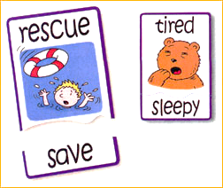

- black __________________
- fast __________________
- bright __________________
Now switch. Have your partner read the word and YOU say and write the synonym.

- small __________________
- large __________________
- smelly__________________
Antonyms (mean the opposite)

Your turn. Read the word and write the antonym that your family partner says.

- black __________________
- fast __________________
- bright __________________
Now switch. Have your partner read the word and YOU say and write the antonym.

- small __________________
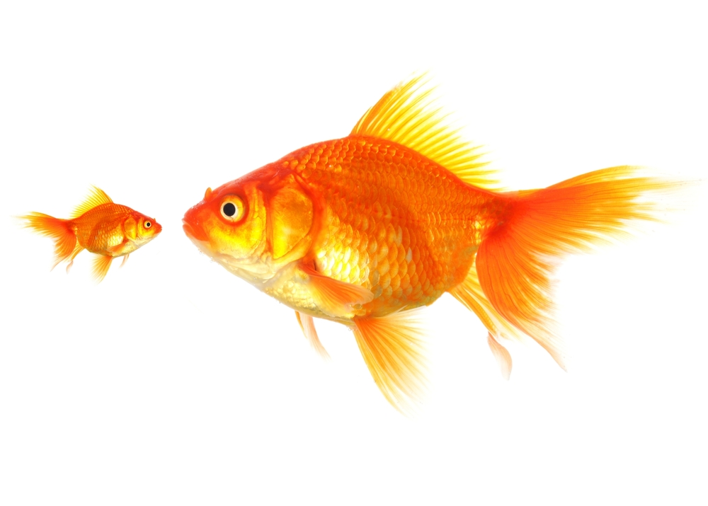
- safe __________________
- good __________________
LET’S FIND OUT

Look over the words in the lists, above. Write a short story or poem using 2 pairs
of synonyms or antonyms from the lists. Circle these words in your story.
Read your story to your family partner.

____________________________________________________________

____________________________________________________________

____________________________________________________________

____________________________________________________________
HOME-TO-SCHOOL COMMUNICATION

Dear Parent,

Please give your reactions to your child’s work on this activity.
Write YES or NO for each statement.
______ 1. My child understood the homework and was able to complete it.
______ 2. My child and I enjoyed the activity.
______ 3. This assignment helped me know what my child is learning in class.

Comment _____________________________________________________________________

Parent Signature ________________________________________________________________

Marshall, J.M., Izzo, A., Schimmel, I., Epstein, J. L., Greenfeld, M. (2016). Teachers Involve Parents in Schoolwork (TIPS) Interactive Homework, Literacy K-3. Colorado Series. Baltimore: Center on School, Family, and Community Partnerships, Johns Hopkins University.

