Student Name _____________________________________ Date ______________

HELP!
Dear Parent,
We are learning to identify picture clues that show a character needs help. I hope you enjoy this activity with me. This assignment is due _________________________________.
Sincerely,
___________________________
Student Signature

THINGS TO REMEMBER

In a story, pictures may give clues about whether a character needs help.

LET’S DO THIS

Work with a family partner. Who is working with you? _________________________

Discuss with your family partner:

What clues in the picture tell you that one girl is helping the other?
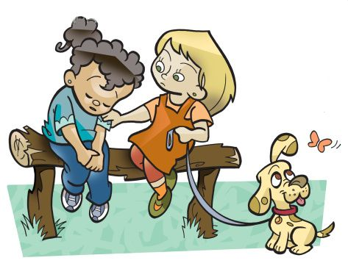

My idea: ____________________________________________________________

My family partner’s idea ________________________________________________

LET’S FIND OUT

Write 1 sentence to tell what kind of help the character needs.
Write 1 sentence on who might help each character?
Read your sentences to your family partner.

- What kind of help does this character need?

_____________________________________________

In a story, who might help this character?

_______________________________________________

- What kind of help does this character need?

____________________________________________

In a story, who might help this character?

____________________________________________

_______________________________________________


HOME-TO-SCHOOL COMMUNICATION

Dear Parent,

Please give your reactions to your child’s work on this activity.
Write YES or NO for each statement.
______ 1. My child understood the homework and was able to complete it.
______ 2. My child and I enjoyed the activity.
______ 3. This assignment helped me know what my child is learning in class.

Comment ________________________________________________________________________

Parent Signature __________________________________________________________________

Parker, C. K., Castillo, M. D., Firme, K. K., Epstein, J. L, & Greenfeld, M. (2016). Teachers Involve Parents in Schoolwork (TIPS) Interactive Homework-Literacy K-3. Colorado Series. Baltimore: Center on School, Family, and Community Partnerships, Johns Hopkins University.

