Student Name____________________________________ Date ______________

Superhero

LET’S DO THIS
Dear Parent,
We are learning to have good conversations, which will help build listening and speaking skills. I hope you enjoy this activity with me. This assignment is due _________________________.

Sincerely,
___________________________
Student Signature

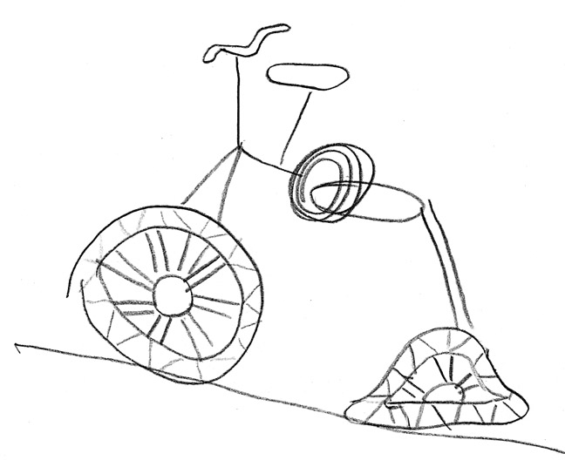

Work with a family partner. Who is working with you? _________________________

- Read this short story to your family partner.

Clara was on her way to school when she met Mario. His bike
had a flat tire. “I will be late for school,” Mario said. “I need help.”
Clara did not have a bike and did not know how to fix a flat tire. She knew that if she stopped, she would be late for school too. She told Devin, “We sure could use help from a Superhero!”

- Talk with your family partner: What might a Superhero do to help Mario?

- Give this Superhero a good name: ___________________________________

- Write 1 sentence to tell how this Superhero used certain powers to help Mario.

________________________________________________________________

________________________________________________________________

LET’S FIND OUT

- Let’s say that Clara wanted to help Mario get to school on time without the help of a Superhero.

What could she say to help Mario right away?

_________________________________________________________________

_________________________________________________________________

- What might Mario say in response to her suggestion?

_________________________________________________________________

________________________________________________________________

- Read to your family partner what you wrote for Clara and Mario to say.

Discuss with your family partner: How do these statements show that Clara
and Mario were listening to each other?

HOME-TO-SCHOOL COMMUNICATION

Dear Parent,

Please give your reactions to your child’s work on this activity.
Write YES or NO for each statement.
______ 1. My child understood the homework and was able to complete it.
______ 2. My child and I enjoyed the activity.
______ 3. This assignment helped me know what my child is learning in class.

Comment _______________________________________________________________________

Parent Signature __________________________________________________________________

Parker, C. K., Castillo, M. D., Firme, K. K., Epstein, J. L., & Greenfeld, M. (2016). Teachers Involve Parents in Schoolwork (TIPS) Interactive Homework-Literacy K-3. Colorado Series. Baltimore: Center on School, Family, and Community Partnerships, Johns Hopkins University.

