Student Name____________________________________ Date____________

What’s Happening?
Dear Parent,
We are learning to make inferences by using clues in a picture to tell what we think might happen in a story or text. I hope you enjoy this activity with me. This assignment is due
_______________________. Sincerely,
___________________________
Student Signature

LET’S DO THIS

Work with a family partner. Who is working with you? _________________________

- Look at the picture with your family partner.

- Write one sentence to answer the questions below,
based on your discussion.

What do you think is happening in this picture?

- What clues in the picture did you use to make this inference?

LET’S FIND OUT

With your family partner, look at the 2 pictures.

Discuss the clues in each picture to make an inference about what will happen next.

Write one sentence to tell what you think will happen next.

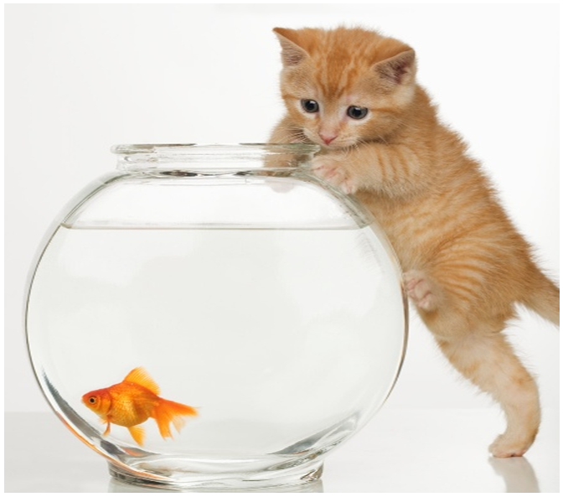
- What do you think will happen next?

____________________________________________

_____________________________________________

2. What do you think will happen next?

_____________________________________________

_____________________________________________


3. Read your sentences to your family partner.

HOME-TO-SCHOOL COMMUNICATION

Dear Parent,

Please give your reactions to your child’s work on this activity.
Write YES or NO for each statement.
______ 1. My child understood the homework and was able to complete it.
______ 2. My child and I enjoyed the activity.
______ 3. This assignment helped me know what my child is learning in class.

Comment _____________________________________________________________________

Parent Signature ________________________________________________________________

Parker, C. K., Castillo, M. D., Firme, K. K., Epstein, J. L., & Greenfeld, M. (2016). Teachers Involve Parents in Schoolwork (TIPS) Interactive Homework-Literacy K-3. Colorado Series. Baltimore: Center on School, Family, and Community Partnerships, Johns Hopkins University.

