Student Name _____________________________________ Date______________

Guess the Invention
Dear Parent,
We are learning about inventors and their inventions. We can use context clues to guess a
famous invention. I hope you enjoy this activity with me. This assignment is due _____________________________________.
Sincerely,
___________________________
Student Signature

THINGS TO REMEMBER

Context clues include words, phrases, and pictures that help us understand what we
read. Sometimes, these clues help us unlock difficult new words in the text.

LET’S DO THIS

Work with a family partner. Who is working with you? _______________________
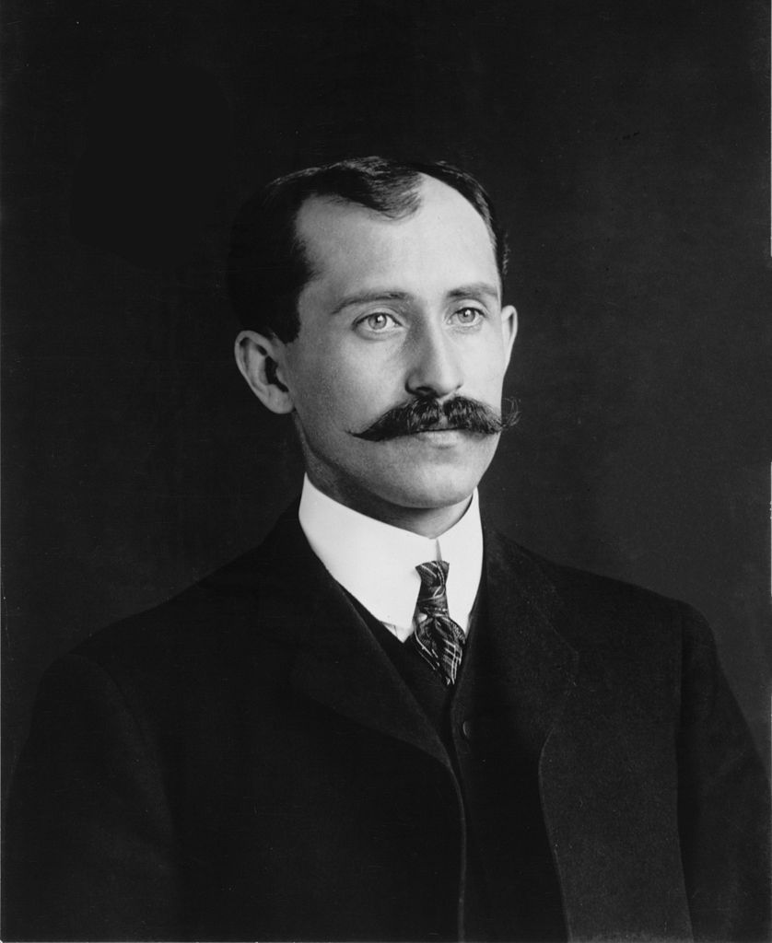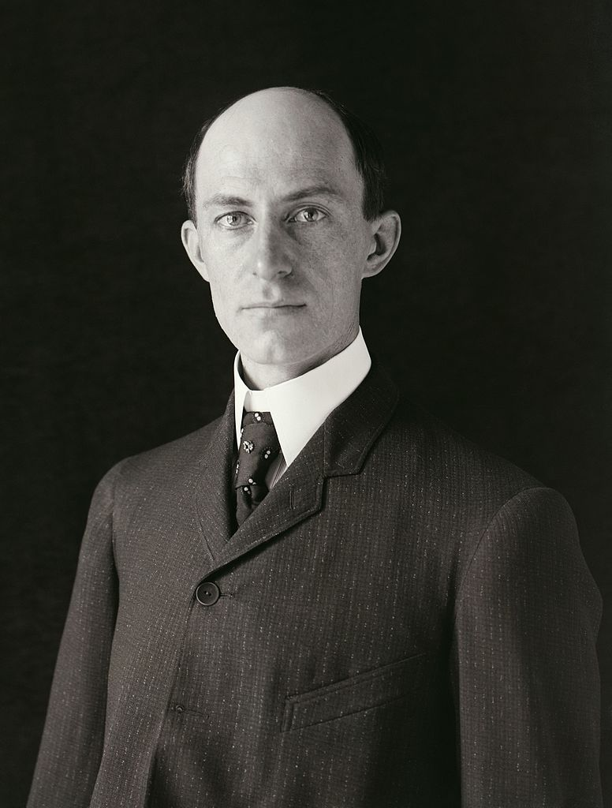
- Read the following passage to your family partner.

An Invention

Two men made this invention in 1903. They were brothers. Their names were Orville and Wilber Wright. This invention was made of wood and was called a “flyer.” Before they invented it, Orville and Wilber opened a bike shop to fix broken bikes. They also made their own new bikes. They saved their money and used it to build things that could fly. The first two things they built to fly did not work. The third “flyer” did. It went 20 feet up in the air and stayed up for 12 seconds. It traveled a distance of 120 feet. It was the start of a great invention! Their invention—the first one to fly—is now in a museum for the world to see.

- After you read the passage, discuss with your family partner what you think was invented. Then, read the sentences in the story that tell you what was invented.

LET’S FIND OUT

Write your answers to these questions.

- I think the invention that the Wright brothers made was ___________________.

- Tell 1 clue from the passage that told you this is what they invented?

_________________________________________________________________________________________

__________________________________________________________________________________________

- How did this invention help solve a problem?

__________________________________________________________________________________________

- Talk with your family partner. What would you like to invent to solve a problem?

_______________________________________________________________

Draw a picture of something that you or your family partner would like to invent.

HOME-TO-SCHOOL COMMUNICATION

Dear Parent,

Please give your reactions to your child’s work on this activity.
Write YES or NO for each statement.
______ 1. My child understood the homework and was able to complete it.
______ 2. My child and I enjoyed the activity.
______ 3. This assignment helped me know what my child is learning in class.

Comments _____________________________________________________________________

Parent Signature ________________________________________________________________

Parker, C. K., Castillo, M. D., Firme, K. K., Epstein, J. L., & Greenfeld, M. (2016). Teachers Involve Parents in Schoolwork (TIPS) Interactive Homework-Literacy K-3. Colorado Series. Baltimore: Center on School, Family, and Community Partnerships, Johns Hopkins University.

