Student Name _____________________________________ Date _______________

Zoo Mix-Up
Dear Parent,
We are learning to break long words into chunks (syllables) to make it easier to read them.
I hope you enjoy this activity with me. This assignment is due __________________________.
Sincerely,
___________________________
Student Signature

THINGS TO REMEMBER

Syllables are small parts of a large word that we say or read.
For example, the word rabbit has two syllables — rab bit

You can hear the syllables if you read a word aloud.

Read a word that has two consonants in the middle rabbit rab bit

Read a word with an ending added on singing sing ing

Read a word with a vowel that says its name baby ba by

Read a word that includes a vowel that says its sound exit ex it

LET’S DO THIS

Work with a family partner. Who is working with you? _________________________

Pretend you went to the zoo with your family partner.

Read the names of the animals you see at the zoo aloud to your family partner.
Together clap out the syllables you hear.
lion
hippo
monkey
panda
giraffe
zebra



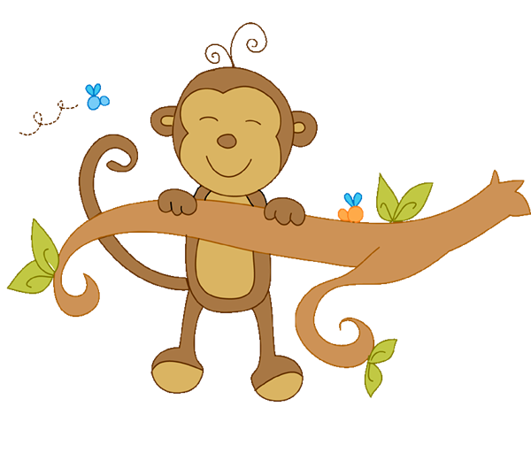


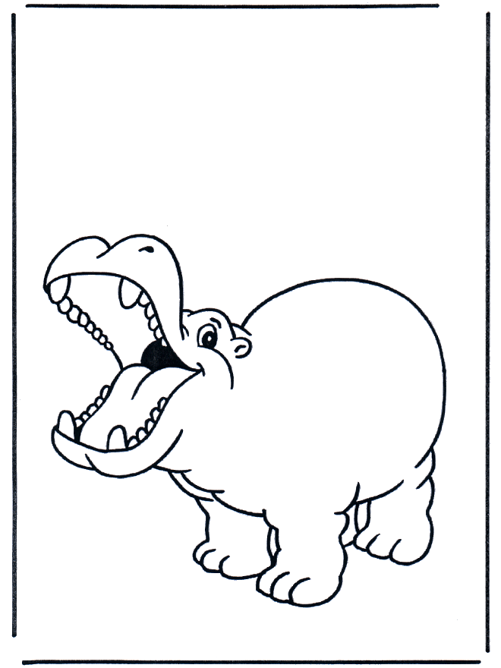

LET’S FIND OUT

Oh no! The syllables of the zoo animals got mixed up!

With your family partner, solve the puzzle.

Combine the 1st and 2nd syllables of each animal’s name to write the
real name on the lines, below. You may solve the puzzle in any order.

There are 3 new zoo animals in the box. Can you figure them out?

The first one is done for you.
1st syllable 2nd syllable
mon pan li key affe ard
gir hip ze da ger on
ti liz bob po bra cat

___ giraffe______ ___________________ ___________________
___________________ ___________________ ___________________

___________________ ___________________ ___________________

With your family partner. Take turns naming other zoo animals.
Say the name of the animal and clap out the syllables.

Can you name an animal with 1, 2, 3, 4, and 5 syllables?

HOME-TO-SCHOOL COMMUNICATION

Dear Parent,

Please give your reactions to your child’s work on this activity.
Write YES or NO for each statement.
______ 1. My child understood the homework and was able to complete it.
______ 2. My child and I enjoyed the activity.
______ 3. This assignment helped me know what my child is learning in class.

Comment _____________________________________________________________________

Parent Signature _______________________________________________________________

Parker, C. K., Castillo, M. D., Firme, K. K., Epstein, J. L., & Greenfeld, M. (2016). Teachers Involve Parents in Schoolwork (TIPS) Interactive Homework-Literacy K-3. Colorado Series. Baltimore: Center on School, Family, and Community Partnerships, Johns Hopkins University.

