Student Name____________________________________ Date_______________

Express Yourself
Dear Parent,
We are learning to read with expression using a variety of texts, including poetry. I hope you enjoy this activity with your child. This assignment is due ___________________________. Thank you!

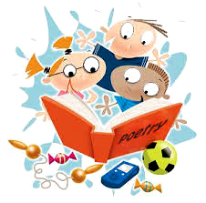

THINGS TO REMEMBER

Reading with expression helps you understand and enjoy the text.

When you see an exclamation mark (!), you read with excitement. When you see a

When you see a question mark (?), you read to ask a question.

When you see a period (.), you read in your regular voice.

LET’S DO THIS

With your child: Practice reading this poem by Mother Goose.
Read each line, pointing to each word.
Point to the punctuation at the end of the line.

Ask your child: Just for fun, read each line of the poem
with expression based on the ending mark.

Little Bo-Peep

1. Little Bo-Peep has lost her sheep?
And can’t tell where to find them?
Leave them alone and they’ll come home.
Wagging their tails behind them.

2. Little Bo-Peep has lost her sheep!
And can’t tell where to find them!
Leave them alone and they’ll come home.
Wagging their tails behind them?

LET’S FIND OUT

Ask your child: Read these phrases of letters and numbers
with expression based on the ending mark.
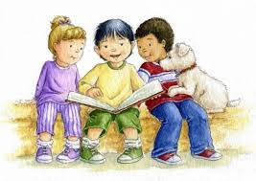

ABCD ! EFG ! HIJK ? LMNOP .

QRS ! TUV . WXYZ ?

1, 2, 3 . 4, 5, 6 ? 7, 8, 9 ? 10, 11, 12 !

13, 14, 15 ! 16, 17, 18, 19, 20 .

Ask your child: Choose a poem that you know. Read or say it in a funny way.
Say each line as a question.
Say each line with an exclamation point!
Say each line in a deep voice or high voice.
Pick one more funny way to read or say the poem.

HOME-TO-SCHOOL COMMUNICATION

Dear Parent,

Please give your reactions to your child’s work on this activity.
Write YES or NO for each statement.
______ 1. My child understood the homework and was able to complete it.
______ 2. My child and I enjoyed the activity.
______ 3. This assignment helped me know what my child is learning in class.

Comment ________________________________________________________________________

Parent Signature __________________________________________________________________

Wilshusen, M., Bognar, J., Handy, T., Epstein, J., & Greenfeld, M. (2016). Teachers Involve Parents in Schoolwork (TIPS) Interactive Homework-Literacy K-3. Colorado Series. Baltimore: Center on School, Family, and Community Partnerships, Johns Hopkins University.

