Student Name _____________________________________ Date ______________

Can you hear me?
Dear Parent,
We are learning that different letters have sounds that go together to make words. We are identifying words with the same sounds at the beginning and end. I hope you enjoy this activity with your child. This assignment is due ______________________________. Thank you!

LET’S DO THIS

Ask your child: Together, let’s read the words in each box.
Underline the beginning sound in each word.
Draw a line to connect the words that have the same beginning sound.

  cat |   pot |   dog |   dig
  pig |   Sam |   bag | 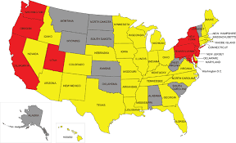  map
  sun |   can |   mop |   bat

Ask your child: Together, let’s read the words in each box.
Underline the ending sound in each word.
Draw a line to connect the words that have the same ending sound.
  wig | 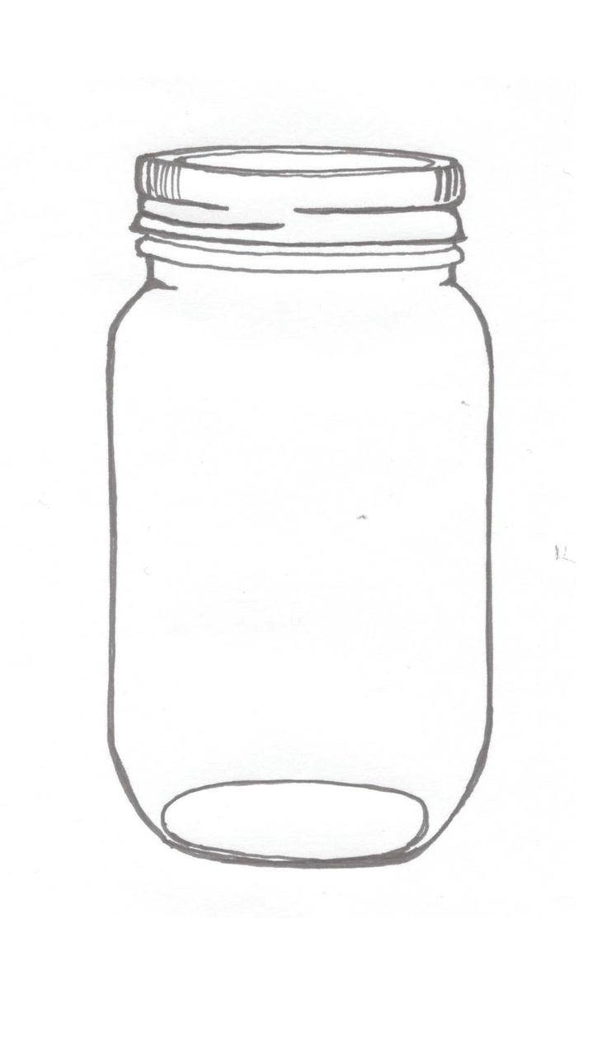  jar | 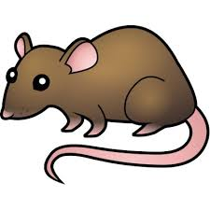  rat |   hat
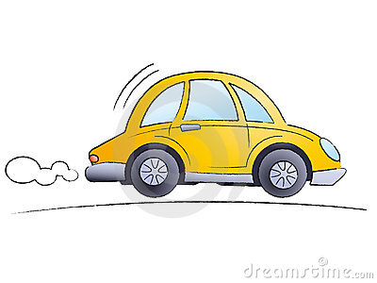  car |   mad | 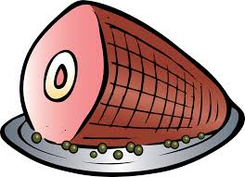  ham |   fan
  sad | 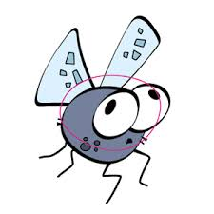  bug |   pan |   jam

LET’S FIND OUT

Ask your child: Draw pictures of 2 favorite foods and write the beginning and ending sounds
in the spaces provided. See the example.
Example:



beginning: d
ending: t

beginning___
ending ___

beginning ___

ending ___

beginning ___

ending ___

HOME-TO-SCHOOL COMMUNICATION

Dear Parent,

Please give your reactions to your child’s work on this activity.
Write YES or NO for each statement.
______ 1. My child understood the homework and was able to complete it.
______ 2. My child and I enjoyed the activity.
______ 3. This assignment helped me know what my child is learning in class.

Comment ________________________________________________________________________

Parent Signature __________________________________________________________________

Wilshusen, M., Bognar, J., Handy, T., Epstein, J., & Greenfeld, M. (2016). Teachers Involve Parents in Schoolwork (TIPS) Interactive Homework-Literacy K-3. Colorado Series. Baltimore: Center on School, Family, and Community Partnerships, Johns Hopkins University.

