Student Name ______________________________________ Date______________

How To Do It
Dear Parent,
We are learning to teach others something we know how to do. I hope you enjoy this activity with your child. This assignment is due ______________________________. Thank you!

THINGS TO REMEMBER

When we tell how to do something we go step by step.

LET’S DO THIS

- Ask your child: Let’s say that a little child asked you about the best way
to wash dirty hands.

Use the pictures to tell the child how to do that.
Tell all 6 steps in order. Say, “First……, second…..

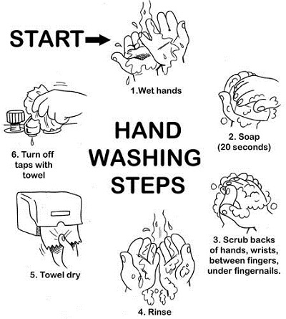

LET’S FIND OUT

- Ask your child: Draw 3 steps to show how to make a bowl of cereal.
Step 1
Step 2

Step 3

- Ask your child: Use your pictures to tell me how to make a bowl of cereal.

- With your child: Tell each other about a time when you asked someone
HOW TO do something.

What did you want to know?
Were the directions clear?
What did you learn?

HOME-TO-SCHOOL COMMUNICATION

Dear Parent,

Please give your reactions to your child’s work on this activity.
Write YES or NO for each statement.
______ 1. My child understood the homework and was able to complete it.
______ 2. My child and I enjoyed the activity.
______ 3. This assignment helped me know what my child is learning in class.

Comment ________________________________________________________________________

Parent Signature __________________________________________________________________

Wilshusen, M., Bognar, J., Handy, T., Epstein, J., & Greenfeld, M. (2016). Teachers Involve Parents in Schoolwork (TIPS) Interactive Homework-Literacy K-3. Colorado Series. Baltimore: Center on School, Family, and Community Partnerships, Johns Hopkins University.

