Student Name ______________________________________ Date _____________

Silent “e” Follows a Rule
Dear Parent,
We are learning about words that end in a silent “e”. These words contain a vowel-consonant-silent “e” pattern. I hope you enjoy this activity with your child. This assignment is due ________________________________. Thank you!

THINGS TO REMEMBER

If a one-syllable word has an “e” at the end, the first vowel makes its long sound and
the “e” is silent. EXAMPLES: Kite, rule, note

LET’S DO THIS

- Ask your child: Tell me the names of these pictures.

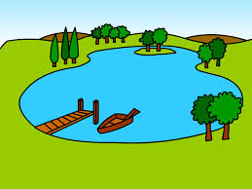




lak__ rob__ kit__ fir__

- Ask your child: Tell me the sound of the first vowel in each word
before you add the silent “e.”

Now, write the silent “e” on the blank for each word.

Read the new word.

Tell me how adding the “e” changed the sound of the first vowel in each word.

- Ask your child: Tell me the names of the pictures, below.
Let’s work together to spell the words on the lines, below.

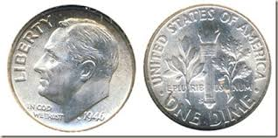

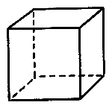

__ __ __ e __ __ __ e __ __ __ e __ __ __ e
LET’S FIND OUT

- With your child: Read the 3-letter words with a short vowel sound.

Then, add the silent “e” and read the 4-letter words with a long vowel sound.

See how the word changes when you add the “silent e.”
cap + e = cape tim + e = time
tap + e = tape con + e = cone
mad + e = made fad + e = fade
hat + e = hate rat + e = rate

- Ask your child: Choose 1 word with a “silent-e” from the box, above.
Draw a picture of that word.

- Tell me a sentence using that word. I will write it here.

________________________________________________________________________________________________

_______________________________________________________________________________________________ .

- Read the sentence with your child, pointing to each word.

Ask your child to read the sentence to you, pointing to each word.

HOME-TO-SCHOOL COMMUNICATION

Dear Parent,

Please give your reactions to your child’s work on this activity.
Write YES or NO for each statement.
______ 1. My child understood the homework and was able to complete it.
______ 2. My child and I enjoyed the activity.
______ 3. This assignment helped me know what my child is learning in class.

Comment ________________________________________________________________________

Parent Signature __________________________________________________________________
Wilshusen, M., Bognar, J., Handy, T., Epstein, J., & Greenfeld, M. (2016). Teachers Involve Parents in Schoolwork (TIPS) Interactive Homework-Literacy K-3. Colorado Series. Baltimore: Center on School, Family, and Community Partnerships, Johns Hopkins University.

