Recently federal railroad authorities have witnessed school buses that were not stopping at railroad crossing, where they are required to stop. Some districts have received incorrect information from resources outside of CDE and DORA that have caused some confusion. Please make sure you go over the clarifications below with ALL of your operators to ensure that they are stopping at the railroad crossings that they are required to. Below are very specific questions I asked Dr. Fischhaber in 2016 and nothing has changed. If you have questions, please do not hesitate to contact me via email at Miller_s@cde.state.co.us. Not stopping when we should be could result in a catastrophic event with the loss of many lives.
Q: What is the statute that applies to school buses and the requirement to stop at railroad crossings?
A: 42-4-707 - 42-4-707. Certain vehicles must stop at railroad grade crossings.
(1) Except as otherwise provided in this section, the driver of a school bus, as defined in paragraph (b) of subsection (5) of this section, carrying any schoolchild, the driver of a vehicle carrying hazardous materials that is required to be placarded in accordance with regulations issued pursuant to section 42-20-108, or the driver of a commercial vehicle, as defined in section 42-4-235, that is transporting passengers, before crossing at grade any tracks of a railroad, shall stop such vehicle within fifty feet but not less than fifteen feet from the nearest rail of such railroad and while so stopped shall listen and look in both directions along such track for any approaching train and for signals indicating the approach of a train and shall not proceed until the driver can do so safely. After stopping as required in this section and upon proceeding when it is safe to do so, the driver of any said vehicle shall cross only in such gear of the vehicle that there will be no necessity for changing gears while traversing such crossing, and the driver shall not manually shift gears while crossing the tracks.
(2) This section shall not apply at street railway grade crossings within a business district.
(3) When stopping as required at such railroad crossing, the driver shall keep as far to the right of the roadway as possible and shall not form two lanes of traffic unless the roadway is marked for four or more lanes of traffic.
(4) Subsection (1) of this section shall not apply at:
(a) (Deleted by amendment, L. 2006, p. 42, 1, effective July 1, 2006.)
(b) Any railroad grade crossing at which traffic is regulated by a traffic control signal;
(c) Any railroad grade crossing at which traffic is controlled by a police officer or human flag person;
(d) Any railroad crossing where state or local road authorities within their respective jurisdictions have determined that trains are not operating during certain periods or seasons of the year and have erected an official sign carrying the legend "exempt", which shall give notice when so posted that such crossing is exempt from the stopping requirement provided for in this section.
(5) For the purposes of this section:
(a) The definition of hazardous materials shall be the definition contained in the rules adopted by the chief of the Colorado state patrol pursuant to section 42-20-108.
(b) "School bus" means a school bus that is required to bear on the front and rear of such school bus the words "SCHOOL BUS" and display visual signal lights pursuant to section 42-4-1903 (2) (a).
(6) Any person who violates any provision of this section commits a class A traffic infraction.

Q: Can you, in simple terms, explain when a school bus is required to stop at a railroad crossing?
A: If the crossing has ANY of the following, the school bus must stop. 42-4-707.1.
- Gates
- Cross buck signs
- Railroad Signage
- Red flashing railroad lights

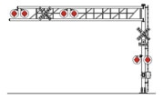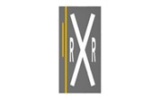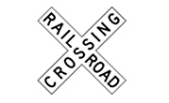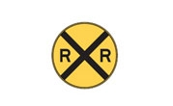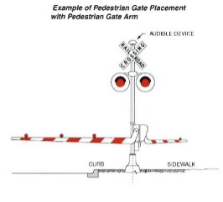
Q: Can you, in simple terms explain when a school bus is NOT required to stop at a railroad crossing?
A: A school bus is NOT REQUIRED to stop at a railroad crossing if there are
- No Gates
- No Red flashing railroad lights
AND
A traffic control signal (red, yellow, green light), flag person or police office are present and regulating traffic. 42-4-707. 4 (a) and (b)

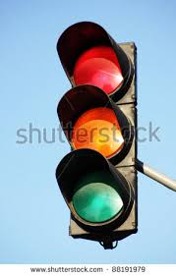

Q: What does it mean for a railroad crossing to be exempt? Does it mean a school bus does not have to stop?
A: Yes, the bus is not required to stop, however, this is a big misunderstanding. Per the law, a train always has the right of way and vehicles must yield to the train. The exempt sign is placed on the cross bucks or light post only when the train is not running or very little train traffic is taking place at the crossing and the train no longer has the right of way, and must yield to vehicles on the roadway. There are only a couple of crossings that are exempt through the entire state of Colorado. 42-4-707. 4.(d)
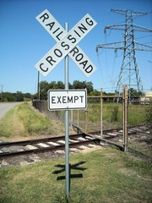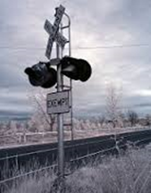
Q: So, per Section 1. (2) This section shall not apply at street railway grade crossings within a business district. Do school buses have to stop at “street railway grade crossings within a business district”?
A: I think the law applies whether in cities or in rural areas. "Street railways" are likely only going to operate in city areas, and the only couple of “street railways” that I can think of in the state (RTD Light Rail in downtown Denver and the Fort Collins Municipal Railway along W. Mountain Avenue in Fort Collins) have traffic signal control of their crossings with roadways. I would think that any other “street railways” that would be constructed in Colorado would have some sort of signal control at the crossings.
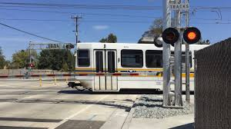

Q: I have some deep concerns regarding some of the railroad crossings that our buses are crossing. I know of at least 2 crossings where the bus has to get too close to the tracks to be able to see. If a train came the bus would certainly be hit.
A: If you can get a list of the crossings that are concerns to districts and send it to me, I will see what we can do to get them reviewed.

