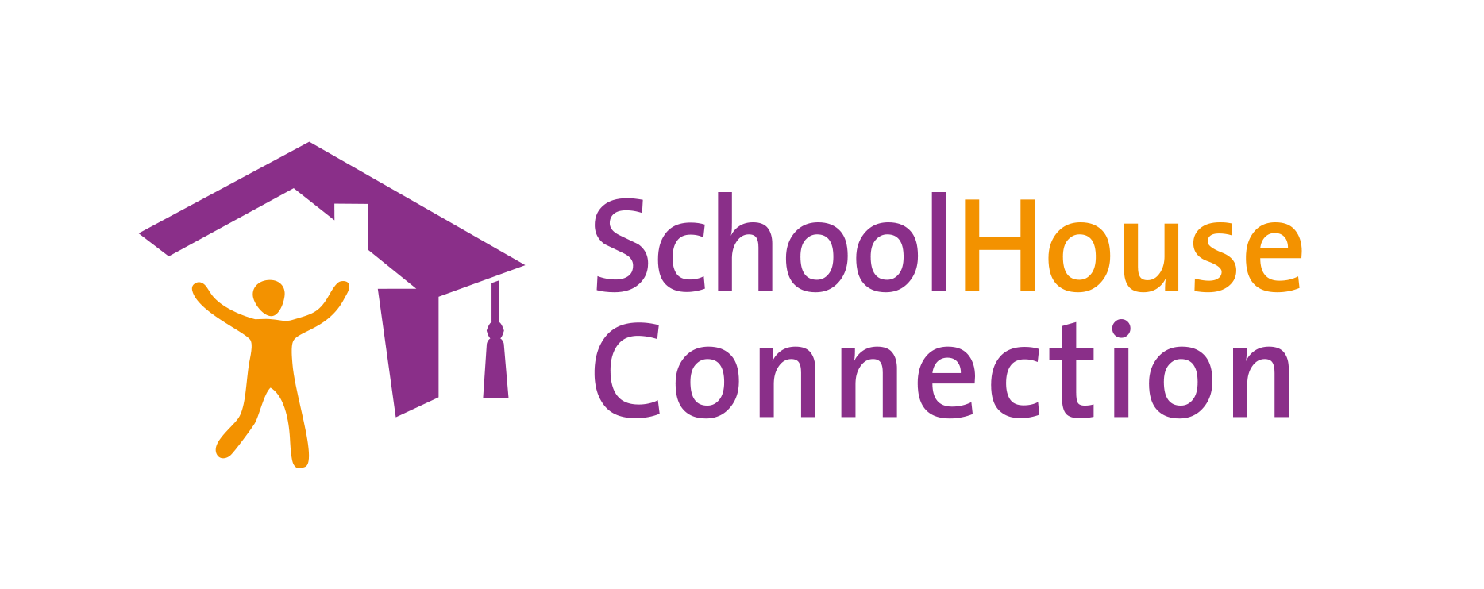

ARP-HCY Sustainability Plan

American Rescue Plan-Homeless Children and Youth (ARP-HCY) funds must be obligated by September 30, 2024 and expended by January 30, 2025. The sustainability planning tool below is designed to assist local educational agencies in prioritizing activities and considering additional funding sources to best sustain initiatives begun with ARP-HCY funds.

Please also refer to the ARP-HCY Planning and Spending Timeline Tool: This planning tool is designed to assist local educational agencies to monitor their spending and plan for the effective and efficient use of funds by the mandated deadlines. It divides the remaining time before the ARP-HCY deadlines into quarters, so that school district liaisons and others can assess their progress on a regular basis, paying particular attention to the needs of children and youth at specific times of the school year.

CURRENT ARP-HCY FUNDING NEEDING TO BE SPENT: $____________________

- Please list current activities funded by ARP-HCY (leave category blank if not applicable):

Category | Activity | Staff Members Involved | Amount of Funding
Wrap-around Services
Academic Support
Transportation
Capacity building and staffing
Housing-related supports
Outreach and identification
Early Childhood
Postsecondary Planning and Transition
Data Collecting and Reporting
Prepaid debit and store cards

- Describe the impact of the activity and include any data collected

Activity | Positive Impact | Data that supports the impact | Data that supports the continued need

- Prioritize activities to continue

Activity | Priority level | Data or other information about prioritization

- What partnerships are needed to continue?

District or community partner | Role | Activity partnership supports

- What other staff members need to be involved?

Staff member | Role | Activity

- What other resources are needed?

Resource | Activity | How to access needed resource

- What other funding sources can be accessed?

- Title I, Part A
- Title II
- Title III
- Title IV
- McKinney-Vento subgrant funds
- State and local funds
- School-based mental health grants
- ESSER/GEER
- Community schools funds
- Community grants or partnerships
- Other funding sources:

- What other resources or support do you need to be successful?

