There are many strategies for setting Student Learning Targets including:
- Individual – Teacher sets individual goals for students and then determines how many students met their individual goals
- Whole Class – Teacher sets a goal that would be applied to all students in a class
- Subgroup of Students – Teacher sets a goal for a group(s) of students with similar baseline data levels
- Case Load – Teacher sets a goal for the specific students he or she supports

There are also many types of growth targets that can be set depending on the types of assessments and baseline data:
- Proficiency Data Targets – students meeting grade level expectations
- Examples: Students will pass the end-of-course exam; Students will score a 3 or better on the AP exam
- Growth Data Targets – students growing over the course of instruction
- Examples: Students will progress once fitness level; Students will make projected growth or better on the MAP assessment
- Averaging Data Targets – students’ average score on an assessment
- Example: Students will answer, on average, 80% of the questions correctly on the end-of-course exam

Work with a partner to do the following:
1: Choose a data set from below.
2: Use the information above to determine the type of Student Learning Target you could create.
3: Create one, or more, expected outcome targets based on the baseline data below.

Performance Assessment/Portfolio Outcomes
+ | √ | - | √ | + | √ | - | √ | + | √ | - | √ | √ | + | - | √ | - | + | + | - | √
Reading Levels
18 | 24 | 24 | 30 | 38 | 40 | 40 | 50 | 50 | 50 | 50 | 50 | 60 | 60 | 60 | 60 | 70 | 70 | 70 | 80 | 80
End of Course Cumulative Exam
66 | 89 | 68 | 75 | 74 | 80 | 94 | 99 | 60 | 55 | 71 | 73 | 95 | 96 | 84 | 82 | 79 | 81 | 98 | 74 | 86
Rubric Results
6 | 4 | 1 | 5 | 5 | 2 | 6 | 2 | 5 | 2 | 1 | 6 | 3 | 3 | 5 | 3 | 1 | 2 | 6 | 4 | 4

Write your expected outcome target(s) in the space below:
Example: Based on the baseline data that I selected the average score for my class was X, I’d like the average score to increase by 5 percent after I provide instruction. Expected Learning Outcome = X+5

Once you have determined a target based on your selected baseline data, determine scales using the chart below:

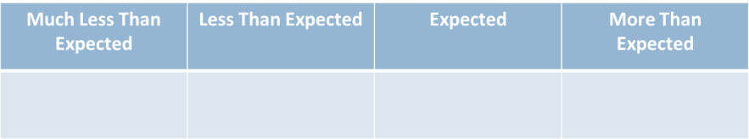

How did you go about determining your scales?

Are your scales rigorous? How do you know?

What tool can provide you a space for setting your scales?

Post-data Provided

Based on the post-data provided, what rating level would you have been assigned?

Knowing your final rating level, how would you improve your target and scale setting?

