Internal Environments Respond to External Changes
By Kevin Lindauer, nbct
John F. Kennedy High School
Denver Public Schools, Denver, Colorado

Submitted as part of the “All Standards, All Students” Summer Institute, 2016
Colorado Department of Education District Sample Curriculum Project

- Essential Elements
- Concept-based Lesson Planning Process Guide

Essential Elements

Element 1: Classroom Context

To help other teachers understand the context of your lesson, describe your content area and grade level, class size, your student population (without any personally identifiable information), and relevant features of your school environment (e.g., access to instructional materials, aspects of the school culture that influence instructional decisions).

I teach biology in an urban school district serving a diverse population of students. My school is 84% Hispanic, 11% White, 2% African American, 2% Asian, and 1% Indian/Native American. As a course, biology is typically taken during 9th or 10th grade. Honors biology classes are also offered. My classes have between 30 and 35 students, generally with mixed abilities. About 14% of my students are identified as requiring special education services, and 26% are English Language Learners. Technology in my school is available in computer labs and mobile computer carts. Unlike other teachers in the Science Department, I utilize a small set of twelve Chromebooks in my classroom as part of a curriculum design initiative that is District wide.

Element 2: Lesson Planning with Rationales for Your Decisions

My lesson plan was designed to elucidate questions from students that lead to student designed experiments using an established protocol. I planned to use striking phenomena centered on bull sharks swimming great distances up freshwater rivers so that students are motivated to ask questions related to the sharks’ internal environments responding to the external conditions of the freshwater rivers. Students were then asked to consider a model—shell-less chicken eggs—to explain the types of changes that occur in living cells when their external environments are changed. Using a generalized protocol for removing the calcium shells from the eggs, massing individual eggs, and changing the external environments with an array of hypertonic and hypotonic solutions. By collecting and sharing data with peers, either on the class or school level, students should be able to make claims about the effects different solutions had on their models (shell-less eggs) supported by qualitative and quantitative data.

Using common materials was decided upon to save money and effort in obtaining materials for student experiments. Shells were removed from common chicken eggs using a bath of distilled white vinegar over a period of 3-5 days with a change of vinegar half-way through. Eggs will retain their membranes with the calcium shell removed that will permit passage of some materials through the membranes allowing eggs to change mass and volume due to diffusion and osmosis in response to the external environments changed by students.

Deciding to have students create their own procedures based on a general protocol allowed me to teach the important aspects of constants, controls, and communication between scientists. Classes had to determine through discussion which parts of their experiments would be constant—such as the amount of solution placed in the beaker with the egg. Students were taught about the importance of controlled experiments and decisions were made on how to accommodate controls on a class-by-class basis using careful teacher questioning to lead students to establish an appropriate control. Taking eggs from the vinegar used to remove the shells, massing the egg, and returning the egg to a vinegar environment was used in all classes.

Over a period of days, students monitored the changes observed as shell-less eggs were placed in a variety of student-determined environments. This simply involved adding different solutions to the shell-less egg in a beaker or plastic cup. Solutions provided by the teacher included distilled water (hypotonic solution), a 50% solution of corn syrup (hypertonic solution), a 20% solution of table salt, and distilled white vinegar (the control discussed above). As students are asked to generate their own experiments, other safe options exist for students to create custom solutions using different salts, concentrations, and chemicals. Some options used by students included popular energy drinks, detergents, milk, and sea water from a salt-water aquarium.

After measuring and recording the mass changes in their shell-less eggs and recording qualitative changes, students were asked to contribute their data to a class data table. Through discussion and analysis of shared results, students recognized patterns of change resulting from the different external environments. Specifically, students were able to note that solutions with more water content resulted in the eggs’ masses increasing while solutions with more dissolved material caused a decrease in the eggs’ masses. Especially good results were obtained comparing the distilled water to the 50% corn syrup solution.

The rationale for this approach is that students will most benefit from science education that emphasized science process skills and critical thinking. In that context, the skills of observing, asking testable questions, designing and conducting experiments, and analyzing shared results are all key pieces of good scientific thinking.

Colorado Academic Standards for Science were used in the planning of this lesson. For this lesson, relevant excerpts from the CAS are:

Content Area: Science
Standard: 2. Life Science
Prepared Graduates:
- Analyze the relationship between structure and function in living systems at a variety of organizational levels, and recognize living systems’ dependence on natural selection
Grade Level Expectation: High School
Concepts and skills students master:
5. Cells use passive and active transport of substances across membranes to maintain relatively stable intracellular environments
Evidence Outcomes | 21st Century Skills and Readiness Competencies
Students can:  - Analyze and interpret data to determine the energy requirements and/or rates of substance transport across cell membranes (DOK 1-2)  - Compare organisms that live in freshwater and marine environments, and identify the challenges of osmotic regulation for these organisms (DOK 2)  - Diagram the cell membrane schematically, and highlight receptor proteins as targets of hormones, neurotransmitters, or drugs that serve as active links between intra and extracellular environments (DOK 1)  - Use tools to gather, view, analyze, and interpret data produced during scientific investigations that involve passive and active transport (DOK 1-2)  - Use computer simulations and models to analyze cell transport mechanisms (DOK 1-2) | Inquiry Questions:  - What variables affect the rate of transport across a membrane?  - Why is it important that cell membranes are selectively permeable?
Relevance and Application:
- Osmotically balanced solutions such as intravenous and ophthalmic solutions are critical in medical settings.
- Drugs target receptor proteins such as hormones and neurotransmitters in membranes and mimic the action of natural signals there.
- Technology is used to support humans on dialysis.
Nature of Science:
- Ask testable questions and make a falsifiable hypothesis about how cells transport materials into and out of the cell and use an inquiry approach to find the answer. (DOK 1-4)
- Share experimental data, and respectfully discuss conflicting results emulating the practice of scientists. (DOK 2-3)
- Recognize and describe the ethical traditions of science: value peer review; truthful reporting of methods and outcomes; making work public; and sharing a lens of professional skepticism when reviewing the work of others.

Element 3: Description of the Lesson Implementation

This is a multi-day lesson involving students generating their own testable questions and designing their own experiments to test their predictions. Asking students to design and conduct their own experiments is something that many are not accustomed to doing. Patience, discussion, and trials are the best remedies for the challenge.

I. Introduction
Students begin with a starter question about maintaining their internal balance based on a scenario read in a previous class about an individual who experienced an upset in their homeostasis due to heat, physical exertion, lack of water consumption, and drinking energy drinks.

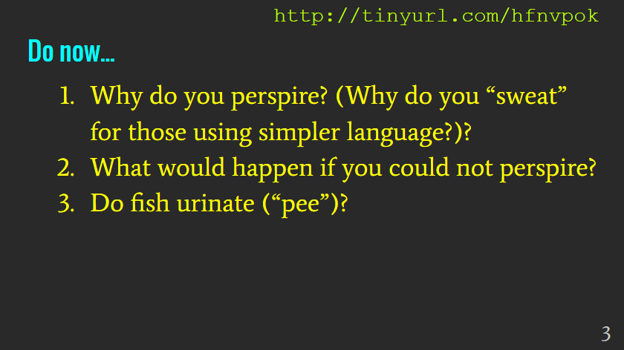

II. Phenomena
Discussion included the reasons for perspiration and the important role temperature control has on living things. Prompts led students to express ideas about the potentially tragic consequences of not being able to cool the body leading to connections with other conditions that must be maintained internally for organisms to survive.

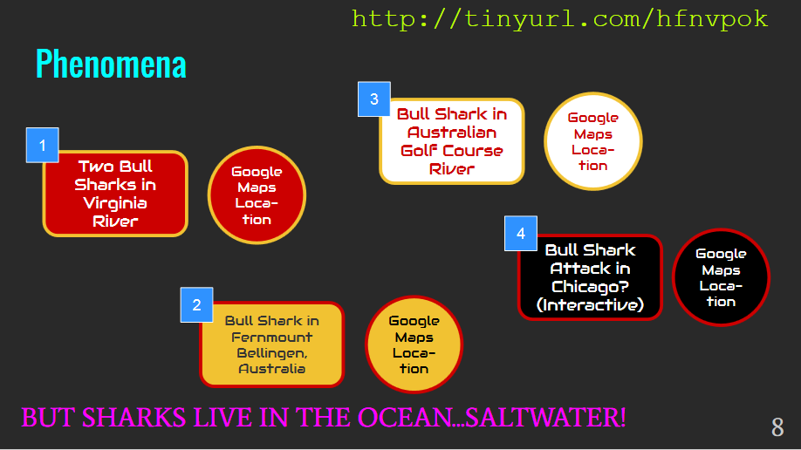

Phenomena and Map Links:
1
http://wtvr.com/2013/08/22/two-bull-sharks-in-virginia-river/
https://www.google.com/maps/place/39%C2%B010'58.6%22N+77%C2%B029'34.7%22W/@39.1829571,-77.4951627,631m/data=!3m1!1e3!4m2!3m1!1s0x0:0x0

2
https://www.youtube.com/watch?v=xzJhqlYk7kM
https://www.google.com/maps/@-30.4682572,152.9417644,18z

3
https://www.youtube.com/watch?v=dn41Odq8hyc
https://www.google.com/maps/place/Carbrook+Golf+Club/@-27.6821428,153.2563382,14z/data=!4m2!3m1!1s0x0:0x305841080017e8ac

4
http://s3.amazonaws.com/uploads.knightlab.com/storymapjs/5f15087581297692d20d2c039b06eb5d/the-more-likely-but-still-unlikely-journey-of-the-shark-that-might-have-attacked-george-lawson-in-lake-michigan-in-1955/index.html

Students model changes in the external environments of living organisms using a chicken egg with the shell removed using a vinegar solution over a period of 3-5 days.
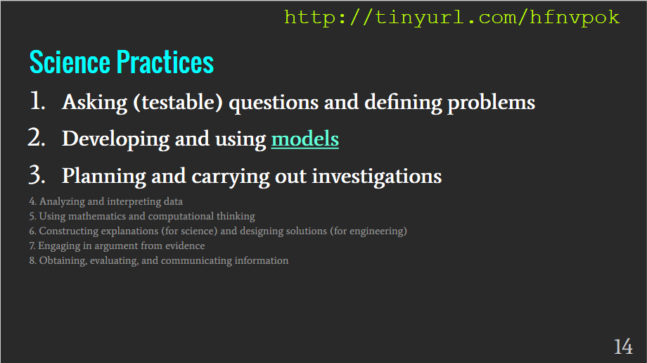
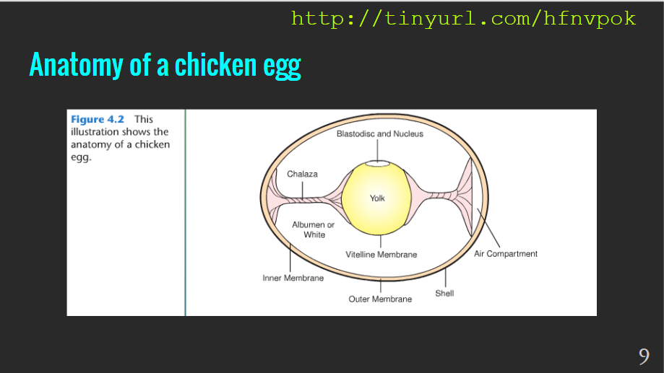

III. Student-designed experiments
In groups of three, students were asked to generate a series of questions related to the phenomena that we could test using shell-less eggs as a model for living cells in large complex organisms. This was a good point to discuss the scientific importance and value in using models to explain phenomena. Students were asked to design experiments using a generalized protocol for massing eggs and changing their external environments. It is important to note that each team will need to write the specific procedure they followed in their group. This requires distinction between “protocol” and “procedure.”

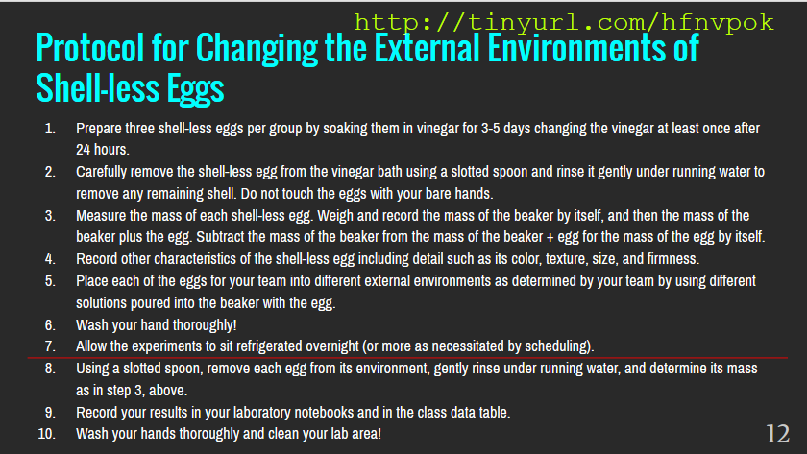

Text of the protocol:
Protocol for Changing the External Environments of Shell-less Eggs

- Prepare three shell-less eggs per group by soaking them in vinegar for 3-5 days changing the vinegar at least once after 24 hours.
- Carefully remove the shell-less egg from the vinegar bath using a slotted spoon and rinse it gently under running water to remove any remaining shell. Do not touch the eggs with your bare hands.
- Measure the mass of each shell-less egg. Weigh and record the mass of the beaker by itself, and then the mass of the beaker plus the egg. Subtract the mass of the beaker from the mass of the beaker + egg for the mass of the egg by itself.
- Record other characteristics of the shell-less egg including detail such as its color, texture, size, and firmness.
- Place each of the eggs for your team into different external environments as determined by your team by using different solutions poured into the beaker with the egg.
- Wash your hand thoroughly!
- Allow the experiments to sit refrigerated overnight (or more as necessitated by scheduling).
- Using a slotted spoon, remove each egg from its environment, gently rinse under running water, and determine its mass as in step 3, above.
- Record your results in your laboratory notebooks and in the class data table.
- Wash your hands thoroughly and clean your lab area!

IV. Data sharing and discussion
Student first analyzed the results in their groups and then shared their thoughts in a class-wide discussion. Students were asked to substantiate claims with evidence from the body of data generated by the class.

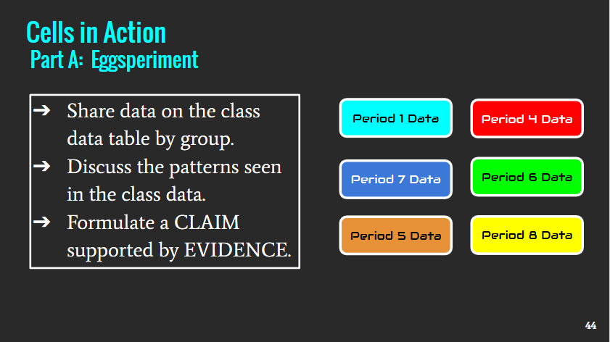

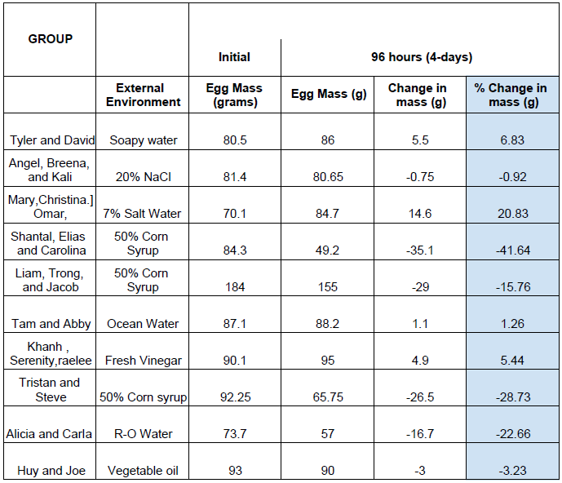
Example of class data: (note that the example shows data after 4 days due to a holiday)

V. Conclusion writing
Students were assigned the task of writing a complete conclusion for their class results that explain what is happening to the eggs as their external environments are changed. Students are prompted to review the process of writing using the Claim-Evidence-Reasoning format.

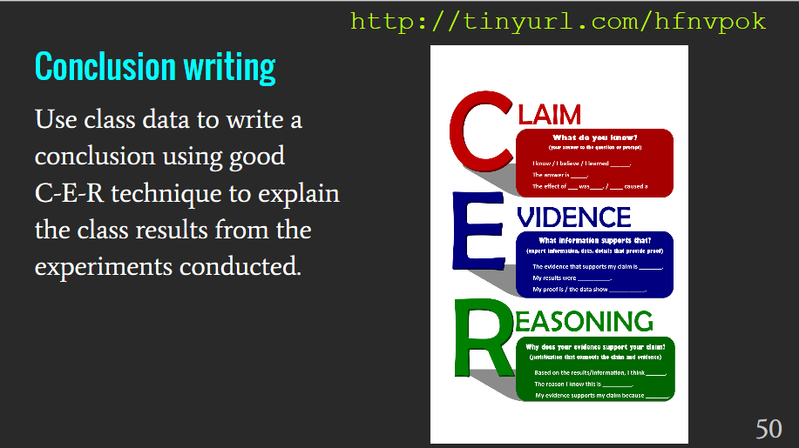

VI. Academic language for the lesson

Homeostasis = the internal balance maintained in living organisms through the expenditure of energy
Barrier = something that separates areas
Independent Variable = the part of the experiment that is changed by the scientist
Dependent variable = the changes observed due to different conditions in an experiment
Control = parallel experiments with no variable changed
Protocol = generalized directions for an experiment
Procedure = specific directions for a specific experiment (conducted by your group)

VII. Content Learning Objective
Students will design in writing an experiment using explanatory language to explore the role that cell boundaries play in maintaining internal homeostasis using shell-less eggs as a model by following a written protocol and share their results from their experiment with the class.

VIII. Colorado Academic Standards Alignment

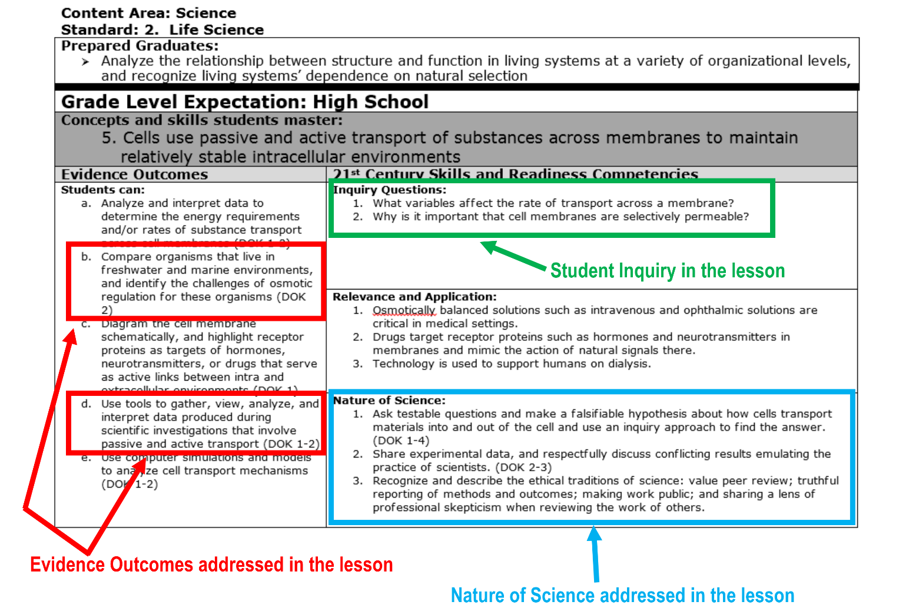

Element 4: Reflection

This lesson plan worked very well to engage students in a level of true inquiry. Most groups were successful in choosing an external environment that caused a notable change in the mass of their shell-less eggs. In some cases, students used materials that caused a reaction with the albumin inside the egg. The instructional strategies were very effective: students consistently demonstrated curiosity and willingness to experiment in an organized way.

Future versions of this lesson could include asking students to take their eggs into a second phase of the experiment where they used the class data to change the external environment once again to reverse the changes they saw in the shell-less egg. Students would collect data and determine how well the external changes they make influence the changes in egg mass.

Students indicated in an exit ticket activity reflection that they liked being able to try things they wanted to try and that they felt more connected to the topic after justifying their claims and more confident in their abilities to “do science.” Through casual observation, students who were in groups that spent more time asking each other questions did seem to have a greater connection to their efforts.

CONCEPT-BASED LESSON PLANNING PROCESS GUIDE

Internal Environments Respond to External Changes
By Kevin Lindauer, nbct
John F. Kennedy High School
Denver Public Schools, Denver, Colorado

Note: The shaded areas indicate the shifts from more traditional lesson planning to a concept-based instructional design and asks teachers to metacognitively reflect on their planning. The red cells and shading indicate the primary focus of our work at the Institute. The process guide is to help make visible “the invisible thinking” in which teachers engage as they plan lessons. The guide is not intended to suggest that templates in use by teachers or in districts should be replaced; in fact, the process guide may be a valuable tool when used “side-by-side” with other lesson planning templates or tools. The intention is to illustrate the type of questioning that should occur consistently with any planning process when considering the instructional shifts implicit in the Colorado Academic Standards.
Shift in  Instructional Design | Lesson Elements and Design | Metacognitive Reflection
The Unit Generalization and Focusing Lens asks students to … | Lesson Focus:  (Connection to Generalization and/or Focusing Lens in the District Sample Curriculum Project)  Students will design and conduct experiments to generate evidence to explain how external environmental changes influence the internal environments of living organisms using a model under laboratory conditions. | How does this specific lesson advance the big idea or generalization of the unit? What connections might be made between other content areas?
This lesson objective / learning target is critical to student understanding because… | Objectives / Learning Targets:  (Key knowledge & skills students will master in the lesson)  (Language may be pulled from the task in the Learning Experience:“…so that students can…”)  I can explain how changes in external environment can influence the internal environment of organisms. | In what ways does the learning target support the generalization?
Instructional strategies | Instructional Strategy Menu (not exhaustive):  - Teacher-provided phenomena  - Student-generated questions  - Hands-on/experiential  - Collaborative groups  - Data sharing | Which instructional strategies will foster learning the lesson’s skills, processes, or content?
In the first 3-7 minutes of the lesson, | Opening (hook / anticipatory set / lesson launch)  Instructional Strategy chosen: Teacher-provided phenomena  - Video: “8-foot bull sharks bagged in Potomac River after bypassing James” (http://wtvr.com/2013/08/22/two-bull-sharks-in-virginia-river/)  - How do bull sharks manage to swim up freshwater rivers unlike other marine organisms?  Why is this strategy impactful:  This strategy uses striking phenomena to establish the concept of external environmental changes affecting the internal environments of living organisms. Students are attracted to and curious about sharks in general, but by comparing the video stories with associated locations, students start to understand the feat is very unusual as these bull shark encounters are often very far from the ocean. Students should consider how many other marine organisms are not found so far from their original habitats making the phenomenon even more interesting. From the phenomenon, students will generate a series of questions that, ultimately, will be used to conduct student designed experiments using shell-less eggs.  Video phenomena make content very accessible to students by providing images and descriptions. Students should be guided to connect changes in external environments to a wide range of environmental factors affecting habitats where organisms live, and how successfully organisms ultimately reproduce in a given environment. Discussion to elucidate personal experience with balance and imbalance supports student connections to the phenomena and content. Differentiation for gifted or advanced students includes expanded studies of marine organisms finding their way into freshwater, freshwater organisms found in saltwater, and examination of organisms--such as salmon and trout--that have both marine and freshwater environments as part of their life cycle. Struggling students can be mixed with groups to support individual needs. To build capacity, English language learners should be supported with academic language use, sentence frames for explaining the phenomenon, and selective grouping to permit active engagement in setting up the physical experiments.  Students may demonstrate misconceptions related to fresh or saltwater environments. Composition of seawater and freshwater environment, especially examples that are local, can be clarifying for many students with limited experience. Most marine organisms have very limited capacity to survive in different salinities; bull sharks are an exceptional example. Students may mistakenly think that marine organisms commonly encroach into freshwater environments.  Student vocabulary:  Salinity Marine Freshwater Balance Homeostasis Dehydration Internal environment External environment Barrier  Scientific Practices:  1. Asking questions (for science) and defining problems (for engineering)  2. Developing and using models  3. Planning and carrying out investigations  How does this strategy support meeting the “just-right challenge,” or “building relationships,” or “creating relevancy,” or “fostering disciplinary literacy”?  Student generated questions need to be authentic and original to the individual. This phenomenon presents students with a disparate events that are authentic and engaging requiring them to consider how the bull sharks survive changes that would kill most other marine organisms. Student capacity to ask questions--thinking like a scientist--related to the phenomenon should reflect their level of experience and expertise in using science practices. | In what ways does the chosen strategy work toward a larger purpose at the beginning of the lesson (e.g., engaging students, increasing curiosity, stimulating student-generated questions, etc.)?  In what ways does the chosen strategy(ies) work toward a larger purpose (e.g. increasing collaboration; interacting with complex texts; situating students in real-life, relevant experiences; increasing student agency; stimulating student discourse; etc.)?  In what ways does the chosen strategy cement the learning?  What evidence will show that the strategies impacted student learning? Were the strategies effective through the learning process?
The Learning Experience will | Learning Experience / Lesson  Instructional Strategy chosen:  Student-generated questions, Teacher-provided inquiry questions  Scientific Practices:  1. Asking questions  2. Developing and using models  4. Analyzing and interpreting data  6. Constructing explanations (for science)  8. Obtaining, evaluating, and communicating information  Why is this strategy impactful:  (In what ways does this strategy move the learner toward meeting the learning target? How would this strategy ensure all students, with differentiated needs, can feel successful?)  This strategy reflects the processes of science, but with a relatable and engaging phenomenon that is followed by student designed experiments. Accessibility to the activity and content is broad and accommodations are equally made.  How does this strategy support meeting the “just-right challenge,” or “building relationships,” or “creating relevancy,” or “fostering disciplinary literacy”?  Inquiry based science discovery that is well facilitated does offer advantages of student engagement with high levels of success, opportunities to engage in authentic science, and use of critical thinking skills.
The closing activity reinforces the learning. | Closure  At first I thought…  Living things did not respond to changes in the external environment but remained the same.  But now, I know...  Living things respond to external environmental changes and must use energy to maintain differences between their internal and external environments or changes to the internal environments could cause problems.  Instructional Strategy chosen:  Why is this strategy impactful:  (In what ways does this strategy move the learner toward meeting the learning target? How would this strategy ensure all students, with differentiated needs, could feel successful?)  Using student-generated questions, and student-designed labs places scientific thinking at the forefront supporting biology content related to homeostasis. Students express a great deal of interest and generate questions that are testable with the model. Students of all levels can be successful as the data collection process is relatively reliable and trouble-free.  How does this strategy support meeting the “just-right challenge,” or “building relationships,” or “creating relevancy,” or “fostering disciplinary literacy”?  Students use their data to support claims made in a written conclusion statement as is proper in scientific practice. This direct correlation between real science and student efforts in the classroom builds relevancy to students as it is their responsibility to apply good practice from question to conclusion, thereby directly building disciplinary literacy as well.
Technological resources that will support student learning and move students toward the learning target. | Technological Resources and Application:  Video clips of phenomena: bull sharks swimming in rivers  Triple-beam balances or electronic scale  Optional: Computers / tablets / chromebooks / cellular phones with Internet access  Optional: Cloud-based spreadsheet (Google Sheets file for each class)  Technological resources are used to show students the phenomenon stimulating curiosity and allowing them to generate questions related to maintaining homeostasis. Because experiments involve determining the mass of shell-less eggs before and after a change in their external environment, scales and balances should have an accuracy to about 0.1 g or better to clearly show any changes. Internet access and computer technologies allow students to witness phenomena, organize data, and share results with the class, school, or greater community. Sharing of results can be accomplished using live online documents such as those created using Google Sheets. Alternatively, students can record and share data in writing on paper. The important point is that students should share data with other groups or classes to establish patterns.  How: In what ways does this chosen resource support meeting the “just-right challenge,” or “building relationships,” or “creating relevancy,” or “fostering disciplinary literacy”?  Utilizing engaging phenomena and placing emphasis of experimenting on the students means that they must exercise skills of critical thinking to answer questions they generated themselves. | How will my students and I strategically use technology resources to enhance the learning experience (and support “meeting the just-right challenge,” “building relationships,” “creating relevancy,” and/or “fostering disciplinary literacy”)?
Formative assessment will be a quick Check for Understanding in which students will demonstrate they are or are not on track. | Formative Assessment  Formative Assessment tool/method:  - Testable questions  - Procedures  - Student discussions  Students must get teacher approval after choosing their “testable question” and completing their procedures prior to experimenting. These serve as opportunities to assess student understanding.  Learning indicators of success:  (What evidence will show that the learner is moving toward mastery of the learning target?)  Students produce written evidence of asking testable questions, data collection, and analysis. Students must relate their findings to the phenomena and utilize scientific language to relate their claims, support them with evidence, and explain their reasoning in light of content mastery. | What “indicators of success” will show that the students are gaining mastery?  How will I use that evidence in a feedback loop?

Reflection: (What are the strengths in the lesson plan? What changes would I make in the lesson plan for next time?)
This lesson was particularly good at focusing and developing student skills on answering student-generated questions in a scientific manner. Using science content as a driving force, appropriate student inquiry seems to have a significant impact on the relevance and longevity of conceptual understanding. Teacher preparation, which requires about one week of forethought and preparation, is well worth the time as once set in motion, the lesson requires little attention outside of classroom. This is an activity that has a large impact on student skill development and content understanding as students were much more engaged and interested in seeing the results of the class with their personal contribution playing a significant role. Facilitating discussion among students seemed to be natural and fluid with many students contributing either by confirming or challenging the results of other teams. Furthermore, with some experiments generating little useful evidence from the class, there seemed to be a high level of critical analysis of the data. With the ability to critically evaluate their peers, students developed a better sense of “good science.” As part of future implementation of this lesson, I would define student grouping and roles carefully to best capitalize on needed areas of growth.
Connection to Performance Goal: (What did I do in this lesson that gives evidence or may be used as an artifact for my professional growth plan?)
Students generate testable questions, written procedures for their experiments, shared data on class data tables, and report results citing evidence to support claims. All of these components demonstrate professional attention to critical thinking skills, science content, proven pedagogy, and progressive application of State Standards and supported techniques.
Student Feedback: (What did students say about the lesson? Did they find it engaging, interesting, appropriately challenging? Did their feedback confirm my own perception of the lesson?)
Students found the activity challenging and engaging. Many expressed frustration at not being given a specific directions for their group experiments, but responded very positively to encouragement and hints as they struggled with figuring out how to design their experiment. Obtaining quantitative data was very empowering and supportive of the use of strong evidence to back claims made from experiments. Students reported that frustrations related to initial design challenges were eclipsed by the feeling of success when looking at the collection of class data. Contributing to a greater body of evidence emphasized responsibility to the collective body of knowledge used by themselves and others to justify claims and address rebuttal.

Time Suggested | 2-3 class periods (minimum) over at least two days  3-5 days preparation of eggs ahead of the lab
Materials Needed | - Shell-less chicken eggs (3 per team) –soaked in vinegar for 3-5 days with at least one fresh vinegar change  - Distilled water  - 50% corn syrup solution (473 ml corn syrup brought up to 1000ml total volume with water)  - Various other solutions as needed for student experiments*  - Triple-beam balance or electronic scale accurate to at least 0.1 g  - Refrigerator to store eggs  *Safely consider other solutions considered by teams. Some solutions, such as ethanol, can cause chemical changes to the proteins inside the shell-less eggs; nevertheless, they are valid experiments that produce unexpected results.
Co-teaching Opportunity | - Classes can collaborate to design, conduct, and share data from experiments between teachers and sections.  - Results can be published for classes to read, both within and outside of the science department.
Cross-Content Connections | Math: students process data to obtain percent change  Technology: students can use spreadsheets for analyzing quantitative data  English: student generated written lab reports using cause and effect language and content related vocabulary

