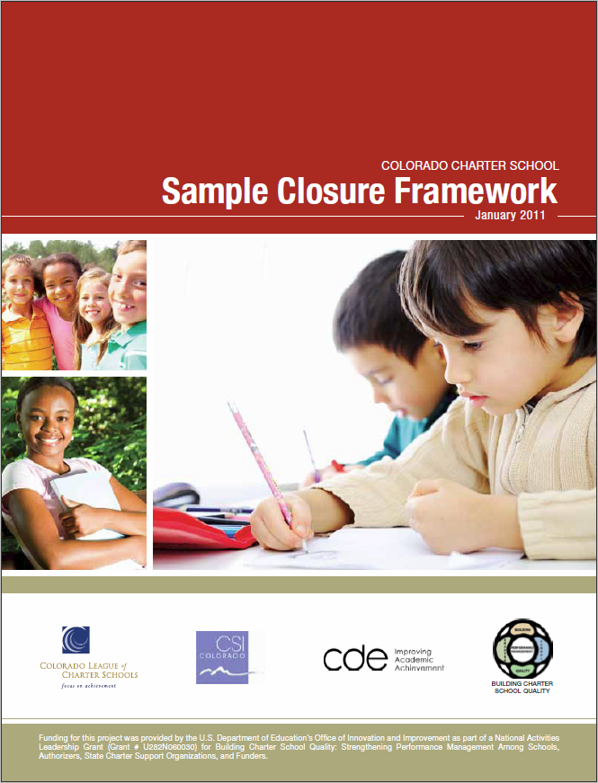
Colorado Charter School Sample Closure Framework
January 2011
Background
This Sample Closure Framework provides a Colorado-specific guide to charter school closure, complementing the Colorado Charter School Standard Application, Checklist, and Review Rubric, A Resource for Developing Charter School Contracts, and Colorado Sample Contract Language and Attachments. All of these documents are a product of a collaborative initiative of the Colorado Department of Education, the Colorado League of Charter Schools, and the Colorado Charter School Institute, and are available at www.charterschoolquality.org.
This Framework benefits from review by authorizers and charter schools. Additional feedback from authorizers and schools will be gathered over time to improve this document to ensure it continues to reflect best authorizing practices in Colorado.
This work is part of a larger four-year project entitled, “Building Charter School Quality: Strengthening Performance Management among Schools, Authorizers, State Charter Support Organizations and Funders,” which was supported by a National Activities grant from the U.S. Department of Education.

Table of Contents
Introduction. . . . . . . . . . . . . . . . . . . . . . . . . . . . . . . . . . . . . . . . . . . . . 4
Background. . . . . . . . . . . . . . . . . . . . . . . . . . . . . . . . . . . . . . . . . . . . . . 5
Notification and Initial Steps. . . . . . . . . . . . . . . . . . . . . . . . . . . . . . . . 7
Develop/Monitor Implementation of the Closure Plan . . . . . . . . . . 8
Finalize School Affairs: Governance and Operations. . . . . . . . . . . . . 9
Finalize School Affairs: Finance. . . . . . . . . . . . . . . . . . . . . . . . . . . . . 11
Finalize School Affairs: Reporting. . . . . . . . . . . . . . . . . . . . . . . . . . . 13
Dissolution. . . . . . . . . . . . . . . . . . . . . . . . . . . . . . . . . . . . . . . . . . . . . 14

Introduction
Closing a charter school can present many challenges, given the data that must be compiled and analyzed, public meetings that must be held, and the political considerations that must be addressed before a charter school chooses to voluntarily close or before the authorizer votes to not renew or to revoke the charter school contract.

Given the challenges, a carefully developed, detailed school closure plan is a high priority. An orderly closure process providing for continuity of instruction until the closure date, identifying new school options for students, and meeting the school’s financial, legal, and operational obligations is in the best interest of all parties. This Colorado-specific checklist of tasks in a template format was developed to assist authorizers and charter schools with the closure process.

This document draws heavily on several sources:
1. Accountability in Action: A Comprehensive Guide to Charter School Closure. Edited by Kim Wechtenhiser, Andrew Wade, and Margaret Lin. National Association of Charter School Authorizers (2010).
2. Colorado Charter School Institute Closure Project Plan (2010).
3. Charter Renewal. Charter Schools Institute, The State University of New York (SUNY ).
4. Pre-Opening Checklist and Closing Checklist. Office of Education Innovation, Office of the Mayor, City of Indianapolis.
5. 2010-2011 Charter Renewal Guidelines. District of Columbia Public Charter School Board.
Colorado charter school authorizers were helpful in reviewing this document to enhance usability and completeness. Additional feedback from authorizers and charter schools will be gathered over time to improve this document to ensure it continues to reflect best Colorado authorizing practices.

Background
Whenever a charter school closes, there are many tasks that must be completed; however, the tasks associated with the winding up of business will be different for each authorizer and charter school, reflecting the circumstances surrounding the closure.

These circumstances include the following:
- Timing of closure – during or at the end of a school year.
- Reasons for closure – for example, financial mismanagement, student performance, or lack of enrollment.
- Charter school capacity – the extent to which the charter school can accomplish the tasks associated with closure.
- Relationship of the parties – can the authorizer and the school work together cooperatively to close the school?
- Expectation of closure – whether the authorizer and charter school expected and planned for the closure.
- Appeals and legal action – the time period before a final decision is reached on closure.
- Student reassignment – the availability of space, school options, and impact on school districts that will be receiving students.
The circumstances outlined above will be affected by whether or not the closure is voluntary. Voluntary closure typically occur when either the school does not seek renewal of its charter or when the school recognizes that it is no longer academically or financially viable. Involuntary closure may occur when a charter renewal application is denied, but may also be precipitated by charter revocation due to a financial crisis or persistent low academic achievement. In such circumstances, the school and authorizer may have genuine disagreements about the school’s performance. In other cases a charter school may believe that renewal is pro forma, ignoring the accountability-for-autonomy agreement that is the foundation of the charter school contract. In these circumstances, closure is unexpected in addition to being involuntary.
In rare circumstances, an involuntary closure may be preceded by an authorizer requesting that the Commissioner of Education invoke the Emergency Powers Act (C.R.S. 22-30.5-701 et seq.) In this case, closure is usually related to financial mismanagement, a threat to district or school property, and/or student safety. An involuntary closure, and especially one where the Emergency Powers Act has been invoked, is likely to present the authorizer with many more difficulties than a voluntary closure.
When the charter school closure is involuntary, an appeal of the decision to the State Board of Education is likely. The appeal process may add up to 90 days before a final decision on closure is reached (30 days to file an appeal and 60 days for the State Board to hear the appeal and make its findings). In rare cases, a second appeal could precede closure. This could result in an additional 90 days before a final decision (30 days for the local board to reconsider its decision and make a final decision, 30 days to file an appeal, and 30 days for the State Board to make a decision) (C.R.S. 22-30.5-108). In any case, an authorizer will need to have contingency plans to address the various scenarios that may occur.
Regardless of how the process unfolds, the authorizer’s staff should meet with the charter school board and principal immediately after the initial closure decision to determine who will send letters to the school districts that are materially affected and to the school’s parents notifying them of the decision. Ideally, all parties will agree on the content of the letters. Additional letters should be sent to parents and school districts updating them about the timing and outcome of any appeals.

Whether or not closure is scheduled during or after the school year is a key factor in developing the closure plan. An end-of-year closure is almost always in students’ best academic and social interests; in addition, it simplifies the financial issues associated with the closure. In the event that the school is unable to operate until the end of the school year, the authorizer will need to consider whether its best interest is served by continuing to operate a school in the charter school facility until a smooth transition is possible.
Regardless of the specifics of the closure plan, there are three primary goals to be accomplished in the winding up of the school’s affairs:
- Providing educational services in accordance with the charter contract until the end of the school year, or the agreed upon date when instruction will stop.
- Reassigning students to schools that meet their educational needs.
- Addressing the school’s financial, legal and reporting obligations.
These goals should be given the highest priority during the closure process.
Based on the circumstances surrounding the closure, not all tasks in this framework may apply. The authorizer and charter school should meet prior to starting closure proceedings and agree which tasks will be necessary and how the authorizer wants to superintend the closure. During this meeting, responsible parties and completion dates should be agreed upon to ensure a transparent and smooth closure. The closure process has many tasks, which are illustrated in the chart below: 1) notification to affected school districts and families; 2) developing and monitoring the closure plan; 3) winding up the school’s affairs in governance and operations, finance, and reporting; and 4) dissolution. The template that follows includes the basic tasks that will usually need to be addressed to close a school; the format allows for the insertion of responsible parties and dates of completion.

A Conceptual Timeline for Closure
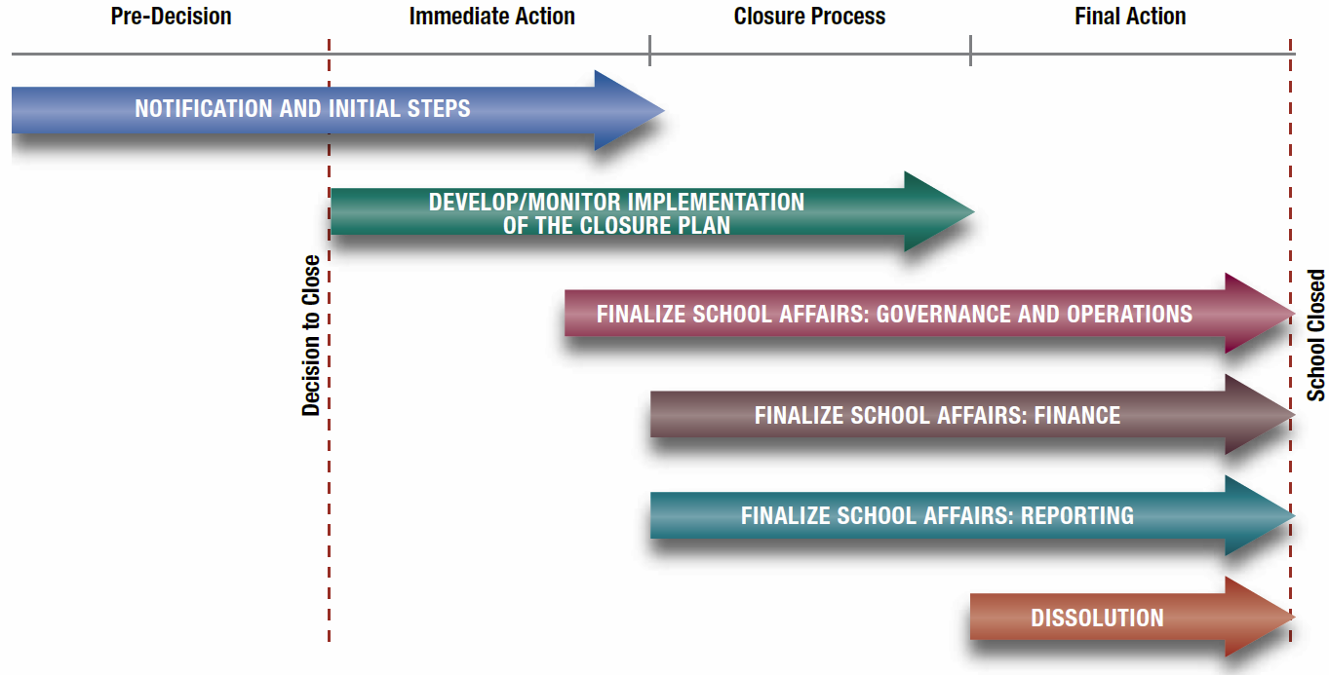
Notification and Initial Steps
The following checklists can be downloaded at www.charterschoolquality.org > Publications & Tools > Authorizers.
Description of Required Actions | Responsible  Party | Completion  Date | Status
Notify Parents / Guardians of Closure Decision
Within one day of the authorizer’s decision to close the charter school, authorizer staff and charter staff/board collaborate to ensure that parents / guardians are notified regarding the closure decision. Such notification includes:
- If applicable, an explanation of the process for an appeal to the Colorado State Board of Education and possible litigation including the implications for families.
- Assurance that instruction will continue through the end of the school year or the date when instruction will cease.
- Assurance that after a final decision is reached, parents/students will be assisted in the reassignment process.
- FAQ about the charter closure process.
- Contact information for parents/guardians with questions.
Notify School Districts Materially Impacted
Within two days of the authorizer’s decision to close the charter school, notify districts materially impacted by the closure decision, including:
- Possible appeals and timeline for final decision.
- Copy of the letter sent to parents.
- Closure FAQ.
- Information about the plan being developed to ensure an orderly closure process..
- Contact information for questions.
Review Budget
- Review budget to ensure that funds are sufficient to operate the school through the end of the school year, if applicable.
- Emphasize the legal requirement to limit expenditures to only those in the approved budget, while delaying approved expenditures that might no longer be necessary until a revised budget is approved.
- Acknowledge that there are unique expenditures associated with closure for both the authorizer and school and that the parties will meet to identify these expenditures and funding sources.
- Ensure that the school continues to collect revenues included in the school’s budget, if applicable.
Meet with Charter School Faculty and Staff
Principal and charter board chair meet with the faculty and staff to:
- Discuss reasons for closure, the status of appeals/legal action and likely timeline for a final decision.
- Emphasize importance of maintaining continuity of instruction through the end of the school year.
- Discuss plans for helping students find new schools.
- Identify date when last salary check will be issued, when benefits terminate, and last day of work.
- Describe assistance, if any, that will be provided to faculty and staff to find new positions.
Send Additional and Final Notifications
Notify parents and affected school districts in writing after key events (e.g., denial of an appeal) and when the closure decision is final. In the letter to parents after the closure decision is final, include:
- The last day of instruction.
- Any end-of-the-year activities that are planned to make the transition easier for parents and students.
- Assistance that will be provided to families in identifying new schools. This may include a list of school options, choice fairs, individual meetings with families, and prospective school visitations.

Develop/Monitor Implementation of the Closure Plan
Description of Required Actions | Responsible  Party | Completion  Date | Status
Establish Transition Team, Develop Closure Plan, and Assign Roles
Transition team includes:
- Lead person from authorizer staff.
- Charter school board chair.
- Lead administrator from the charter school.
- Lead finance person from the charter school.
Develop plan, exchange contact information and assign roles.
Establish a Schedule for Meetings and Interim Status Reports
Agree on a meeting schedule to review progress and interim, written status reports to include:
- Reassignment of students.
- Return or distribution of assets.
- Transfer of student records.
- Notification to entities doing business with the school.
- The status of the school’s finances.
- Submission of all required reports and data to the authorizer and/or state.
Submit Final Report
Submit a final report to the authorizer detailing completion of the closure plan.

Finalize School Affairs: Governance and Operations
Description of Required Actions | Responsible  Party | Completion  Date | Status
Maintain Identifiable Location
Maintain the school’s current location through the winding up of its affairs or relocate its business records and remaining assets to a location with operational telephone service that has voice message capability.
Notify Commercial Lenders / Bond Holders
Within 10 days after the final decision on the charter school closure and after all appeals have been exhausted, notify banks, bond holders, etc., of the school’s closure and a likely date as to when an event of default will occur as well as the projected date of the last payment by the school toward its debt.
Terminate EMO /CMO Agreement (if applicable)
Review the management agreement and take steps needed to terminate the agreement at the end of the school year or when the charter contract expires.
- The management company should be asked for a final invoice and accounting, including an accounting of any retained school funds and the status of grant funds.
- The school and the management company should agree upon how the company will continue to provide educational services until the last day of instruction.
- The school and the management company agree when other services including business services will end.
Protect School Assets
Protect the school’s assets and any assets in the school that belong to others against theft, misappropriation and deterioration.
- Maintain existing insurance coverage on assets, including facility and vehicles, until the disposal of such assets in accordance with the closure plan.
- Negotiate school facility insurance with entities that may take possession of school facility – lenders, mortgagors, bond holders, etc.
- Obtain or maintain appropriate security services. Action may include moving assets to secure storage after closure or loss of facility.
Maintain Corporate Records
Maintain all corporate records related to:
- Loans, bonds, mortgages and other financing.
- Contracts.
- Leases.
- Assets and asset distribution.
- Grants -- records relating to federal grants must be kept in accordance with 34 CFR 80.42.
- Governance (minutes, bylaws, policies).
- Employees (background checks, personnel files).
- Accounting/audit, taxes and tax status, etc.
- Personnel.
- Employee benefit programs and benefits.
- Any other items listed in the closure plan.
Determine where records will be stored after dissolution.

Finalize School Affairs: Governance and Operations (continued)
Description of Required Actions | Responsible  Party | Completion  Date | Status
Notify Employees and Benefit Providers
Formally notify all employees of termination of employment at least 60 days before closure to include date of termination of all benefits in accordance with applicable law and regulations (i.e. COBRA) and eligibility for Colorado Unemployment Insurance pursuant to any regulations of the Colorado Department of Labor. Notify benefit providers of pending termination of all employees, to include:
- Medical, dental, vision plans.
- Life insurance.
- Cafeteria plans.
- 403(b), retirement plans.
- PERA.
Consult legal counsel as specific rules and regulations may apply to such programs.
Notify Contractors and Terminate Contracts
- Notify all contractors of school closure.
- Retain records of past contracts and payments.
- Terminate contracts for goods and services as of the last date such goods or services will be needed.
Transfer Student Records and Testing Material
Send student records, including final grades and evaluations, to the authorizer, including:
- Individual Education Programs (IEPs) and all records regarding special education and supplemental services.
- Student health / immunization records.
- Attendance record.
- Any testing materials required to be maintained by the school.
- Student transcripts and report cards.
- All other student records.
Document the transfer of records to include:
- The number of general and special education records transferred.
- Date of transfer.
- Signature and printed name of the charter school representative releasing the records.
- Signature and printed name of the authorizer’s representative who receives the records.
Inventory assets
Inventory school assets, and identify items:
- Loaned from other entities.
- Encumbered by the terms of a contingent gift, grant or donation, or a security interest.
- Belonging to the EMO/CMO, if applicable, or other contractors.
- Purchased with federal grants (dispose of such assets in accordance with federal regulations).
- Purchased with Public Charter School Program startup funds (transfer assets to another charter school within the district or state).
Return assets not belonging to school where appropriate documentation exists. Keep records of assets returned.
Notify Food and Transportation Services and Cancel Contracts
Cancel school district or private food and/or transportation services for summer school and the next school year.

Finalize School Affairs: Finance
Description of Required Actions | Responsible  Party | Completion  Date | Status
Review and Revise School Budget
- Review the school’s budget and overall financial condition.
- Make revisions that take into account closure and associated expenses while prioritizing continuity of instruction.
- Identify acceptable use of reserve funds.
Maintain IR S 501(c)(3) Status
Maintain IRS 501(c)(3) status, including:
- Notify IRS regarding any address change.
- File required tax returns and reports.
Notify Funding Sources / Charitable Partners
Notify all funding sources, including charitable partners of school closure. Notify state and federal agencies overseeing the school’s grants that the school will be closing.
List all Creditors and Debtors
Formulate a list of creditors and debtors and any amounts accrued and unpaid with respect to such creditor or debtor.
- This list is not the same as the contractor list, above, but may include contractors.
- Creditors include lenders, mortgage holders, bond holders, equipment suppliers, service providers and secured and unsecured creditors. A UCC search should be performed to identify secured creditors.
- Debtors include persons who owe the school fees or credits, any lessees or sub-lessees of the school, and any person holding property of the school.
Notify Creditors
Notify all creditors of the school’s closure and request a final bill.
Notify Debtors
Contact all debtors and request payment.
Determine PER A Obligations
Contact PERA to determine remaining liabilities for employee retirement program.
Itemize Financials
Review, prepare and make available the following:
- Fiscal year-end financial statements.
- Cash analysis.
- Bank statements for the year, investments, payables, unused checks, petty cash, bank accounts, and payroll reports including taxes.
Collect and void all unused checks and destroy all credit and debit cards. Close accounts after transactions have cleared.
Close Out All State and Federal Grants
Close out state, federal, and other grants. This includes filing any required expenditure reports or receipts and any required program reports, including disposition of grant assets.
Prepare Final Financial Statement
Retain an independent accountant to prepare a final statement of the status of all contracts and other obligations of the school, and all funds owed to the school, showing:
- All assets and the value and location thereof.
- Each remaining creditor and amounts owed.
- Statement that all debts have been collected or that good faith efforts have been made to collect same.
- Each remaining debtor and the amounts owed.

Finalize School Affairs: Finance (continued)
Description of Required Actions | Responsible  Party | Completion  Date | Status
Complete Final Financial Audit
Complete a financial audit of the school in accordance with the Charter Schools Act by a date to be determined by the authorizer.
Reconcile with Authorizer
Reconcile authorizer billings and payments, including special education payments or other “lagged” payments. If the school owes the authorizer money, it should list the authorizer as a creditor and treat it accordingly.

Finalize School Affairs: Reporting
Description of Required Actions | Responsible  Party | Completion  Date | Status
Prepare End-of-Year Reports
Prepare and submit all required end-of-year reports to the authorizer.
Prepare Final Report Cards and Student Records Notice
Provide parents / guardians with copies of final report cards and notice of where student records will be sent along with contact information.

Dissolution
Description of Required Actions | Responsible  Party | Completion  Date | Status
Dissolve the Charter School
- The charter school board adopts a resolution to dissolve that indicates to whom the assets of the non-profit corporation will be distributed after all creditors have been paid.
- Unless otherwise provided in the bylaws, the members (if any) or board votes on the resolution to dissolve. A non-profit corporation is dissolved upon the effective date of its articles of dissolution. (C.R.S. 7-134-103).
Notify the Secretary of State
After the resolution to dissolve is authorized, dissolve the corporation by delivering to the Secretary of State for filing articles of dissolution setting forth:
- The name of the non-profit corporation.
- The address of the non-profit corporation’s principal office.
- The date dissolution was authorized.
- If dissolution was authorized by the directors, a statement to that effect.
- If dissolution was approved by the members, a statement of the number of votes cast for the proposal to dissolve.
- Such additional information as the Secretary of State determines is necessary or appropriate.
Notify Known Claimants
Give written notice of the dissolution to known claimants within 90 days after the effective date of the dissolution.
End Corporate Existence
A dissolved non-profit corporation continues its corporate existence, but may not carry on any activities except as is appropriate to wind up and liquidate its affairs, including:
- Collecting its assets.
- Transferring, subject to any contractual or legal requirements, its assets as provided in or authorized by its articles of incorporation or bylaws.
- Discharging or making provision for discharging its liabilities.
- Doing every other act necessary to wind up and liquidate its assets and affairs.
(C.R.S. 7-134-105).
Notify IRS
Notify the IRS of dissolution of the education corporation and its 501(c)(3) status and furnish a copy to the authorizer.

