Markets are systems which allow people to exchange resources, goods and services. When countries trade with each other they have to determine if they will both benefit from the transaction. You are an economic expert that has been employed to develop a trade network between countries in the Eastern Hemisphere. You will create this network and write the proposal for this network.
- Identify two countries for which you will create a trade network.
- Develop and describe the trade network you would create based on the evidence provided in the documents.
- Develop a written argument that explains why the trade network would mutually benefit each country.

Document 1: Map of the Eastern Hemisphere
The letters in the circled regions below indicate the location of each country.
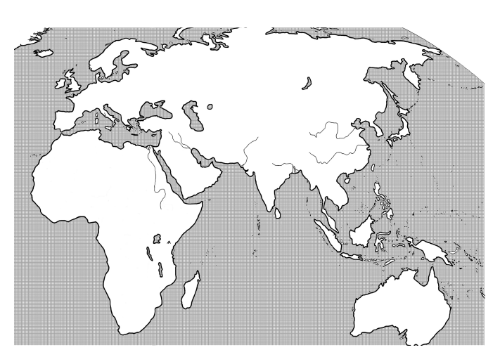

C
A

B

Document 2: Country Statistics from the CIA Fact Book
Country A
Population | 1.189 billion
GDP per capita | $3,500
Exports | Petroleum products, precious stones, machinery, iron and steel, chemicals, clothes
Imports | Crude oil, precious stones, machinery, fertilizer, iron & steel, chemicals
Literacy (definition: age 15 and over who can read and write) | 61%
Life expectancy at birth | 66 years
Median age | 26.6 years

Country B
Population | 10 million
GDP per capita | $600
Exports | Livestock, bananas, hides, fish, charcoal, scrap metal
Imports | Manufactured goods, petroleum products, food, construction materials
Literacy (definition: age 15 and over who can read and write) | 37.8%
Life expectancy at birth | 50 years
Median age | 17.8 years

Country C
Population | 126 million
GDP per capita | $34,000
Exports | Transportation equipment, motor vehicles, semiconductors, electrical machinery, chemicals
Imports | Machinery & equipment, fuels, food, chemicals, textiles, raw materials
Literacy (definition: age 15 and over who can read and write) | 99%
Life expectancy at birth | 82 years
Median age | 44.8 years

Document 3
Country A: Over one billion people live in Country A where the median age is 26.6 years. The average life span in Country A is 66 years and 61% of those over the age of 15 are able to read and write. More than half of the Gross Domestic Product (GDP) comes from the service sector, which includes technology support, financial services and transportation. Only one fourth of the country’s GDP comes from industry and agriculture comprises less than 20 percent.

Country B: The population of Country B is 10 million and the median age is only 17.8 years. The average life span of individuals in Country B is 50 years and the literacy rate for those over 15 is 37.8 percent. Sixty percent of the Gross Domestic Product (GDP) comes from agriculture, which includes fruits, vegetables, and livestock. Only one third of the country’s GDP comes from the service sector and only 7 percent comes from industry.

Country C: One hundred twenty-six million people live in Country C where the median age is 44.8 years. The average life span in Country C is 82 years and 99 percent of those over the age of 15 can read and write. Nearly 75 percent of the Gross Domestic Product comes from the service sector and less than one percent comes from agriculture. Twenty-five percent of the country’s GDP comes from industry, which includes processing raw materials and manufacturing equipment.

