Public policy is often written to influence how people make decisions and to achieve a balance between competing social economic goals which include
- Economic stability
- Allocation of resources
- Economic Growth
Choose two of the following documents and compare and contrast the economic reasoning behind the policy. How is the policy attempting to balance the economic system’s goals? Evaluate and predict the impact the policy might have.
Document A: Data is Power: Michigan Fights Childhood Obesity by Tracking It
Source: ABC News, September 24, 2011
http://abcnews.go.com/Health/Diet/michigan-track-kids-weight-statewide-registry/story?id=14518613
In an attempt to combat Michigan's childhood obesity epidemic, Gov. Rick Snyder announced today that the state would begin tracking kids' body mass index through the Michigan Care Improvement Registry. Although the policy would be one of the most extensive government anti-childhood obesity efforts, pediatricians were divided over whether it would have the desired impact.
The tracking system would encourage pediatricians to calculate patients' BMI using height and weight measurements, and report these numbers to the state through the existing immunization tracking system, the Michigan Care Improvement Registry. The numbers would be reported anonymously, meaning that the child's identity would not be connected to his or her BMI in state records.

The hope is that having doctors track height and weight in this way would encourage more discussion among parents, kids and doctors about the dangers of being overweight, says Geralyn Lasher, director of communications at the Executive Office of the Governor.

"BMI is a very poor tracking mechanism for a child, because it doesn't look at body fat. It looks at height and weight," says Dr. Dan Cooper, a chairman of the pediatrics department at the University of California at Irvine. "Take a high school football player who's 6 feet 1, and mostly muscle and someone who is 6 feet 1 and 30 percent fat, and they will have the same BMI," he says.

Data Is Power?
"It is absolutely essential that pediatricians track BMI in their patients," Scirica says. "Obesity in childhood is highly predictive of obesity later in life, and the longer a child remains overweight and the more overweight they become, the harder it becomes to achieve a healthy weight."

Childhood obesity is "arguably the No. 1 pediatric health problem," says Ayoob, "so if reporting on BMI -- something doctors should already be tracking on their own -- allows for documentation of a worsening or improvement, this could also help influence future policy."

Document B: Amid Protests, Greece Adopts New Austerity Plan
The New York Times October 20th, 2011

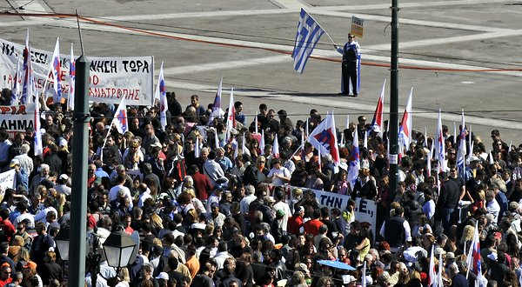
After a day of violent demonstrations against government cutbacks, Greek Socialist lawmakers on Thursday gave their final approval to a raft of tough new austerity measures, taking a critical step toward securing crucial foreign aid and averting a default.
The measures — including additional wage cuts, pension cuts, layoffs for public sector workers and changes to collective bargaining rules to make it easier to hire and fire — were passed on Thursday night with the support of all but one of the governing Socialist party’s 154 legislators.
Ahead of Thursday’s vote, (Prime Minister George) Papandreou and Finance Minister Evangelos Venizelos appealed to lawmakers to approve the entire package. Greece’s foreign lenders say the changes are needed to liberalize Greece’s economy, but they have met with intense popular anger.
“They are cutting our wages and diminishing our way of life for the sake of the banks,” said Nick Zolotariof, 40, who works in the public administration in Dionysos, a suburb of Athens. He said his salary had been cut to $1,235 a month from $1,650.
The Athens police said that about 50,000 demonstrators poured into the central Syntagma Square outside Parliament on Thursday. It soon became a war zone, as anarchists began throwing stones and firebombs at members of the Communist-backed labor union, PAME, who fought back while the police stood by.
Thursday’s vote came as European Union leaders prepared to meet Sunday for a final decision on the release of the next $11 billion installment of aid to Greece, part of a $150 billion bailout engineered last year. They will also be looking at a much broader European rescue designed to protect the bloc should Greece default. And, within days, a so-called troika made up of the European Commission, the European Central Bank and the International Monetary Fund is to issue its newest report on the Greek crisis.

Document C: States with laws banning texting while driving
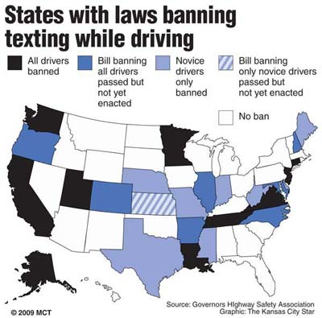

Document D: Recipients of US Foreign Aid
