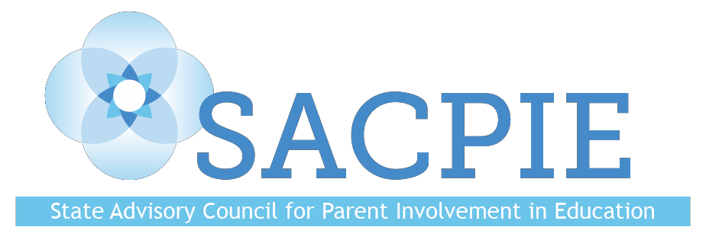

Quarterly Meeting

Tuesday, May 15, 2018
Denver, CO
MINUTES

Members Present: DJ Anderson, Kristen Collins, Yoni Geffen, Dr. Kris Greer, Brandon Hellwig, Eryn Kaiser, Leslie Levine, Dee Leyba, Kim McLachlan, Dr. Gloria Miller, Marci O’Gray, Monica Peloso, Joanna Peters, Jennifer Posschier, Kay Trotter, Joyce Thiessen-Barrett, Kim Watchorn (Vice-chair), Stacey Zis, (Chair)

Guests: Evie Hudak, Dr. Darcy Hutchins, David Ramer

Welcome and Introductions
- Members and guests introduced themselves.

Approval of Minutes from Tuesday, February 13, 2018
- The minutes were approved without alterations.

Public Comment
- No public comment.

2018 Legislative Session Update – Evie Hudak, Colorado PTA
- School finance – all of the bills PTA opposed were not passed. Did pretty well in finance.
- Early Childhood did great – all of the bills PTA supported passed, all those opposed failed.
- Educational quality and equity – did okay.
- Metal health and suicide prevention – did okay.
- Other health and safety issues – terrible.
- Family engagement provisions of HB 1355 – low performing schools and plans for improvement.

SACPIE Spotlight – Live Well Colorado
Leslie Levine
- Making healthy food choices.
- Double Up Food Bucks – people on food assistance can double from $20 to $40 (spend $20, and then get $20 worth of Colorado grown fruits and vegetables.)
- Live Well receives federal and state funding for the program.
- Looking for college age student volunteer interns.

Colorado’s 2Gen Initiative – Tara Smith, State Two Generation Program Coordinator, Governor’s Office
- Strategy to lift families out of poverty.
- Core components:
  - Social capital
  - Early childhood education
  - postsecondary and employment pathways
  - economic assets
  - health and well-being
- New research demonstrates a 13% return on investment in high-quality early childhood for each year of a child’s life, and a college degree doubles a parent’s income.
- For families with young children who have an annual income of $25,000 or less, a $3,000 increase during the years of early childhood yields a 17% increase in adult earnings for those children.
- Brains of new parents undergo major structural changes just as babies’ brains do.
- Parents with health insurance are more likely to seek care for themselves and their children.
- SACPIE members discussed and offered thoughts on 2Gen approaches and resources.

Early Childhood Education Initiatives in Colorado – SACPIE Early Childhood Education Committee
- 90% of a child’s brain development happens before age 5.
- Early Childhood Leadership Commission (ECLC) was created by state law; it ensures that there is collaboration among the numerous Early Childhood agencies.
- Early Childhood Colorado Framework – a shared vision.

CDE Update – Darcy Hutchins, CDE Family Partnerships Director
- Darcy is still accepting Promising Partnership Practices – deadline is June 1.
- Half of the Coffee Chats will be done virtually (so more people can attend).
- Dual Capacity Building Framework – need to build capacity in the staff and the parents together (goals for 2018-2019).
- SACPIE will have a sunset review in 2019 – Darcy will compile reasons why SACPIE should continue.

Committee Sharing
- Early Childhood
  - Their last meeting was spent preparing for today’s presentation.
  - Next meeting will be held June 26.
- Elementary
  - Will have seven Promising Partnership Practices.
  - Began brainstorming their FSCP Key topics – possibly how to empower parents when they realize their child may need special services, or what a partnership looks like.
  - Finished editing on their two brochures (the READ Act and Overcoming Hurdles).
- Secondary
  - Family engagement usually drops off in secondary schools.
- Higher Education
  - Committee members will be presenting the first week of June at a conference in Durango.
  - Have five Promising Partnership Practices.
  - Trying to get a member from the Colorado Department of Higher Education (CDHE).

Upcoming SACPIE Meetings
Tuesday, August 21, 2018 11:00 am-3:00 pm
Tuesday, November 13, 2018 11:00 am-3:00 pm

Disclaimer: The views and opinions expressed in this document are those of the State Advisory Council for Parent Involvement in Education (SACPIE) and do not necessarily reflect the official position or policy of the Colorado Department of Education or the Colorado State Board of Education.

