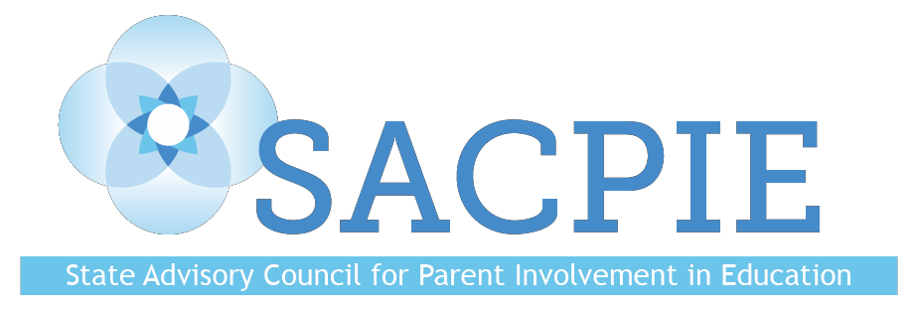

Quarterly Meeting

Tuesday, November 13, 2018
Golden, CO
MINUTES

Members Present: Tomas Mejia (proxy for Noemi Aguilar), DJ Anderson (Chair), Kristen Collins, Yoni Dobie-Geffen, Kris Greer (via phone), Brandon Hellwig, Stacy Johns, Leslie Levine (Vice-chair), Dr. Gloria Miller, Veronica Palmer (via phone), Amanda Pelatier (via phone), Joanna Peters, Joyce Thiessen-Barrett, Michael Vente, Kim Watchorn

Absences: Ann Bruce, Pam Christy, Sofia Esteve, Eryn Kaiser, Dee Leyba, Kim McLachlan, Maci O’Grady, Monica Peloso, Kay Trotter, Stacey Zis

Guests: Darcy Hutchins, Evie Hudak, David Ramer, Patty Schmidt (via phone)

Welcome and Introductions
- Members and guests introduced themselves.

Public Comment
- Sara Nadelman, Human Trafficking Specialist, Division of Child Welfare, Colorado Department of Human Services
    - Supports county departments of human services in their response to human trafficking.
    - Grant was awarded to achieve full implementation of a comprehensive, collaborative, jurisdiction-wide approach to preventing and reducing the impact of child/youth trafficking.

Approval of Minutes from Tuesday, August 21, 2018
- Minutes were approved unanimously without amendment.

CDE Family Partnership Update – Darcy Hutchins
- Recap of Kickoff for Family and School Partnership in Education Month:
    - Easy to move around the room and view posters.
    - Well attended.
    - Good venue, but not easy to get to.
    - Joyous and celebratory.

- December 5, Colorado Symphony will host Darcy’s coffee chat and play a free concert. Other local arts organizations will be represented, focusing on arts education in schools.
- SACPIE handouts archive will be in a Google Drive.
- 2018 SACPIE Annual Report is due December 31; subcommittee reports are due to Darcy by November 30.

Family-School-Community Partnering Definition Feedback – Vito Borrello, Executive Director, National Association for Family, School and Community Engagement (NAFSCE); Chris Miller, State Child Find Specialist, CDE; and Darcy Hutchins
- Working with 19 states to develop and implement a Family-School-Community Partnering (FSCP) framework.
- Colorado is the only state to have a legislated and funded council (SACPIE).
- Purpose: Develop systemic and sustainable state- and district-level structures that integrate and elevate FSCP that link to positive student outcomes and an inviting school culture. (This is a work in progress.)
- The definition for FSCP will guide the framework.
- Members discussed definitions of FSCP and offered suggestions.

SACPIE Revamp and Planning for 2019 – DJ Anderson and Leslie Levine
- Members discussed and shared why they wanted to join SACPIE.
- Members voted on two priorities for 2019:
  - Involve parents in programs to raise academic achievement, increase high school graduation rates, decrease student dropout rates, and close the achievement and growth gap.
  - Increase parent involvement in education-related committees at the local and state levels.
- Members voted on which groups to inform:
  - School districts.
  - Parent led state and local outside advocacy organizations (Padres y Jovenes Unidos, STAND for Children, Together Colorado, RISE, PTA, etc.).
- Members discussed and voted on committees; the committees for the coming year will be:
  - Early Childhood
  - K-12
  - Higher Education

Governor’s Education Leadership Council Focus Group – Tyler Gamble
- Tyler and two colleagues conducted a focus group at the August SACPIE meeting.
- Preliminary draft document was presented and discussed.
- Deadline for the final document is December 10.
- Members offered feedback.

Upcoming SACPIE Meetings
Tuesday, February 12, 2019 11:00 am-3:00 pm
Tuesday, May 21, 2019 11:00 am-3:00pm
Tuesday, August 20, 2019 11:00 am-3:00pm

Disclaimer: The views and opinions expressed in this document are those of the State Advisory Council for Parent Involvement in Education (SACPIE) and do not necessarily reflect the official position or policy of the Colorado Department of Education or the Colorado State Board of Education.

