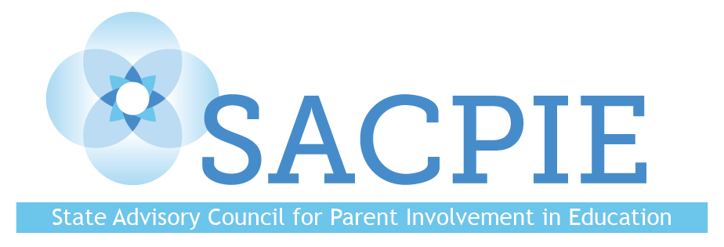
Tuesday November 15, 2022
AGENDA

9:00 Welcome and Introductions

9:30 Business

9:45 State Board of Education and SACPIE Updates—Dr. Lisa​ Escárcega

10:00 SACPIE Member Resource Sharing

10:30 Break

10:45 Updated National Standards for Family-School Partnerships—Staci Ruddy

11:15 SACPIE’s Legislated Responsibilities—Yoni Dobie-Geffen
Small Group Discussion—Putting the legislated responsibilities into action

12:00 Lunch

12:45 SACPIE Website Revisions Update—Dr. Jes Stroope

1:15 CDE Update—Dr. Darcy Hutchins
Small Group Discussion—Prepping for SACPIE Annual Report

1:45 Wrap-Up

2:00 Adjourn

