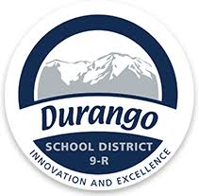
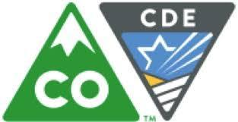
PWR Symposium

You are invited to join host Durango 9-R Schools, districts from Southwest Colorado, and CDE’s office of Postsecondary and Workforce Readiness for a PWR Symposium.

Explore Capstone implementation strategies, work-based learning, lessons learned, and student work from schools in the region.

When: Friday, March 1
9:00 a.m. – 2:00 p.m. (lunch provided)

Where: Durango School District 9-R
Administrative Offices, Board Room
201 East 12th Street
Durango, CO 81301

What: Beginning with the class of 2021, graduating seniors will demonstrate readiness according to the Graduation Guidelines Menu of Options. Schools and districts are working with their communities to implement various menu options, especially capstone, industry certificates, and work-based learning (WBL).

Who: All are invited; please bring a team from your school or district.

Expected Outcomes for the Day:
- Learn from local practitioners about their implementation processes
- Connect Graduation Guidelines with Postsecondary and Workforce Readiness (PWR)
- Get feedback from teachers/administrators in peer schools about your expectations, plans, program ideas, and struggles for capstone, industry certificates, and WBL
- Engage with students and hear their advice about the process

Please forward this invitation to your colleagues and neighbors.

REGISTER HERE
(No cost)

For more information, contact:
Andy Burns, Deputy Superintendent, Durango 9-R, via Johnnie Schmidbauer, jschmidbauer@durangoschools.org
Robin Russel, Graduation Guidelines Manager, CDE, russel_r@cde.state.co.us, or
Andy Tucker, Director of Postsecondary and Workforce Readiness, CDE, tucker_a@cde.state.co.us

