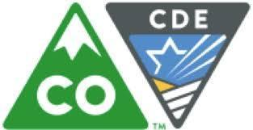
PWR Symposium

Explore Multiple Pathways to Graduation for Students in Alternative Education

You are invited to join your peers in alternative education for a Postsecondary and Workforce Readiness (PWR) Symposium.

Engage in strategic conversations about capstone, work-based learning, industry certifications, ICAP, graduation rates, and accountability.

When: Monday, June 10
9:00 a.m. – 2:00 p.m. (lunch provided)

Where: Nikola Tesla Education Opportunity Center
School District 11
2560 International Circle
Colorado Springs, CO

What: Beginning with the class of 2021, graduating seniors will demonstrate readiness according to the Graduation Guidelines Menu of Options. Schools and districts are working with their communities to build relevant and meaningful pathways for student success.

Who: Alternative Education Programs, Alternative Education Campuses, and district partners

Expected Outcomes for the Day:
- Learn from local educators and practitioners about their implementation processes
- Connect Graduation Guidelines with Postsecondary and Workforce Readiness (PWR)
- Get feedback from teachers/administrators in peer schools about local expectations, plans, program ideas, and struggles for pathways that include capstone, industry certificates, and work-based learning
- Engage with students and hear their advice about the process

Please forward this invitation to your colleagues who work in alternative education.

REGISTER HERE
(No cost)

For more information, contact Erin Loften, Improvement Planning, Loften_E@cde.state.co.us
Andy Tucker, Director of Postsecondary and Workforce Readiness, CDE, Tucker_A@cde.state.co.us
Robin Russel, Graduation Guidelines Manager, CDE, Russel_R@cde.state.co.us

