When to Summit a Claim

Summer Food Service Program Claim Instructions

In the Colorado Nutrition Portal

Submit Summer Food Service Program reimbursement claims monthly. Claims for reimbursement must be submitted within 60 calendar days following the close of the claiming month.

Access the Colorado Nutrition Portal

Enter claim into the [Colorado Nutrition Portal](https://co.cnpus.com/Colorado/Splash.aspx)

* Log in using your username and password
* Click on ‘**Claims**’ on the blue ribbon and then click on ‘**Claim-SFSP**.’

* Select the month for which you will be submitting a claim.
* Once you click on the claim month, select ‘**Add Original Claim**.’

* The claim site list will populate. Click ‘**Add**’ next to the site for which you are entering a claim.
* Provide the **total number of days food is served** for the approved meals being served at this site

(questions 1-5). **Tip:** For PY 2025 non-congregate sites, the total number of days food is served will include only the days of actual meal service or distribution (i.e., if you distributed 5 days’ worth of food four times during the month, you would have four days of food served). **Tip:** Click the blue information icon for help completing the claim

* Provide the **number of first meals served** and the **number of second meals served** for approved meals served at this site.
  + Second meals cannot be claimed for reimbursement when using non-congregate service.
* Complete questions **6-10 for Self-Prep and/or Vended-Rural Meals**; complete questions **11-15 for Vended-Urban Meals**.
* Complete 6-10 OR 11-15 only, depending on the meal preparation type listed in the site application.

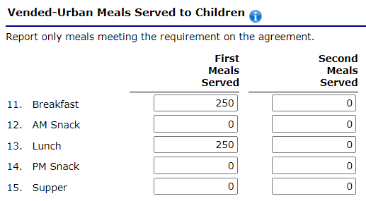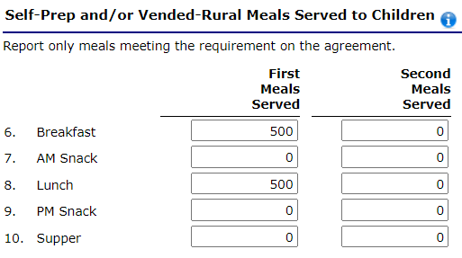

**Notes:**

* Include both congregate and non-congregate meals in questions 6-10 or 11-15.
* The number of first meals served should be equal to or less than the Average Daily Meals (ADM) (this automatically calculates) times the number of days food is served.
* If you receive an error regarding ADM, revise the site application with the correct ADM and resubmit it for approval.
* A limited number of second meals served as a unit at congregate sites can be claimed for reimbursement, as long as the total number of second meals does not exceed two percent of first meals served by the sponsor, for all sites, during the claiming period. You may enter the total number of second meals, and the system will calculate the two percent on the summary screen.

Non-congregate meal counts

* Sites providing non-congregate meals must also complete the Non-Congregate Meal Service Operation section located at the bottom of the claim. Meal counts will populate based on questions 6-10 or 11-15 and may be edited if needed.

* + Sites serving both congregate and non-congregate meals will edit the populated numbers to only include the non-congregate meal totals.
* Claim reimbursement will be determined based on the number of meals entered in questions 6-10 or 11-15. This non-congregate section is only for required reporting purposes.

At the bottom of the claim page, click the red ‘**Save**’ button. Then click ‘**Finish**.’ The claim site list screen will be shown. Enter in all claims for all sites claiming for the month selected.

**Notes:**

* **Warnings**: It is possible that warnings will pop up; please review these to ensure your claim is correct; claims can be submitted with warnings.
* **Errors**: It is possible that errors will pop up; please review these to ensure your claim is correct; claims cannot be submitted with errors. **Tip**: The total number of days food is served must align with the calendar in the site application. ADM must be less than what is in the approved site application. For non-congregate sites offering multi-day meals, ADM must reflect the average meals distributed per meal distribution.

Once all claims have been entered, click the red ‘**Continue**’ button.

* The Claim for Reimbursement—Sponsor Information screen will populate.
* **It is important to adjust question 1: Period covered by this claim**. The ‘**From**’ date is the first day the claim covers, and the ‘**To**’ date is the last day the claim covers.
  + This step is also what allows a claim to be combined with another month, provided that one of the month’s operating days is ten or less.
* Click the red ‘**Continue**’ button.

* Next, the Claim for Reimbursement Summary screen will populate. This summarizes the total amount earned for reimbursement. Please check this screen for accuracy.
* Click the Certification box and then click on the red “Submit for Payment’ button. A page will come up thanking you for submitting your claim. Click ‘**Finished**.’ The Claim Year Summary Screen under Claim Status will show ‘Accepted,’ and the Date Received column will be populated for the month.
* To expedite the receipt of payment, please submit your claim as early as possible after the claim month is over.