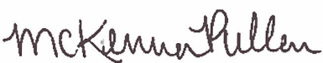
^{State of Colorado}
^{Be it known that}
Completed 1.5 hours of training in
Name
CDE and Nourish Recipe Reading Training
October 13, 2021
Learning Codes: Menu Planning (1140), Food Production (2110) (2130)
McKenna Pullen
Nutrition Programs Senior Consultant
Colorado Department of Education

