Documentation for Food Items

Smart Snacks Documentation Examples

Smart Snacks documentation for food items must include:

* Nutrition Facts Label
* Ingredients List





Alliance for a Healthier Generation Smart Food Planner

Documentation of calculator results is optional, however if you do maintain these results you must also maintain nutrition facts labels and ingredient lists.



Documentation for Beverages

Smart Snacks documentation for beverages must include:

* Nutrition Facts Label
* Ingredients List

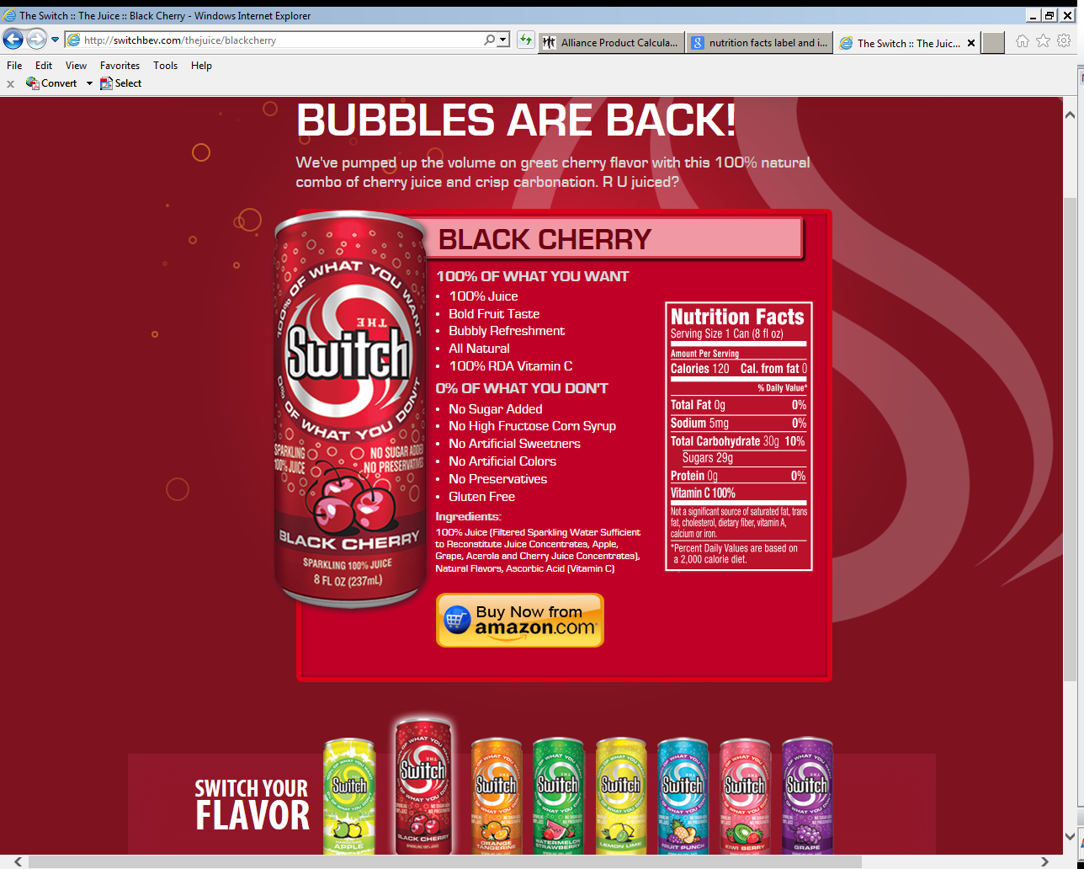

Additional Resources

* CDE Office of School Nutrition: <http://www.cde.state.co.us/nutrition/nutricompetitivefoods.htm>
* USDA Food and Nutrition Service Smart Snacks in School: <http://www.fns.usda.gov/healthierschoolday/tools-schools-smart-snacks>
* Colorado Healthy Beverages and Competitive Food Policies: <https://www.cde.state.co.us/nutrition/cocompetbeveragescompetfoodpolicies>