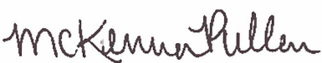
^{State of Colorado}
^{Be it known that}
Completed 1.5 hours of training in
Name
CDE and Nourish Meal Quality Training #3
February 24, 2021
Learning Codes: Menu planning 1100; Food Production 2100; Program Management 3200
McKenna Pullen
Nutrition Programs Senior Consultant
Colorado Department of Education

