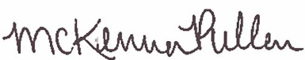
^{State of Colorado}
^{Be it known that}
Completed 1.5 hours of training in
Name
CDE and Nourish Kitchen Math Training
August 18, 2021
Learning Codes: Food Production (2110) (2130), Serving Food (2210)
McKenna Pullen
Nutrition Programs Senior Consultant
Colorado Department of Education

