[Insert District Name] 20__-20__ Solicitud Para Comidas Gratis y Reducido Precio Escuela y Estudio De Datos Económicos Familiares
En las escuelas que participan en la provisión comunitaria de elegibilidad (CEP), recibo de comidas escolares no depende de devolver este formulario de hogares. En las escuelas no-CEP, este formulario se utilizará para determinar la elegibilidad para las comidas escolares.Complete una sola solicitud por hogar. Secciones obligatorio completado para los estudiantes en el CEP y non-CEP escuelas se describen abajo. Favor de usar un bolígrafo.

Mencione a todos los estudiantes que asisten [Insert District Name] (si necesita más espacios para nombres adicionales, adjunte otra hoja)

Niño de Head
Acogida Start Fugitivo Sin Hogar Migrante
Fecha de nacimiento
M M D D A A
PASO 1
Grado
Inicial
Apellido del estudiante
Nombre del estudiante
Marque todas las que apliquen. Lea Cómo solicitar comida escolar gratuita y de precio reducido para más información.

Si algún miembro del hogar (incluido usted) actualmente recibe asistencia de cualquiera de los siguientes programas: SNAP, TANF o FDPIR enumeran el número de caso a continuación.

PASO 2
Programa de Asistencia Nutricional Suplementaria (SNAP), Asistencia Temporal para Familias Necesitadas (TANF/Colorado Works – Asistencia Básica en Efectivo o Asistencia Alternativa Estatal), o Programa de Distribución de Alimentos en Reservas Indígenas (FDPIR). Provea el número de caso y vaya al Paso 4.

- Ingresos del estudiante
Por favor incluya el ingreso TOTAL, si alguno, recibido por los estudiantes mencionados antes.
$
Semanal | Cada 2 Semanas | 2x Mes | Mensual | Anual

Ingreso del estudiante
PASO 3
Número de caso FDPIR
Número de caso SNAP
Número de caso TANF
Informe el ingreso de TODOS los miembros del hogar (omita este paso si proporcionó un número de caso en el PASO 2)

¿Con qué frecuencia?
- Todos los demás miembros del hogar (inclúyase a sí mismo)
Escriba los nombres de todos los miembros del hogar que no mencionó en el Paso 1 (inclúyase a sí mismo) aun si no reciben ingresos. Por cada miembro del hogar mencionado, solo si reciben ingresos, informe el TOTAL BRUTO (ANTES DE IMPUESTOS Y DEDUCCIONES) por cada fuente redondeando los dólares (no centavos). Si no reciben ingresos de ninguna fuente, escriba ‘0’. Si escribe ‘0’ o deja cualquier espacio en blanco, usted certifica que no tiene que informar ingresos.

¿Con qué frecuencia?

¿Con qué frecuencia?

Semanal | Cada 2 Semanas | 2x Mes | Mensual | Anual

¿Con qué frecuencia?
Ingresos del trabajo
Pensiones/Jubilación/
cualquier otro ingreso
Asistencia pública/ Manutención de hijos/Manutención de cónyuge
Semanal | Cada 2 semanas | 2x Mes | Mensual | Anual

Semanal | Cada 2 Semanas | 2x Mes | Mensual | Anual

Nombres de todos los otros miembros del hogar
(Nombre y apellido)
$
$
$
$
$
$
$
$
$
$
$
$
Marque si no tiene SSN
XXX-XX-
Últimos números del Seguro Social (SSN) del adulto que firma o marque ‘NO SSN’ SOLO si completó el Paso 3B. Este elemento no es necesario para las escuelas sólo CEP.

Total de miembros del hogar
(Estudiantes y adultos de los pasos 1 y 3)

"Certifico (prometo) que toda la información en esta aplicación es verdadera y que todos los ingresos son reportados. Entiendo que la información proporcionada puede ser usada en conexión con los programas educativos federales y estatales. En concreto, entiendo que el distrito escolar puede obtener financiamiento federal y / o estatal adicional basado en la información que he proporcionado. Al firmar abajo, estoy de acuerdo en que el estado de elegibilidad de mi hijo / a puede ser compartido para estos propósitos específicos y como lo permite la ley sin aviso y / o consentimiento específico. Entiendo que si esta información se da en conexión con el recibo de fondos federales, y que los oficiales de la escuela pueden verificar (verificar) la información. Soy consciente de que si doy información falsa a propósito, mis hijos pueden perder los beneficios de las comidas y yo podré ser procesado bajo las leyes estatales y federales aplicables ".

PASO 4 Información de contacto y firma del adulto. Envíe la solicitud firmada y completa a: [Insert School/District Mailing Address]

# Apt o # Lote
Código postal
Dirección de correo electrónico
Ciudad
Dirección Postal o PO Box
CO
FIRMA del miembro adulto del hogar
Nombre y apellido de la persona que firma en letra de imprenta
Fecha de hoy
Teléfono

PASO 5 Divulgación de información
La información proporcionada en esta solicitud se utilizará junto con los programas educativos estatales y es posible que se comparta con las oficinas de Medicaid o del Programa Estatal de Seguro Médico para Niños (SCHIP). Por favor, marque la casilla para excluirse: t:
NO comparta información con Medicaid/SCHIP
Vea el reverso de la solicitud
List Specific Program

Examen de Aceleración de Oportunidades Universitarias y/o Cuotas de Libros

Examen de Colocación Avanzada (AP) y/o Cuotas de Libros (AP)
Por favor, comparta mi información con los siguientes programas que he marcado:
Para ahorrarle tiempo y esfuerzo, la información que usted proporcionó en este formulario se podrá compartir con otros programas para los cuales sus hijos puedan calificar. Para los siguientes programas, debemos tener su permiso para compartir su información. Rellenar esta sección del formulario no cambiará el hecho de que sus hijos reciban comidas gratuitas o a precio reducido. Su información NO SE COMPARTIRÁ a menos que marque una de las casillas siguientes:
OPCIONAL Identidad racial y étnica de los niños
Tenemos que pedir información sobre la raza y etnia de sus hijos. Esta información es importante y nos ayuda a asegurarnos de que estamos sirviendo plenamente a nuestra comunidad. Responder a esta sección es opcional y no afecta el cumplimiento de su hijo con los requisitos para comida gratuita o de precio reducido.
Asiático
Raza (marque una o más):
Indio americano o nativo de Alaska
Negro o afroamericano
Nativo de Hawái u otra isla del Pacífico
Hispano o latino
Ni hispano ni latino
Etnia (marque una):
Blanco

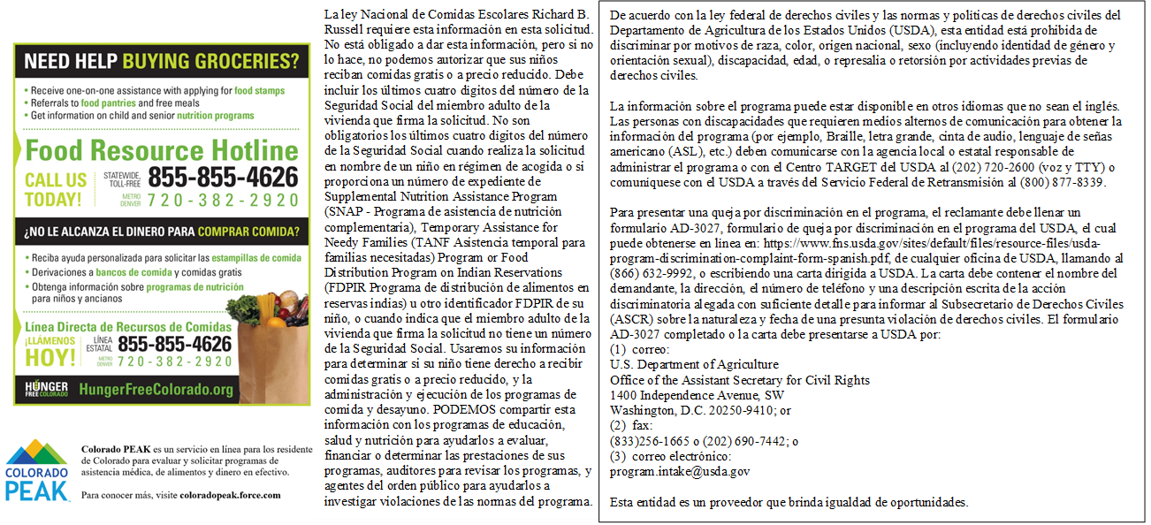
Podría también calificar para el Programa de Asistencia Nutricional Suplementaria. Vea más información a continuación.

NO ESCRIBA DEBAJO DE ESTA LÍNEA. SOLO PARA USO DEL DISTRITO
Annual Income Conversion: Weekly x 52; Bi-Weekly x 26; 2 Times per Month x 24; Monthly x 12
Application Type:   Total Household Income: $ Household Size:_  Household Income Frequency -  Weekly  Bi-Weekly  2x/Month Monthly Annually  Categorical Eligibility - SNAP FDPIR TANF Foster  Homeless/Migrant/Runaway/Head Start | Application Status:  Approved - Free Reduced  Denied - Over Income Guidelines Incomplete/Missing: Notes:
Determining Official Signature: Approval/Denial Date: Notification Sent:

