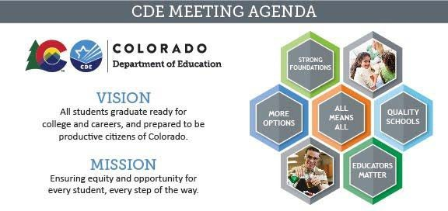

Meeting Logistics & Desired Outcomes

Meeting: ESSA Committee of Practitioners Date & Time: Thursday, August 19th at 9:00am Location: Virtual: Zoom

Meeting Leads:

Objectives:

Laura Gorman (Chair), Tammy Giessinger and Jeremy Meredith (CDE Co-Leads)

To allow the Colorado Department of Education the opportunity to provide updates to and elicit recommendations from the Colorado Committee of Practitioners regarding relevant and timely issues related to CDE’s responsibilities under the Elementary and Secondary Education Act (ESSA).

Agreed Upon Norms:

* Be present and engage fully.
* Let everyone have a voice and be heard! Don’t talk over each other.
* When not talking, turn off mic on your computer/phone to minimize background noise.
* Begin and end meetings on time. Stick to times allotted for topics, to the extent possible, or develop next steps for moving the work forward if running out of time.
* Use time productively.
* Assume positive intent and ask for clarification when something lands wrong.
* Come prepared.
* The chair of the meeting should enforce the norms.

Attendees: Clint Allison, Amy Beruan, Erich Dorn, Laura Gorman, Christy Sinner, Mitzi Swiatkowski, Clare Vickland.

*Feel free to share your agenda topic submissions through the* [*submission request form.*](https://app.smartsheet.com/b/form/80d4a142008c43ef9fd51be7e7e25346) *Please let us know if you have any questions.*

Agenda Items and Next Steps

|  |  |  |  |
| --- | --- | --- | --- |
| **Headline Time Presenters** | **Agenda Description** | **Type of Agenda Item Format**  **Prep** | **Summary/Notes** |
| **Co-Chair Nomination**  *Laura Gorman & Jeremy Meredith* | CoP will review nominations and elect a co-chair. | **Type:** Decision Item  **Prep:** Review co- chair nominations. | * Amy Beruan elected as co- chair. |
| **CoP Membership**  *Jeremy Meredith* | CoP will review applications and vote on memberships.   1. Zuben Bastani 2. Rochelle Garcia- Gomez 3. Sandy Gecewicz 4. Alan Nall 5. Cheryl Taylor 6. Joey Willett | **Type:** Decision Item  **Prep:** Review new member applications. | * All membership applications have been approved. * Discussed vacancies and elevated ideas for recruitment, re. incentives, direct outreach, etc. Laura Gorman to contact fiscal representatives in Montrose.   Feedback from CoP Members:   * Requested map illustrating current representation/roles, and underrepresented   positions/locations. |
| **Meeting Format**  *Jeremy Meredith* | Discussion of in-person and/or remote options for future meetings. | **Type:** Discussion and Feedback **Prep:** N/A | Feedback from CoP Members:   * Requested true hybrid format be made available for 2021-22 meeting dates, allowing for in- person and virtual attendance.   + CDE Response: CDE plans on accommodating a hybrid format, contingent on logistics, and public health orders. * Co-chairs will attend September   9 meeting virtually. |
| **Closing**  *Laura Gorman & Jeremy Meredith* | Co-Chairs offer any reflections. Close out meeting. |  | * Next meeting Thursday, September 9: CDE will attempt to offer an in- person meeting if logistically feasible to do given the short timeline.   Feedback from CoP Members:   * Requested a list of historical annual   CoP meeting topics. |