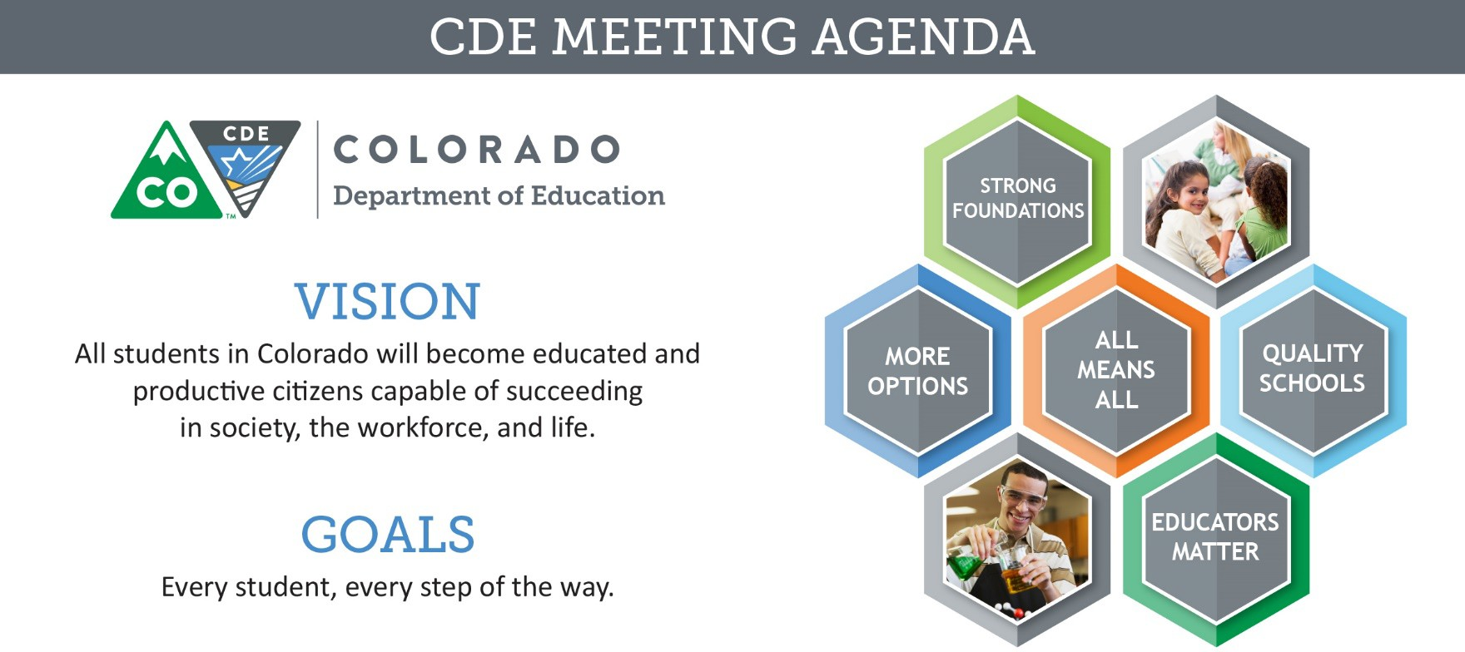

# Meeting Logistics & Desired Outcomes

Meeting: ESSA Committee of Practitioners Date & Time: April 26, 2018 9:30 am

Location: Colorado Children’s Campaign

Meeting Leads: Jesús Escárcega, Clinton Allison, Colleen Brooks

Objectives: To allow the Colorado Department of Education the opportunity to provide updates to and elicit recommendations from the Colorado Committee of Practitioners regarding relevant and timely issues related to CDE’s responsibilities under the Elementary and Secondary Education Act, including:

* Staffing in the Office of ESEA Programs
* CoP Membership requirements and commitments for the 2018-2019 school year
* CDE’s ESSA State Plan
* Potential Professional Development Grant Opportunity,
* Supports to New ESEA Directors,
* Consolidated Application, and
* Monitoring

# Agenda Items and Next Steps

## 9:30 – 9:45 Committee Business

*Jesús Escárcega, Clinton Allison, Colleen Brooks*

|  |  |  |  |
| --- | --- | --- | --- |
| **Topic** | **Preparation and Process** | **Expected Outcome** | **Summary** |
| Approval of January and February Meeting Minutes | Prep: None | Decision | * Meeting minutes from last meeting - Approved |
| * Review minutes from previous meetings |
| CoP Membership | **Prep: Respond to inquiries regarding attendance at previous meeting, if**  **contacted** | Update | * Let Colleen know if members would like to |

CDE Values: All Students, Collaboration, Communication, Customer Service, Honesty, Innovation, Integrity, Respect, Transparency.

|  |  |  |  |
| --- | --- | --- | --- |
| **Topic** | **Preparation and Process** | **Expected Outcome** | **Summary** |
|  | * Review bylaws and requirements regarding membership, including member representation and term limits * Determine the approximate number of vacancies that will need to be filled during the upcoming year |  | continue in their position or no longer continue   * Giving everyone two weeks to consider what they want to do * If Colleen doesn’t hear from you, we will assume that you either will finish up your membership or not continue * CDE will send out an email with the application and the areas that are needed |
| ESEA Staff and Organizational Changes | Prep: None | Update | * Out of the five offices that we have, we are going to merge three of them * Nazie will be the director of that new office * CLDE: We are looking to add staff members * Working on communication of who the districts need to reach out to from our office |
| * New ESEA Staff Members:   + Kristen Collins, Consultant   + Jeremy Meredith, Title II Coordinator and ESEA Specialist   + Michelle Prael, Program Support * Updates regarding Office of ESEA Programs organizational structure and staff roles |

## 9:45 – 10:15 Executive Director’s Update

*Pat Chapman*

|  |  |  |  |
| --- | --- | --- | --- |
| **Topic** | **Preparation and Process** | **Expected Outcome** | **Summary** |
| ESSA State Plan | Prep: None | Update | * We still don’t have approval |
| * Update on the approval process of Colorado’s ESSA State Plan |
| Supports Coordinator | Prep: None | Feedback | * There is a from CDE and the field to clarify points of contact * A letter will be sent out this week to identify who CDE should reach out to and who the districts should contact from CDE * Planning to attend meetings for BOCES and superintendent groups for feedback * Districts that didn’t write district defined:   + Easy   + Everyone is on   board |
| * Update regarding the role of CDE’s Supports Coordinators |



|  |  |  |  |
| --- | --- | --- | --- |
| **Topic** | **Preparation and Process** | **Expected Outcome** | **Summary** |
|  |  |  | * Unsure as to what   we can and can’t ask for   * Would be helpful to hear what district defined did * District Defined:   + Biggest issue: Time   + Planning upfront would have been   helpful |

## 10:15 – 11:30 Technical Assistance

*Nazanin Mohajeri-Nelson, Morgan Cox, Alice Collins, Jennifer Simons, Colleen Brooks*

|  |  |  |  |
| --- | --- | --- | --- |
| **Topic** | **Preparation and Process** | **Expected Outcome** | **Summary** |
| Supports to Schools Identified for Improvement | **Prep:**   * **Discuss the use of the Rubric for Comprehensive Support Plans with appropriate district personnel to provide feedback regarding the use and process** * **Discuss the following questions regarding the development and implementation of Targeted Support Plans**   + Where are your schools in developing TS improvement plans?   + How have you been supporting the schools in this process? Which parts have you been supporting? Who is involved in the development?   + What process are you going to use for review and approval before schools implement their plans? Who | Feedback | * Creating a process about CS Schools and how they have to build an improvement plan   + We want them to be approved by April 2019   + The rubric should be released by the end of June * CDE has reached out to some of you about |

|  |  |  |  |
| --- | --- | --- | --- |
| **Topic** | **Preparation and Process** | **Expected Outcome** | **Summary** |
|  | will be involved in the review and  approval? If process has been determined, please describe the review and approval process.   * What are your plans for monitoring implementation of the TS improvement plans? Who will be involved? If monitoring plans have been developed, please describe your monitoring plans. * If applicable, what is the BOCES role in supporting member districts and schools in the development, implementation, and monitoring of TS plans?   To review the [Targeted Support and](http://www.cde.state.co.us/fedprograms/essa_csi_tsi) [Improvement plan requirements,](http://www.cde.state.co.us/fedprograms/essa_csi_tsi) visit:  <http://www.cde.state.co.us/fedprograms/ess> a_csi_tsi |  | these conversational  questions   * Cold calls are difficult to jump into. Might not be talking to the right person and that will get incorrect information * Districts appreciate that they don’t have to get more documents and like that we are trying to make this a unified whole * Document needs to be sent out electronically * Might be better to have a face to face meeting about this instead of a webinar   + That is the intent * Call Nazie with any questions |
| * Follow-up discussion regarding the rubric for Comprehensive Support plans * Discussion regarding status of Targeted Support plan development * Presentation of opportunities available to support schools identified for improvement |
| EL Redesignation Guidance | Prep: None | Feedback |  |
| * Presentation of updated redesignation guidance |
| Licensure Updates and *Possible* Professional Development Grant Opportunity | **Prep: Review documents related to EL professional development requirements.** | Feedback | * Educators coming out will be prepared and wouldn’t have to the PD part * Districts don’t want it to be a unfunded mandate   + There are funding sources available if they are align with the standards   written into |
| * Presentation of updated requirements for professional development for all in- service educators * Presentation of potential professional development grant opportunity under Title III, Part A |



|  |  |  |  |
| --- | --- | --- | --- |
| **Topic** | **Preparation and Process** | **Expected Outcome** | **Summary** |
|  |  |  | the licensure  rules   * Non-public schools are not excluded from it. |
| New ESEA  Directors: Toolkit and Supports | **Prep: Connect with ESEA Directors and Administrators in your district or BOCES to determine the highest priority need to know areas for the first year of working in this**  **position.** | Feedback | * In the process of developing a resource for new individuals coming into a new director role. What would that look like, what would you like see from CDE? * We are going to do outreach with districts and bring back   suggestions |
| * Discussion regarding supports CDE may provide to new ESEA Directors and Administrators that would be the most helpful throughout their first year in this position |

## 11:30 – 12:15 Consolidated Application

*DeLilah Collins, Colleen Brooks, David Schneiderman*

|  |  |  |  |
| --- | --- | --- | --- |
| **Topic** | **Preparation and Process** | **Expected Outcome** | **Summary** |
| Guidance Update | **Prep: Review District Managed Activities Guidance and Carryover for Equitable**  **Services to Non-public Schools documents** | Update | * In the process of developing a resource for new individuals coming into a director role. What would that look like and what would you like to see from CDE? * Action: do outreach with districts to bring back suggestions |
| * Presentation of guidance documents and waiver/request process |

|  |  |  |  |
| --- | --- | --- | --- |
| **Topic** | **Preparation and Process** | **Expected Outcome** | **Summary** |
| 2018-19  Application Platform | **Prep: Review webinar recording and**  **associated documents from** [**April 18 Virtual**](http://www.cde.state.co.us/fedprograms/virtualnetworkingmeeting)[**Network Meeting**](http://www.cde.state.co.us/fedprograms/virtualnetworkingmeeting) **(if unable to participate live) (**<http://www.cde.state.co.us/fedprograms/vir> tualnetworkingmeeting) | Update | * Platform will be available   May 4th   * Streamline the application – will not allow incomplete application submissions * Assurances will change depending on your selection * Significant changes to the BOCES application – specifically for the ARAC to avoid erros * Trainings will start after the launch of the application * Metro and pueblo will combine in training and be in Castle Rock May 22nd * Will open office hours in June to provide additional support * Let CDE know if there are any issues or anything that needs to be changed * SNS due May 30th –   requires board action |
| * Preview and discuss updates to the application platform and provide update regarding in-person training opportunities * Present and discuss Consolidated Application Manual; provide feedback regarding changes or improvements |
| ESSA Grant Award Letters | Prep: None | Update | * GALs instead of GANs * Biggest change: CDE needs wet signatures (two of them) before sending to districts   + Districts do not have to sign it but nonprofit and non- government agencies do have to sign it * This starts July 1st |
| * Provide information regarding updated Grant Award Notification process |

## 12:15 – 1:00 Break for Lunch

**1:00 – 4:00 Joint Monitoring Stakeholders Workgroup and CoP Meeting**

*Joey Willett, DeLilah Collins, Colleen Brooks*

|  |  |  |  |
| --- | --- | --- | --- |
| **Topic** | **Preparation and Process** | **Expected Outcome** | **Summary** |
| Process and Protocols | Prep: None | Update | * Goal: we want 10-15 indicators * Currently have 25 universal indicators   + Monitoring Process   Document: |
| * Review CDE process and protocols, including the risk assessment tool, for use in desk review and onsite monitoring |



|  |  |  |  |
| --- | --- | --- | --- |
| **Topic** | **Preparation and Process** | **Expected Outcome** | **Summary** |
|  |  |  | lored/compliance –  need to make language uniform   * Appreciate the graphs and timeline but difficult to read (move to appendix) * Update from 17/18 calendar year since it is ending * Identify what qualifies low, middle, high risk * Email Joey on comments   or thoughts about the document |
| Indicators | Prep: None | Feedback | * Instead of Schoolwide Plan indicator – make Evaluation of Schoolwide programs a universal indicator * TA Evaluation would be a better universal indicator than Identifying TA Programs * Overall: 10-11 require additional submissions, 8 already have information in place, and 3-5 will be   based on the final expenditure report |
| * Review prioritized monitoring indicators to determine appropriate content and scope for desk reviews in alignment with risk assessment tool * Review indicator resources by category identify to identify available supports, as well as gaps therein or non-existent resources |
| Next Steps | Prep: None | Feedback |  |

|  |  |  |  |
| --- | --- | --- | --- |
| **Topic** | **Preparation and Process** | **Expected Outcome** | **Summary** |
|  | * Determine appropriate next steps in the   monitoring process rollout, as well as the role of the monitoring stakeholder workgroup |  | * Continue forward and look   at the 25 as a universal indicator set   * June 7th is our next scheduled meeting in Aurora * Send Joey ideas to revise the documents * Think about guiding questions * Will hear from Lindsay or Joey about the guiding questions for next meeting * CoP meeting: May 17th 10- 12 virtually |