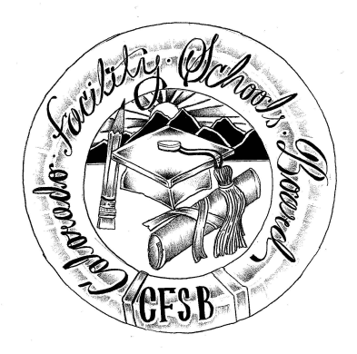
Colorado Facility Schools Board Agenda
June 9, 2022
11:30 a.m. until the completion of the agenda

Shiloh Family Resource Pavilion In-Person & Zoom Virtually

11:30  12:00 | Lunch  Board Meeting will start - Call to Order  Approval of Minutes  Approval of Agenda | Action Item  Action Item
12:05 | Facility Schools Unit Update  - CDE/Facility Internal Updates  - Data Management and Systems Support  - iReady/Tuition Cost  - Monitoring/Updates from the Field  - Frontline/State Assessments  - Curriculum/Induction/OOD Consortium  - Update from Attorney General’s Office | Judy Stirman  Quinn Enright  Lori Kochevar  Robin Singer/Ann Symalla  Annie Haskins  Wendy Dunaway  Isabel Broer
12:30  12:45  1:00  1:15 | Diploma Signatures  Board Seat Updates  Kelly O’Shea – Comments regarding Board seat  Opportunity for the Public to Address the Board  Members of the public who wish to address the board must sign up prior to the meeting. Presentations are limited to 5 minutes. | Action Item  Judy Stirman  Kelly O’Shea
1:20 | Next Steps
1:25 | Adjournment of Meeting

