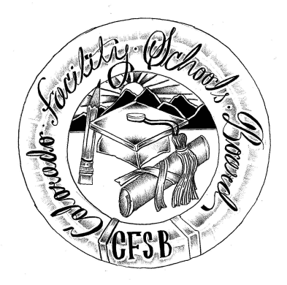
Colorado Facility Schools Board Agenda
January 13, 2021
11:30 a.m. until the completion of the agenda

Virtual – Zoom Meeting

11:30 | Board Meeting will start - Call to Order  Approval of Minutes  Approval of Agenda | Action Item  Action Item
11:35 | Facility Schools Unit Update  - CDE/Facility Internal Updates  - Data Management and Systems Support  - iReady/Tuition Cost  - Monitoring/Updates from the Field  - Frontline/Anlar/State Assessments  - Curriculum/Induction/OOD Consortium  - Update from Attorney General’s Office | Judy Stirman  Quinn Enright  Lori Kochevar  Robin Singer  Judy for Annie Haskins  Wendy Dunaway  Isabel Broer
12:05  12:25  12:45  1:05  1:00  1:20  2:00 | Policies and Procedures  Tuition Cost  i-Ready Request for Proposal (RFP)  BREAK  Supplemental Funding Summary  JBC/Stakeholders Group/Bill – Update and Feedback  Opportunity for the Public to Address the Board  Members of the public who wish to address the board must sign up prior to the meeting. Presentations are limited to 5 minutes. | Robin Singer  Judy Stirman/Lori Kochevar  Judy Stirman  Wendy Dunaway  Judy Stirman and Wendy Dunaway
2:10 | Next Steps
2:15 | Adjournment of Meeting

