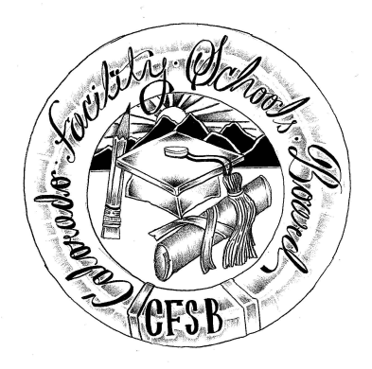
Colorado Facility Schools Board Agenda
August 12, 2021
11:30 a.m. until the completion of the agenda

Virtual – Zoom Meeting

Time | Activity | Presenter
11:30 | Board Meeting will start - Call to Order  Approval of Minutes  Approval of Agenda | Action Item  Action Item
11:35 | Facility Schools Unit Update  - CDE/Facility Internal Updates/AnLar  - Data Management and Systems Support  - iReady/Tuition Cost  - Monitoring/Updates from the Field  - Curriculum/Induction/Kaleidoscope/Out of District Consortium  - Introductions | Judy Stirman  Brittany Hanley/Quinn Enright  Lori Kochevar  Robin Singer/Ann Symalla  Wendy Dunaway  Annie Haskins/Quinn Enright
12:00  12:10  12:45  1:15  1:30  1:50 | New Programs  Joshua School New Building  Board Seats/State Board of Education Presentation  Stakeholder’s Group  ABA Programs  Opportunity for the Public to Address the Board  Members of the public who wish to address the board must sign up prior to the meeting. Presentations are limited to 5 minutes. | Judy Stirman  Martha Muth  Judy Stirman  Wendy Dunaway  Judy Stirman/Robin Singer/Ann Symalla
2:00 | Next Steps
2:05 | Adjournment of Meeting

