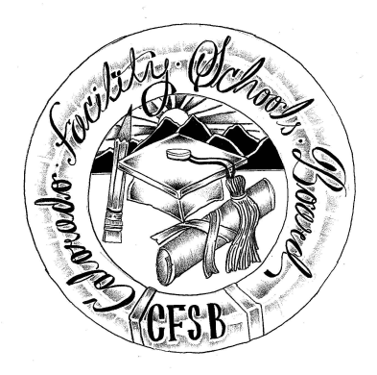
Colorado Facility Schools Board Agenda
March 7, 2024
9:30a.m. until the completion of the agenda

Venue: Shiloh House – Centennial CO
In-Person

9:15am  9:30am  9:40am  10:00am  11:00am  11:05am  12:00pm  12:30pm  1:00pm  1:30pm  2:00pm  2:10pm  2:40pm  2:45pm | Arrival  Board Meeting will start - Call to Order  Approval of Minutes  Approval of Agenda  Rocky Mountain Leadership Academy  Board Strategic Planning  Break  Operating Procedures  Lunch  Annual Training on Board Best Practices and Legal Requirements  Specialized Day School Authorization  Tuition Cost Update/ECEA Rule Update  Board Vacancies  Facility Schools Unit Update  CDE/ESSU/Facility Internal Updates  Data Management and Systems Support  Monitoring/Updates from the Field/ Annual Report  IEP System Updates/ State Assessments/ELD Plan  Induction/Workgroup  Program Support  Opportunity for the Public to Address the Board  Members of the public who wish to address the board must sign up prior to the meeting. Presentations are limited to 5 minutes.  Next Steps/Adjournment of Meeting  Next Meeting Date – April 11, 2024  (In-person at Morgridge Academy) | Action Item  Action Item  Brittney Hoffman/Kent Moe  Virginia Winter  Jenna Zerylnick  Jenna Zerylnick  Wendy Dunaway  Ann Symalla/Lori Kochevar  Judy Stirman  Judy Stirman  Lori Kochevar  Ann Symalla  Wendy Dunaway  Darren Serrato  Members of the Public  Board

