C:\Users\Cabrera_C\AppData\Local\Microsoft\Windows\Temporary Internet Files\Content.IE5\3Y0PK1GC\MC900088970[1].wmf

***Special Services Providers***

**Professional Practice Note Catcher**

**Critical Effects of S.B. 191**

* Requires statewide minimum standards for what it means to be an “\_\_\_\_\_\_\_\_\_\_\_\_\_\_\_\_\_\_” Special Services Provider
* Requires \_\_\_\_\_\_\_\_\_\_\_\_\_ evaluation of all Special Services Providers
* Requires that all Special Services Providers be evaluated at least \_\_\_\_\_\_\_\_\_\_\_ on the \_\_\_\_\_\_\_\_\_\_\_ of the students they support

**Key Priorities for Implementation of Colorado’s Special Services Provider Evaluation System**

What are the **5 Key Priorities for Colorado’s Special Services Provider Evaluation System** the State Council for Educator Effectiveness considered for their work?

1. \_\_\_\_\_\_\_\_\_\_\_\_\_\_\_\_\_\_\_\_\_\_\_\_\_\_\_\_\_\_\_\_\_\_\_\_\_\_\_\_\_\_\_\_\_\_\_\_\_\_\_\_\_
2. \_\_\_\_\_\_\_\_\_\_\_\_\_\_\_\_\_\_\_\_\_\_\_\_\_\_\_\_\_\_\_\_\_\_\_\_\_\_\_\_\_\_\_\_\_\_\_\_\_\_\_\_\_
3. \_\_\_\_\_\_\_\_\_\_\_\_\_\_\_\_\_\_\_\_\_\_\_\_\_\_\_\_\_\_\_\_\_\_\_\_\_\_\_\_\_\_\_\_\_\_\_\_\_\_\_\_\_
4. \_\_\_\_\_\_\_\_\_\_\_\_\_\_\_\_\_\_\_\_\_\_\_\_\_\_\_\_\_\_\_\_\_\_\_\_\_\_\_\_\_\_\_\_\_\_\_\_\_\_\_\_\_
5. \_\_\_\_\_\_\_\_\_\_\_\_\_\_\_\_\_\_\_\_\_\_\_\_\_\_\_\_\_\_\_\_\_\_\_\_\_\_\_\_\_\_\_\_\_\_\_\_\_\_\_\_\_

**Special Services Providers Historical Timeline – Key Understandings**

**2012-13** \_\_\_\_\_\_\_\_\_\_\_\_\_\_\_\_\_\_\_\_\_\_ \_\_\_\_\_\_\_\_\_\_\_\_\_\_\_\_\_\_\_\_\_\_\_\_\_\_\_\_\_\_\_\_\_\_\_\_\_\_\_

\_\_\_\_\_\_\_\_\_\_\_\_\_\_\_\_\_\_\_\_\_\_\_\_\_\_ \_\_\_\_\_\_\_\_\_\_\_\_\_\_\_\_\_\_\_\_\_\_\_\_\_\_\_\_\_\_\_\_\_\_\_

**2013-14** \_\_\_\_\_\_\_\_\_ \_\_\_\_\_\_\_\_\_\_\_\_\_\_\_\_\_\_\_\_\_\_\_\_\_\_\_\_\_\_\_\_\_\_\_\_\_\_\_\_\_\_\_\_\_\_\_\_\_\_\_\_

**2014-15** \_\_\_\_\_\_\_\_\_\_\_\_\_\_\_\_\_\_\_\_\_\_ \_\_\_\_\_\_\_\_\_\_\_\_\_\_\_\_\_\_\_\_\_\_\_\_\_\_\_\_\_\_\_\_\_\_\_\_\_\_\_

\_\_\_\_\_\_\_\_\_\_\_\_\_\_\_\_\_\_\_\_\_\_\_\_\_\_ \_\_\_\_\_\_\_\_\_\_\_\_\_\_\_\_\_\_\_\_\_\_\_\_\_\_\_\_\_\_\_\_\_\_\_

**2015-16** \_\_\_\_\_\_\_\_\_ \_\_\_\_\_\_\_\_\_\_\_\_\_\_\_\_\_\_\_\_\_\_\_\_\_\_\_\_\_\_\_\_\_\_\_\_\_\_\_\_\_\_\_\_\_\_\_\_\_\_\_\_

**Special Services Provider and Teacher Quality Standards**

Write one or two words in the blank that best describes the context for each quality standard. The first one is done for you.

|  |  |  |
| --- | --- | --- |
| **Standard** | **Special Services Providers** | **Teacher** |
| **1** | Professional Expertise | Know Content |
| **2** |  |  |
| **3** |  |  |
| **4** |  |  |

**Evaluation Process**

Fill in the missing blanks for the Evaluation Process.

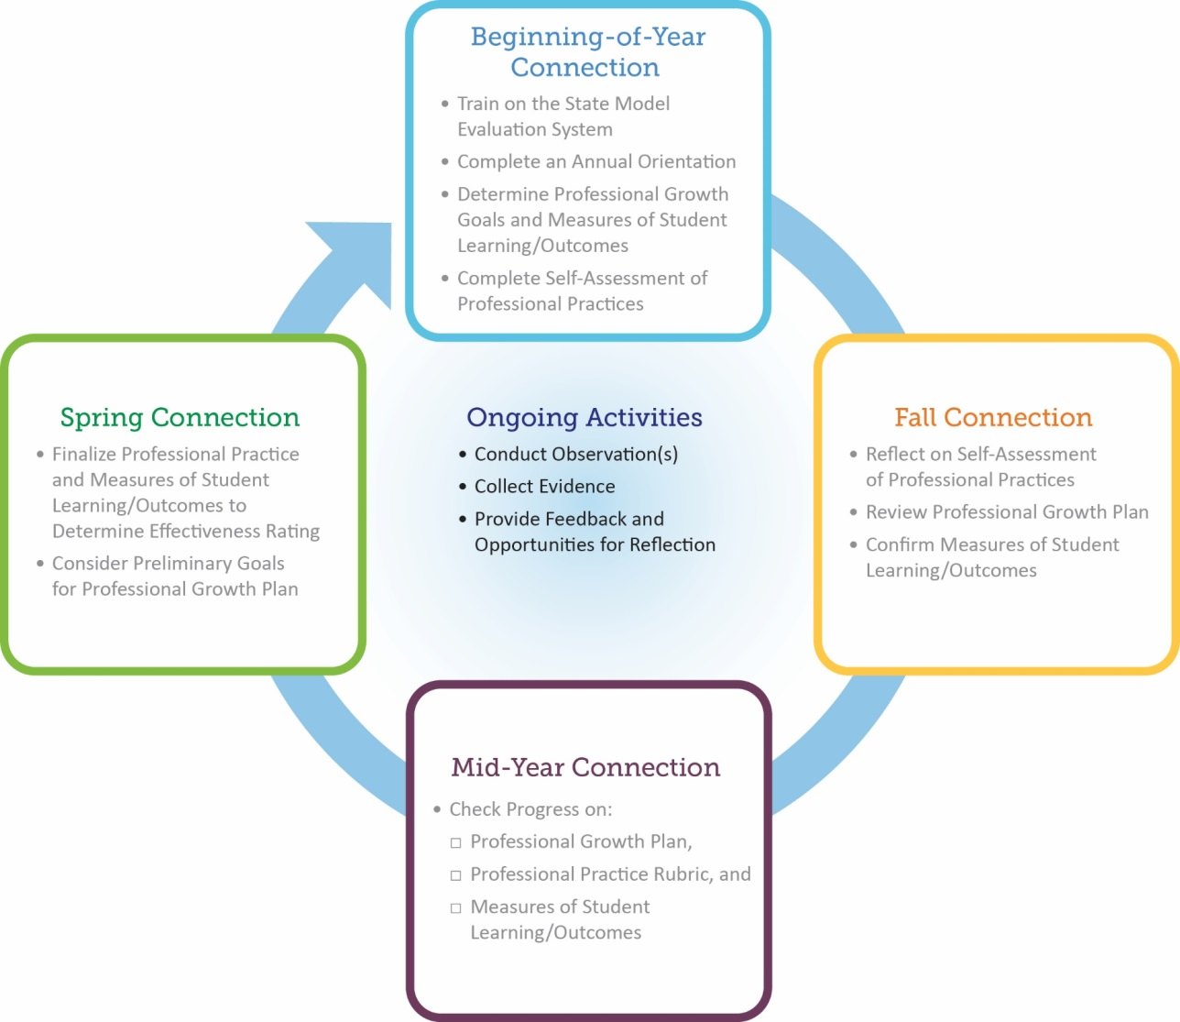

**Artifacts**

When are artifacts needed in the State Model Evaluation System?