SB22-070: State Model Evaluation System

Overview of Revised Scoring and Cut Points

Overview
In preparation to implement Senate Bill 22-070, the Colorado State Model Evaluation System (SMES) will undergo a revision to its scoring system. The following offers details regarding the calculations and updated cut scores associated with the revisions. The revised scoring was created with input from stakeholders, tested for consistency with historic pilot data from over 5,000 teachers, and will begin with implementation of SB22-070 in the 2023-24 school year.

Final Effectiveness Score and Rating
The total available points for an educator’s final effectiveness rating (FER) will shift to 1000 (from the current total of 1080). The revision will seek to increase transparency in the scoring process as well as solidly reflect the earned scores for each component, i.e., professional practices and measures of student learning/outcomes (MSL/MSO).
Final Effectiveness Rating
(1000 points total)
100%
Professional Practices Rating
(700 points total)
70%
MSL/MSO Rating
(300 points total)
30%

Final Effectiveness Rating | Revised Scoring Cut Points | Current Cut Points
Highly Effective | 801 – 1000 (199 points) | 844 – 1080 (236 points)
Effective | 407 – 800 (393 points) | 506 – 843 (337 points)
Partially Effective | 188 – 406 (218 points) | 236 – 505 (269 points)
Ineffective | 0 – 187 (187 points) | 0 – 235 (235 points)
PLEASE NOTE:
- A final rating of Effective remains the rating to meet the state standard.
  - A Partially Effective rating should indicate areas for growth and development towards meeting the state standard.
  - Educators rated Highly Effective should expect to earn a professional practice rating that is above the state standard (i.e., Accomplished or Exemplary) and a minimum MSL/MSO rating of Expected.
- If an educator earns an MSL/MSO rating of Less than Expected, the highest FER they can achieve is Effective.
- The revised scoring expands the available FER points of Effective (i.e., meeting the state standard) and ensures that a Highly Effective rating is achieved when there is alignment between professional practice and MSL/MSO scores.

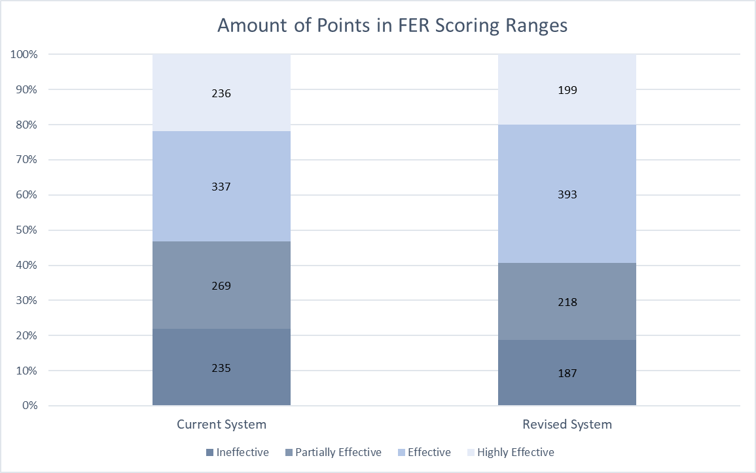
The graphs below compare the available points within each final rating category for the current scoring system (1080 total points, 50:50 ratio between professional practices and MSLs/MSOs) and the revised scoring system (1000 total points, 70:30 ratio):

The score range for each rating reflects an emphasis on educators earning a score based on a preponderance of evidence from professional practices. Please note that scores that meet the state standard include Level 3 within the Quality Standards rubrics, a rating of Proficient for professional practices, and a rating of Expected for MSL/MSO. When combined, these scores lead to a final effectiveness rating of Effective.
The following provides an explanation of how the revised cut points are determined:
Final Effectiveness Rating | Revised Scoring Cut Points | Determination of Cut Points
Highly Effective | 801 – 1000 | High=maximum available points, i.e., 1000 points (700 + 300)  Low=one point more than high cut point for Effective rating (800 + 1)
Effective | 407 – 800 | High=Professional Practices maximum points (700) + MSL/O Expected low point (100)*  Low=Professional Practices Proficient low point (307) + MSL/O Expected low point (100)*
Partially Effective | 188 – 406 | High=Prof. Practices Partially Proficient high point (306) + MSL/O Expected low point (100)*  Low=Prof. Practices Partially Proficient low base point (3.75) into 1000-point scale (x 50)
Ineffective | 0 – 187 | Professional Practices Basic base cut points (0 – 3.74) into 1000-point scale (x 50)
*Indicates direct influence of MSL/MSO score in calculation of FER cut points. Cut points that do not include a direct influence from the MSL/MSO score are calculated using established base scoring (cut points) from the professional practices scores.

Professional Practices Scoring
The total points available for professional practices in the revised scoring system will be 700. There will be no change to the base cut scores, therefore, overall professional practices scores will remain consistent. There will be no change to the levels and descriptors for professional practices scores, i.e., scores within the rubric are Level 1, Level 2, Level 3, Level 4, and Level 5; and the total professional practices rating of Basic, Partially Proficient, Proficient, Accomplished, and Exemplary. The only change when calculating the weighted score for each Quality Standard is to align with the total points available for professional practices, i.e., 700 points.
The process for calculating the total earned score for professional practices remains the same and is made up by adding together the weighted score for each Quality Standard.

Total
Prof. Practice Score
Weighted Quality Standard I Score
Weighted Quality Standard II Score
Weighted Quality Standard III Score
Weighted Quality Standard IV Score

The weighted score for each Quality Standard is determined using the following calculation (please note: the total points available for each Standard is determined by the number of Elements [4 points per Element]):

Weighted Quality Standard Score
Total Earned Points
Total Points Available for Prof. Practices
Weight
for the Standard
Total Points Available
in the Quality Standard

Professional Practice Level | Revised Scoring  Cut Points*  Multiplier = 35 | Base Point Range | Current Scoring  Cut Points  Multiplier = 27
Exemplary | 657 – 700 (43 pts) | Level 5: 18.75 – 20 | 507 – 540 (33 pts)
Accomplished | 482 – 656 (174 pts) | Level 4: 13.75 – 18.74 | 372 – 506 (134 pts)
Proficient** | 307 – 481 (174 pts) | Level 3: 8.75 – 13.74 | 237 – 371 (134 pts)
Partially Proficient | 132 – 306 (174 pts) | Level 2: 3.75 – 8.74 | 102 – 236 (134 pts)
Basic | 0 – 131 (131 pts) | Level 1: 0 – 3.74 | 0 – 101 (101 pts)
*The only change to the cut points for Professional Practices is the multiplier from the base points to align with the revised total points available of 700. The base score of 20 points and base score ranges remain the same.
**Meets state standard.

Measures of Student Learning/Outcomes Scoring
The total points available for MSLs/MSOs in the revised scoring system will be 300. The levels available for the MSL/MSO score will be revised from four to three. Specifically, the levels will shift to More than Expected, Expected, and Less than Expected—the score of Much Less than Expected will no longer be included. The calculation to determine the total MSL/MSO score remains the same, with new parameters for minimum and maximum number of measures to include:
Total
Measures of Student Learning/Outcomes Score
Sum of weighted scores (WS) for each measure*
For example: WS1 + WS2 + WS3

*Minimum number of measures is two (2) and maximum number of measures is five (5) total.
The process for a district to determine the MSL/MSO weights by percentage at the beginning of the school year remains the same, although now it will be based on a total of 30%, with a maximum collective portion of 10% for teachers and principals (minimum of 1%). All percentages assigned to the different measures must total 30%.
While the process for selecting measures and determining the corresponding success criteria also remains the same, the calculation to determine the weighted score for each measure is revised to align with the revised total points available for the MSL/MSO score, i.e., 300 points.
Selected Weight for MSL/MSO
(percent)
Weighted MSL/MSO Score
(WS)
Earned Score based on
Success Criteria
Multiplier to 300-pt scale
(100)

Total Percent for MSLs/MSOs

The Earned Score is based on the Success Criteria determined by the evaluator and educator. The following earned score value is applied when the criteria meets expectations, exceeds, or does not meet expectations:
Less Than Expected = 0; Expected = 1.5; More Than Expected = 3.

MSL/MSO Score | Revised Scoring Cut Points | Revised  Base Range* | Current  Base Range
More Than Expected | 201 – 300 | 2.01 – 3.00 | 2.50 – 3.00
Expected | 100 – 200 | 1.00 – 2.00 | 1.50 – 2.49
Less Than Expected | 0 – 99 | 0 – .99 | .50 – 1.49
Much Less Than Expected | NA | NA | 0 – .49
Colorado Department of Education
Educator Effectiveness Office
educator_effectiveness@cde.state.co.us
*The total base points for MSL/MSO do not change. The revised cut points reflect the shift from four ratings to three.

