School and District Accountability

Q&A

How does Colorado’s Accountability System Work?

Colorado’s education accountability system is based on the belief that every student should receive an excellent education and graduate ready to succeed. Successful schools and districts are recognized and serve as models, while those that are struggling receive support. As required by state and federal laws, Colorado identifies those schools and districts for support based on their overall performance, graduation rates and/or performance of historically underserved students. Schools and districts that fall into one or more of these three categories receive a variety of supports and resources.

How are schools and districts rated?
Each year, Colorado schools and districts receive performance ratings to let them and their communities know how well they are doing. The ratings are based on achievement and growth on state assessments, along with such postsecondary measures as graduation rates, drop-out rates, college entrance exams and college matriculation rates. The ratings help the Colorado Department of Education and State Board of Education make decisions about how to help struggling schools. The idea is to identify those schools and districts with the greatest need in order to direct resources and support and potential consequences.
State assessments used for accountability include:
- Colorado Measures of Academic Success (CMAS) in math and English language arts – third through eighth grade
- CMAS science – fifth, eighth and 11th grades
- PSAT – ninth and 10th grade
- SAT – 11th grade

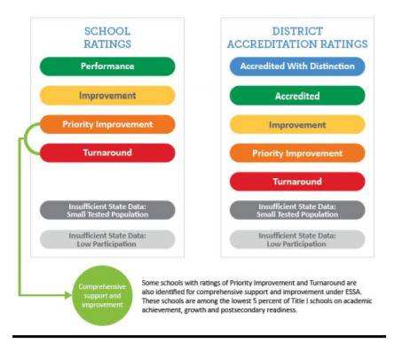
What is the result of the ratings?
Preliminary ratings are released in late summer, allowing districts to submit additional performance data to CDE through the Request to Reconsider process if they disagree with the initial rating.
Schools and districts with persistent low ratings should be implementing research-based strategies to improve student outcomes. Schools and districts with the lowest two ratings for five or more years will receive specific direction from the Colorado State Board of Education for a pathway to pursue.
Schools with ratings of Priority Improvement and Turnaround are also identified for comprehensive support and improvement under the federal Every Student Succeeds Act.

Who makes final determination?
For districts, the education commissioner makes the final determination of accreditation ratings. For schools, the commissioner makes recommendations to the State Board of Education that makes the final determination.
What does the Accountability System mean for my child?
The state of Colorado’s accountability system was created to provide specific, detailed information about academic performance of schools and districts with data that can be compared to other schools and districts around the state. The system provides a consistent review every year at how schools and districts are doing, based on the assessment data available (both achievement and growth), and the post-secondary workforce readiness indicators (such as graduation rates, dropout rates, matriculation rates and college entrance exam scores). The system also is about accountability. We celebrate and learn from successful schools, and struggling schools are identified for extra resources and support.
In addition, the federal Every Student Succeeds Act (ESSA) law requires CDE to identify schools and districts for improvement if they have low graduation rates. Both four- and seven-year graduation rates are used to identify schools and districts in need of support. Schools get support if they have fewer than 67 percent of their students graduating in four years or seven years.
Also, ESSA requires CDE to identify schools in need of support based on the performance of specific groups of students.
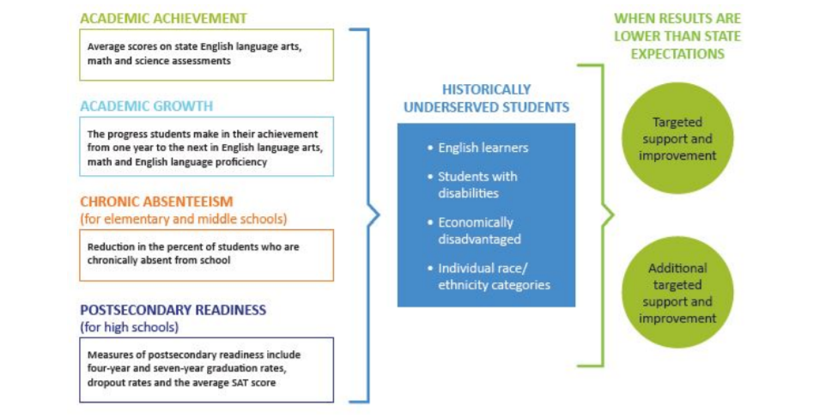

WHERE CAN I LEARN MORE?
- Find your child’s school ratings here: www.cde.state.co.us/schoolview/performance.
- Learn about the frameworks: http://www.cde.state.co.us/accountability/performanceframeworks

