Growing Readers Together

Engaging Family, Friend & Neighbor Caregivers in Early Literacy
Goals & Objectives
In order to build bridges of support between Family, Friend & Neighbor Caregivers and public libraries, Growing Readers Together has adopted the following goals:
- FFN caregivers will have the skills, confidence, and resources to engage the children in their care with early literacy materials and activities daily.
- Public library staff will have strategies to connect FFN caregivers in their area with early literacy services both in the library and through local partners.
- Growing Readers Together will develop state-level infrastructure for early literacy support to FFN caregivers and the children in their care.
- Children under six across Colorado will be exposed to language and literacy-rich experiences in informal childcare settings and at the library.

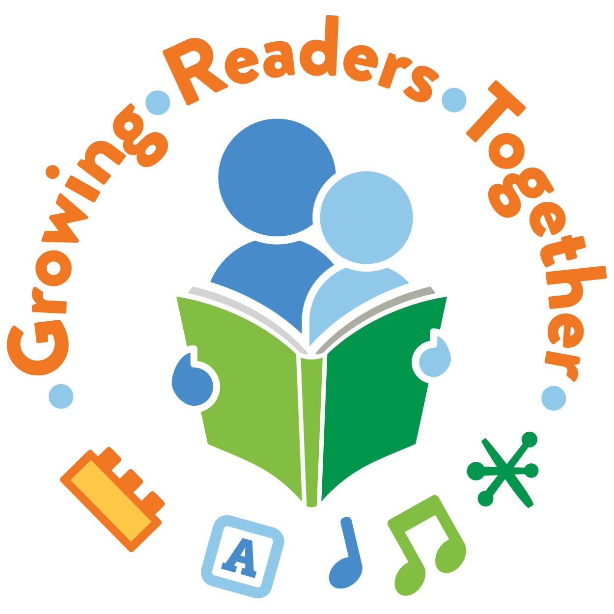

Children Under Six and Family, Friend and Neighbor (FFN) Caregivers
According to the 2013 report School Readiness for All: The Contribution of Friend, Family, and Neighbor (FFN) Care in Colorado, in 2013 an estimated 142,100 children under six experienced some type of unlicensed, informal childcare. Because FFN care is so prevalent, it is important to learn more about these caregivers and how best to support them. Through a series of community conversations, School Readiness for All begins to build a context around these caregivers by identifying their needs. One major outcome highlighted in the report is caregivers’ desire for information and support: “the strongest message across conversations was the near-uniform interest on the part of FFN providers in receiving information and training resources.”

Public Libraries
A study conducted by the Harvard Family Research Project indicates that “64% of U.S. public library directors report librarians engage informal caregivers (e.g., grandparents, home-based caregivers, etc.) of young children in early childhood program activities daily or a few times a week.”
To provide local context, in June 2016 State Library staff surveyed Colorado public library directors to ascertain their interest in and capacity for supporting FFN caregivers in their communities. Thirty-eight percent of the directors surveyed (38%) indicated interest. Of those indicating interest, the following needs were noted to effectively serve this population: assistance with outreach to FFN (86%), expansion of community partners (80%), display and play resources in the library (73%), materials for young children in the library and available for check out (61%), and staff training (61%).

An Opportunity Realized
Growing Readers Together (GRT) was thus created to support local public libraries as they identify, locate and build partnerships with FFN caregivers in their communities. Through connection with their local public library, FFN can better support the early literacy development of their young charges. Likewise, libraries can expand and enrich their early literacy services to the community.

Participating Communities
The orange markers on the map below indicate libraries that participated in Growing Readers Together between 2016 – 2020. Now in its fifth year, GRT continues to increase participation across the state (blue markers on the map). The participating libraries represent small, medium and large cities and towns, whose experiences provide diversity in terms of the strategies used to reach FFN providers as well as strategies used to engage them in developing early literacy skills.
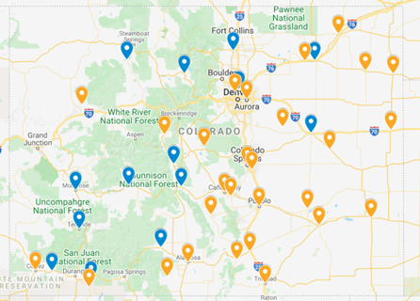
Where Can I Learn More?

https://www.cde.state.co.us/cdelib/growingreaderstogether

Participating Libraries 2016-20
Alamosa Public Library
Aurora Public Library
Burlington Public Library
Canon City Public Library
Combined Community Library (Ordway)
Conejos County Library District
Cortez Public Library
Fort Morgan Public Library
Garfield County Public Library District
John C. Fremont Library District (Florence)
Ignacio Community Library District
La Junta/Woodruff Memorial Library
La Veta Public Library
Lake County Public Library (Leadville)
Lamar Public Library
Lincoln County Bookmobile
Park County Public Library
Pikes Peak Library District (El Paso County, CO Springs)
Pines & Plains Libraries (Elbert County)
Pueblo City-County Library District
Security Public Library
Spanish Peaks Library (Walsenburg)
Sterling Public Library
Trinidad Carnegie Public Library
West Custer County Library District (Westcliffe)
Westminster Public Library
Wray Public Library
Yuma Public Library
Participating Libraries 2021
Del Norte Public Library
East Morgan County Library Distrtict
Grand Grand County Public Library District
Gunnison County Library District
Limon Memorial Library
Loveland Public Library
Mancos Public Library
Montrose Regional Library District
Northern Chaffee County Library District (Buena Vista)
Pine River Library (Bayfield)
Rangeview Library District (Anythink)
South Routt County Library District (Oak Creek)
Southern Chaffee County Regional Library District/Salida
Wilkerson Public Library (Telluride)

