

CHARTER SCHOOL WAIVER REQUEST GUIDANCE

Prepared by the CDE School of Choice Office

# Overview

Charter schools may receive waivers from specified areas of statute once a charter contract has been established. This flexibility is intended to provide charters with the autonomy to fully implement the educational plan outlined in the school’s contract with the authorizing district. Charter school waiver requests must meet the requirements set in the Charter School Act (22-30.5-101, C.R.S.).

There are two types of waivers that apply to charter schools: automatic and non-automatic. ***Automatic waivers*** are those that are automatically granted to all charter schools upon the establishment of a charter contract, renewal or extension, for the term of the contract. Although they are automatic, a charter school contract must list the automatic waivers the school is invoking, but it need not include a Rationale and Replacement Plan (RRP) for those automatic waivers. (22-30.5-105(3), C.R.S.). The current automatic waiver list is included in the *Automatic Waiver* section below and can also be found on the Colorado Department of Education’s (CDE’s) [waiver webpage](http://www.cde.state.co.us/cdechart/waivers) ([http://www.cde.state.co.us/cdechart/waivers).](http://www.cde.state.co.us/cdechart/waivers))

All other waivers from state statute and rule are considered ***non-automatic waiver*** requests and must be reviewed and approved by the State Board of Education. See the *Non-automatic Waiver* section of this document for more information. Unlike automatic waivers, non-automatic waivers must include a RRP. A sample RRP can be viewed on the CDE [waiver webpage](http://www.cde.state.co.us/cdechart/waivers) ([http://www.cde.state.co.us/cdechart/waivers).](http://www.cde.state.co.us/cdechart/waivers))

Local school boards may approve waivers to district policy for a charter within their district; these kinds of waivers do not need to be approved by the State Board of Education.

# Areas of Statute Charter May Not Waive

## Please be aware that, under state law, charter schools may not seek waivers from any of the following areas of statute (as outlined in 22-30.5-104(6)(c), C.R.S.):

* School accountability committees as described in §22-11-401, C.R.S.
* Assessments required to be administered pursuant to §22-7-1006.3, C.R.S.
* School performance reports pursuant to Title 22, Article 11, Part 5, C.R.S.
* The Public School Finance Act of 1994, Title 22, Article 54, C.R.S.
* The Children’s Internet Protection Act, Title 22, Article 87, C.R.S
* The Exceptional Children's Educational Act, Title 22, Article 20, C.R.S.
* The requirement to post on the internet the statutes for which waivers are granted as provided in §22-44-305, C.R.S.
* Any provision of §22-1-130, relating to notification to parents of alleged criminal conduct by charter school employees
* Suspension and expulsion of students in preschool through second grade pursuant to §22-33-106.1, C.R.S.
* Discrimination based on hair texture, hair type, hair length or a protective hairstyle that is commonly or historically associated with race pursuant to §22-30.5-104(3), §22-32-110(1)(k) and §22-63-206(1), C.R.S.

In addition, the State Board of Education does not have authority to grant waivers from non-education statutes (statutes outside of title 22); or Federal statutes, including ESSA and IDEA.

# Automatic Waivers

Pursuant to 22-30.5-103, C.R.S., automatic waivers are now defined as those being granted automatically to all charter schools upon the establishment of a charter contract, renewal or extension, for the term of the contract. A charter school **is not required** to submit an RRP for an automatic waiver; however, a charter school must identify which automatic waivers it plans to invoke. The list of automatic waivers that have been approved by the state board are as follows:

|  |  |
| --- | --- |
| **Automatic Waiver List (As of 6/2/17)** | |
| **Statutory Citation** | **Description** |
| *22-32-109(1)(f), C.R.S.* | Local board duties concerning selection of staff and pay |
| *22-32-109(1)(t), C.R.S.* | Determine educational program and prescribe textbooks |
| *22-32-110(1)(h), C.R.S.* | Local board powers-Terminate employment of personnel |
| *22-32-110(1)(i), C.R.S.* | Local board duties-Reimburse employees for expenses |
| *22-32-110(1)(j), C.R.S.* | Local board powers-Procure life, health, or accident insurance |
| *22-32-110(1)(k)(I), C.R.S.* | Local board powers-Policies relating the in-service training and official conduct |
| *22-32-110(1)(ee), C.R.S.* | Local board powers-Employ teachers’ aides and other non-certificated personnel |
| *22-32-126, C.R.S.* | Employment and authority of principals |
| *22-33-104(4), C.R.S.* | Compulsory school attendance-Attendance policies and excused absences |
| *22-63-301, C.R.S.* | Teacher Employment Act-Grounds for dismissal |
| *22-63-302, C.R.S.* | Teacher Employment Act-Procedures for dismissal of teachers |
| *22-63-401, C.R.S.* | Teacher Employment Act-Teachers subject to adopted salary schedule |
| *22-63-402, C.R.S.* | Teacher Employment Act-Certificate required to pay teachers |
| *22-63-403, C.R.S.* | Teacher Employment Act-Describes payment of salaries |
| *22-1-112, C.R.S* | School Year-National Holidays |

# Non-Automatic Waivers

A charter school may operate free from specified state rules and statutes as provided in §22-30.5-104(6)(b), C.R.S. by requesting waivers. To obtain these waivers, all charter schools must go through a formal process to waive out of any state statute and rule that is not considered an automatic waiver. Once this process is completed, the State Board of Education has the authority to grant or deny the request for each non-automatic waiver. Regardless of waiver approval, the charter school is subject to all federal and state laws and constitutional provisions prohibiting discrimination on the basis of disability, race, creed, color, sex, sexual orientation, national origin, religion, ancestry, or need for special education services (22-30.5-104(3), C.R.S.).

Once a request for state waivers is approved, the waivers are valid through the term of the contract between the charter school and its authorizer. If a charter school contract exceeds five years, then the State Board has authority to review the school’s waivers to deem whether the waivers continue to be necessary.

A charter school waiver request is submitted to the state by the authorizer after an updated request is signed. The authorizer is only required to provide a **complete copy of the signed charter contract** (22-30.5-104(6)(d), C.R.S.). A complete, signed copy of the charter contract should include:

* A clear start and end date of the term of the charter contract
* Signatures of both the charter school and authorizing local board
* A list of automatic waivers the school is invoking
* A list of the non-automatic waivers from state statute and rule the school is requesting
* A RRP for each non-automatic waiver requested (per 22-30.5-105(2), C.R.S.) that addresses the manner in which a charter school shall comply with the intent of the state statutes and/or state board rules

# Rationale and Replacement Plans (RRP)

Each waiver being requested by the charter school must have an associated Rationale and Replacement Plan (RRP). A [sample RRP](http://www.cde.state.co.us/cdechart/samplerrp) can be viewed at [http://www.cde.state.co.us/cdechart/samplerrp.](http://www.cde.state.co.us/cdechart/samplerrp) Each waiver from state statute and rule must contain rationale as to why the waiver is being requested and a replacement plan indicating how the school will continue to meet the intent of the law. Two or more statues can be combined under the same RRP as long as the plan explains why each waiver is being requested and addresses how the intent of each statue will still be met. In addition to a RRP, CDE recommends as best practice that the charter school include information about the following in their RRP:

* + Financial impact of waiving out of the law or policy
  + How the impact of the waivers will be evaluated
  + Expected outcome from waiving out of this law or policy

To help schools better understand how specific waivers may apply, we have organized waivers into three different categories: *delegatory, policy commitments, or substantive.*

## Delegatory

Delegatory waivers are waivers in which the authority has been delegated from the authorizing board to the charter school governing board to create policies and practices.

*Example: Journey Academy shall be delegated the authority from the School District to in accordance with the Charter School Agreement.*

## Policy commitments

Policy commitment waivers are ones that commit a charter school governing board to develop their own policy that is separate and independent of their authorizer or the state, but provides flexibility to modify a policy without having to update a contract.

*Example: The School will adopt its own policies concerning that will meet or exceed the intent of the law.*

## Substantive

Substantive waivers have RRPs that provide greater detail on how the charter school will meet the intent of the law. They are meant to clarify that certain minimum standards will still be met. Typically, they are used for provisions related to licensure and school readiness.

# Process and Required Documents for Requesting Waivers

**The following diagram provides an overview of the waiver process:**



Local District Board Actions

During Approval or Renewal

* The charter contract

or amendment submitted to the authorizing local board of education includes a list of waivers from state statute, state rule, and district policy.

* There is a rationale for why each non- automatic state waiver was requested and replacement plan for how the charter school will continue to meet the intent of the law.
* The local board approves or denies the requests.



Local District Staff Actions

Re: Non-Automatic State Waiver Requests

* The authorizing

district submits the complete charter contract, with signatures, to CDE within 10 days of approval. See [www.cde.state.co.us](http://www.cde.state.co.us/)

/cdechart/waivers.

* The complete charter contract should include: the contract term, a list of all the automatic waivers being invoked, a list of all the non-automatic waivers the school is requesting, and a RRP for each of the requested non- automatic waivers.
* The state board of education has 45 days once a complete contract is received to either grant or deny the waivers.



CDE Staff Actions

* The Schools of Choice

Office will review the request and submit it to the State Board for review and approval.

* Once the waiver request is approved by the State Board of Education, the Schools of Choice Office will send an electronic approval letter to the charter school contact and will copy the authorizer using the contact information provided.
* On its financial transparency webpage, the charter school must include a standarized description of all the automatic waivers being invoked, a list of all the non- automatic waivers the school is requesting, and a RRP for each of the requested non- automatic waivers.

# Posting Waivers

Pursuant to CRS 22-44-305, charter schools need to update their financial transparency website within thirty days of state approval of their waivers. This posting must include:

* + A list of all the non-automatic waivers the school is requesting, and a rationale and replacement plan for each of the requested non-automatic waivers.
  + The standardized description and rationale document for each automatic waiver, created by CDE, which includes only the automatic waivers the school has invoked. The document that shall be used can be downloaded on the CDE [waiver webpage](http://www.cde.state.co.us/cdechart/waivers) (https://[www.cde.state.co.us/cdechart/waivers).](http://www.cde.state.co.us/cdechart/waivers))
  + Contact information for a person employed by the charter school who is available during regular school hours and can provide additional information about the charter school’s automatic waivers.

**Example of Financial Transparency webpage:**

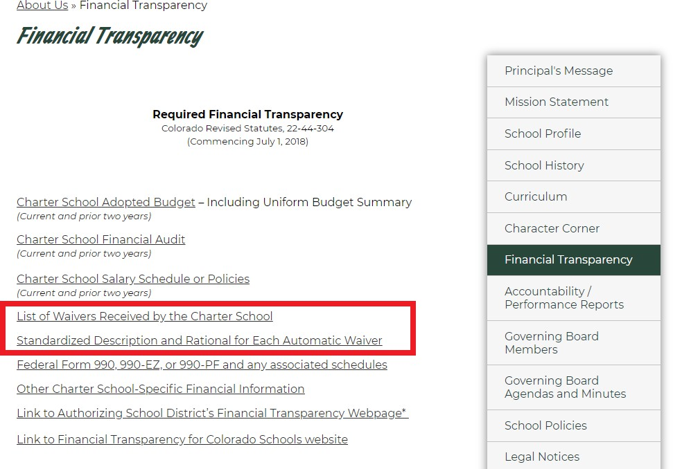

# Frequently Asked Questions (FAQs)

## What are some common non-automatic waivers charter schools request? Where can I see the approved waivers for each charter school?

A report that shows all the approved waivers for each charter school, including common non-automatic waivers, is posted on the [waiver webpage](http://www.cde.state.co.us/cdechart/report-waiversbycharterschool-0) (<http://www.cde.state.co.us/cdechart/report-waiversbycharterschool-0)> of the CDE website. This report is updated monthly following each state board meeting.

## For how long are waivers valid?

Waivers are valid until the contract with the authorizer expires. State waivers need to be approved either when a new contract is written or waiver requests are changed.

## Is a charter school required to request waivers from state statute or rule?

No. Each charter school determines, in cooperation with its authorizer, which waivers to request, and may choose not to request any.

## How does a charter school decide which waivers to request?

Charter schools should examine each statute to see if they would need a waiver (in addition to those automatically granted) to implement their educational plan or model. Commonly schools seek flexibility with those things that statute defines as the responsibility of the district, just to make clear that they are accepting that responsibility. Charters often seek legal counsel when seeking waivers, but it is not required that they do so. The Schools of Choice Office cannot provide legal advice, but is happy to talk with you about waiver selection or preview your list of waivers and their replacement plans prior to submitting your request to your authorizer. Please contact the Schools of Choice contact listed at the end of this document with questions.

## Are there examples of a Rationale and Replacement Plan (RRP) to reference?

Yes. We provide a sample RRP on the [waiver webpage](http://www.cde.state.co.us/cdechart/waivers) ([http://www.cde.state.co.us/cdechart/waivers).](http://www.cde.state.co.us/cdechart/waivers)) Please keep in mind that this is just one example. It is not required that every RRP have this format. It is required that each non- automatic waiver from state statute and rule, and district policy, must contain rationale as to why the waiver is being requested and a replacement plan as to how the school will continue to meet the intent of the law. Oftentimes this means that the school will meet the intent of the law in a different way, and/or exceed expectations written in law and policy. The replacement plan may also simply be a transfer of power from the local authorizing board or school district to the charter school.

## Can a charter school request a waiver from the School Readiness Assessments?

Charter schools may request to waive school readiness in order to use an assessment of their choosing; however, as true for all waivers, schools are accountable for explaining how they will meet the intent of the law. Adequate replacement plans will address the following key components of the statute:

* + Identify how the school will assess each component of school readiness as it is defined in statute; physical well-being and motor development, social and emotional development, language and comprehension development, cognition, and general knowledge. The school must confirm that the instrument used will be a “valid” instrument.
  + Confirm that the assessment will be administered within the first 60 days of the school year.
  + Briefly describe how the school will develop individualized readiness plans for students based on what they learn from their readiness assessment(s).
  + Confirm that the School Readiness Assessments will not be used for retention purposes.

## Where can I find my waivers?

Schools should have a list of their current waivers from state statute (and Rationale and Replacement Plans); however, schools also can find their waivers and replacement policies in their last charter application. Most schools can download their plans from the [State Board of Education Board Docs site](http://www.boarddocs.com/co/cde/Board.nsf/Public) at [http://www.boarddocs.com/co/cde/Board.nsf/Public.](http://www.boarddocs.com/co/cde/Board.nsf/Public)

## Is it enough to post my contract (or application) if it has the waivers in it?

Yes, it is enough for the non-automatic waiver section; however, the school needs to post the automatic waiver document as a separate link. If the waivers are part of a larger document, the school needs to provide clarification on where waivers and replacement plans can be found within the document.

# More Resources

For more information and resources, visit the CDE [waiver webpage](http://www.cde.state.co.us/cdechart/waivers) at: https://[www.cde.state.co.us/cdechart/waivers.](http://www.cde.state.co.us/cdechart/waivers)

* + [Optional Cover Sheet (DOC):](http://www.cde.state.co.us/cdechart/charterschoolwaiverrequestcoverpage) <http://www.cde.state.co.us/cdechart/charterschoolwaiverrequestcoverpage>
  + [Comparison of Waiver Laws (PDF):](https://www.cde.state.co.us/choice/comparisonwaiverlaws) https://[www.cde.state.co.us/choice/comparisonwaiverlaws](http://www.cde.state.co.us/choice/comparisonwaiverlaws)

# Contact

For questions about the waiver request process, please contact:

Janyse Skalla

Senior Policy Consultant [Skalla_J@CDE.STATE.CO.US](mailto:Skalla_J@CDE.STATE.CO.US)