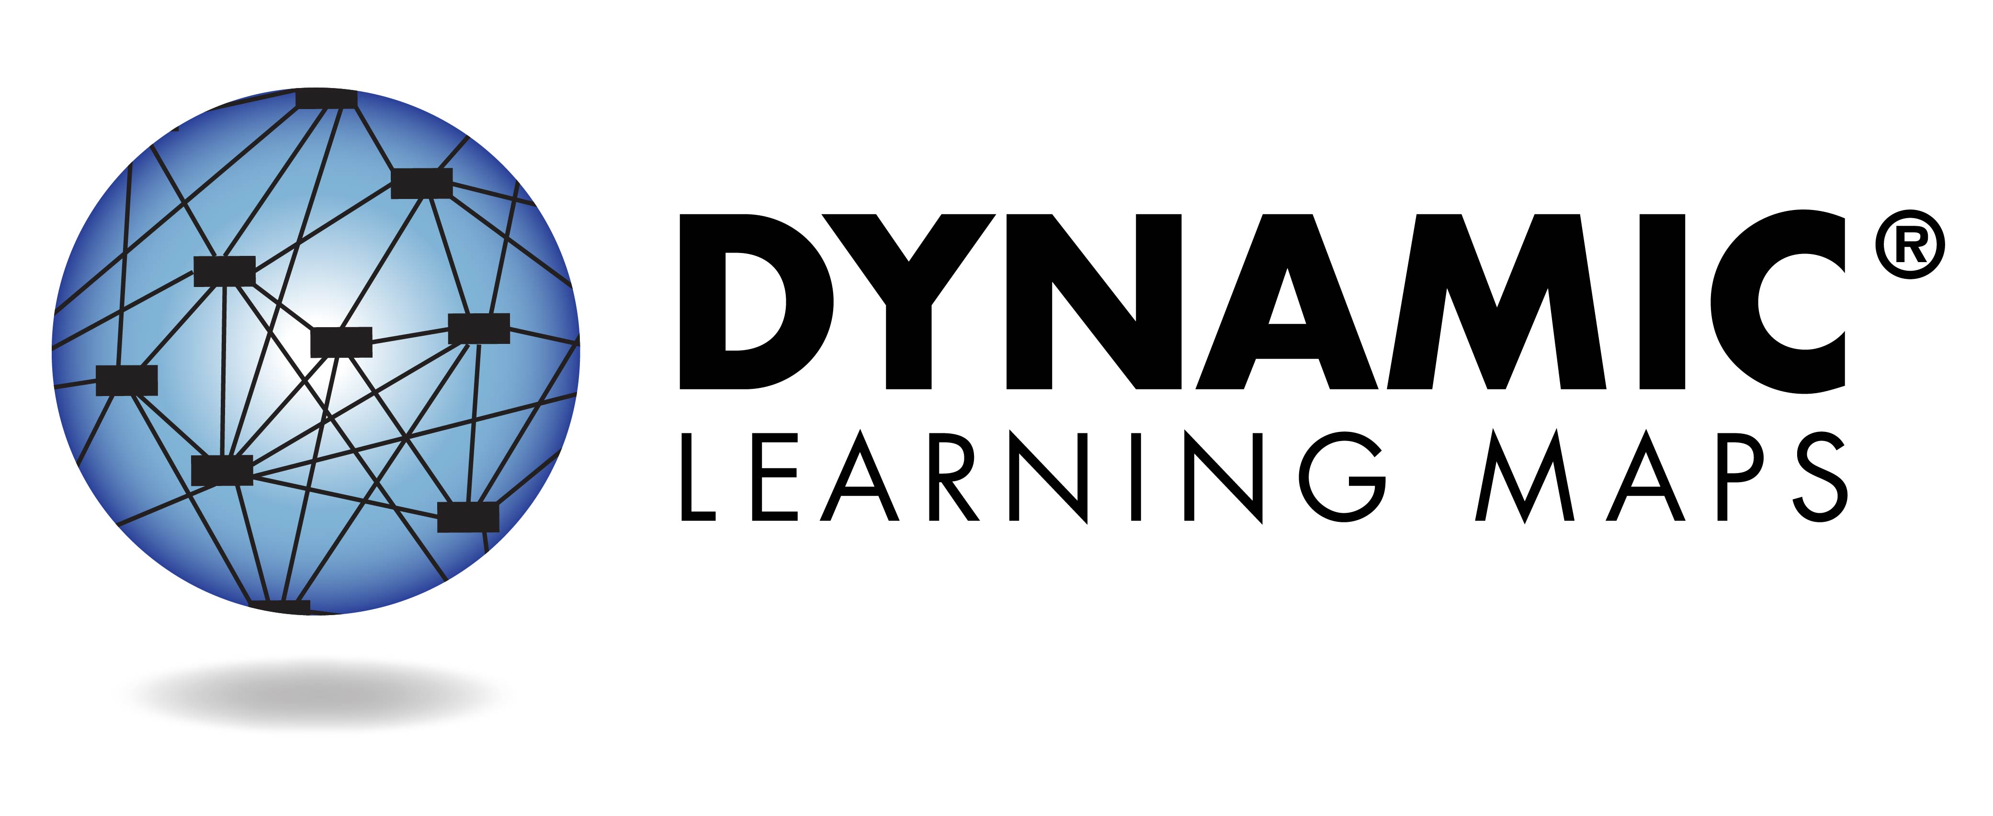
What is the Dynamic Learning Maps® Assessment?
This year, your child’s teacher used the Dynamic Learning Maps® (DLM®) Alternate Assessment System to test academic progress in English language arts (reading and writing), math, and/or science. This assessment is designed for students with many types of significant cognitive disabilities. It is a completely individualized test designed so students can show what they know and can do. The assessment is given in short parts called testlets so your child does not become too tired or stressed.

Results from the embedded assessment given during the school year provide information that the teacher can use to guide classroom instruction.

Your child will receive an Individual Student Score Report for each subject tested. This report indicates the skills your child demonstrated during the assessment.

Understanding Your Child’s Individual Student Score Report

2017-2018 School Year

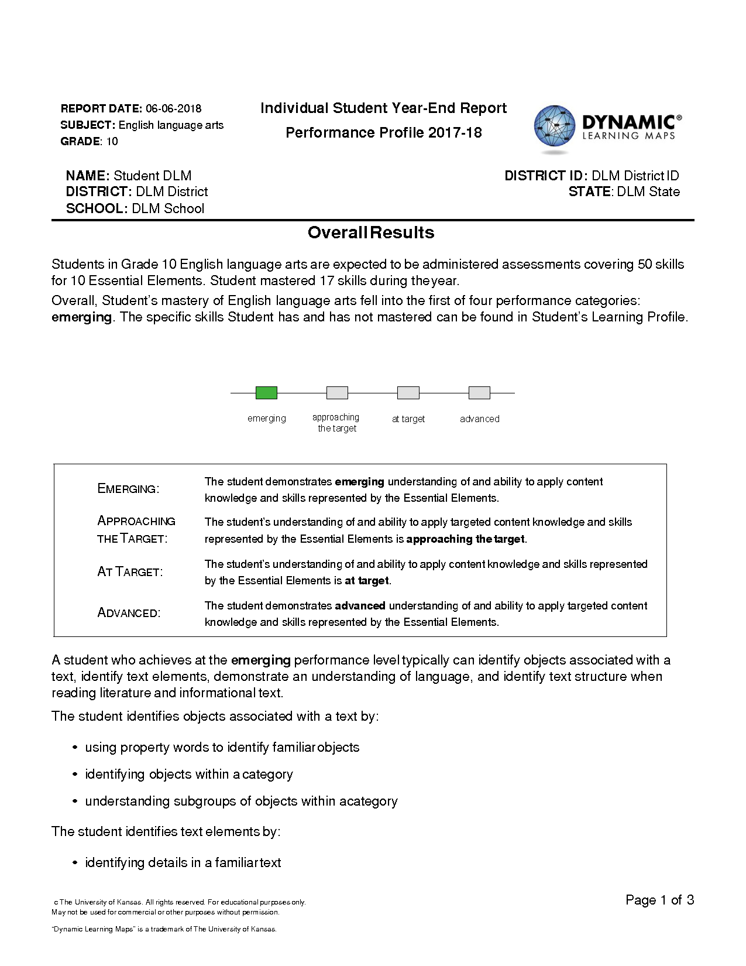
Overview
Each Individual Student Score Report contains information about your child’s performance for one subject. This report includes the Performance Profile.

Performance Profile
The first part of the Performance Profile describes your child’s overall performance based on Essential Elements, which are the alternate achievement standards for this subject. The performance levels are:
- emerging
- approaching the target
- at target
- advanced
“At target” means your child has met the alternate achievement standards in this subject at your child’s grade level.
This part of the report also lists examples of skills mastered by students at your child’s performance level. Your child may or may not demonstrate all of these skills.

Performance Profile, continued
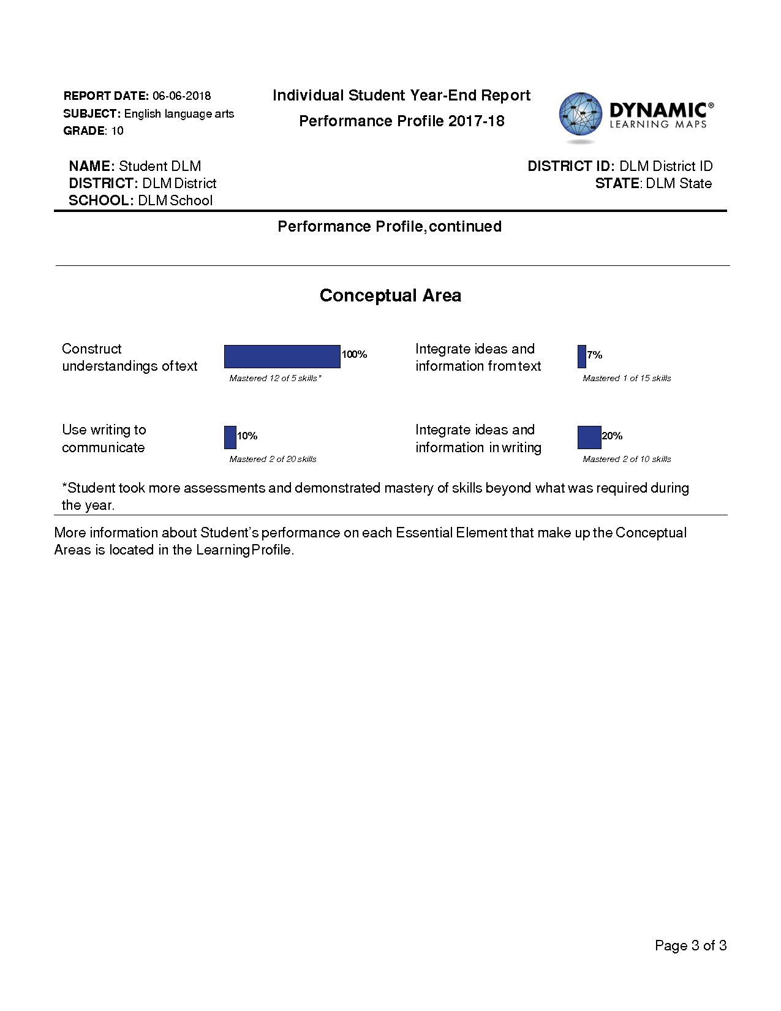
The second part of the Performance Profile describes the percentage of skills your child demonstrated on related academic skills. These skills meet or lead up to grade-level content for students with the most significant cognitive disabilities.
Your child’s mastery of skills is an estimate of mastery made with reasonable certainty. As is the case with any test result, your child's ability to demonstrate certain skills may vary from one testing attempt to another. Please keep in mind that the skills demonstrated during this assessment provide only one piece of evidence of what your child knows and can do.

