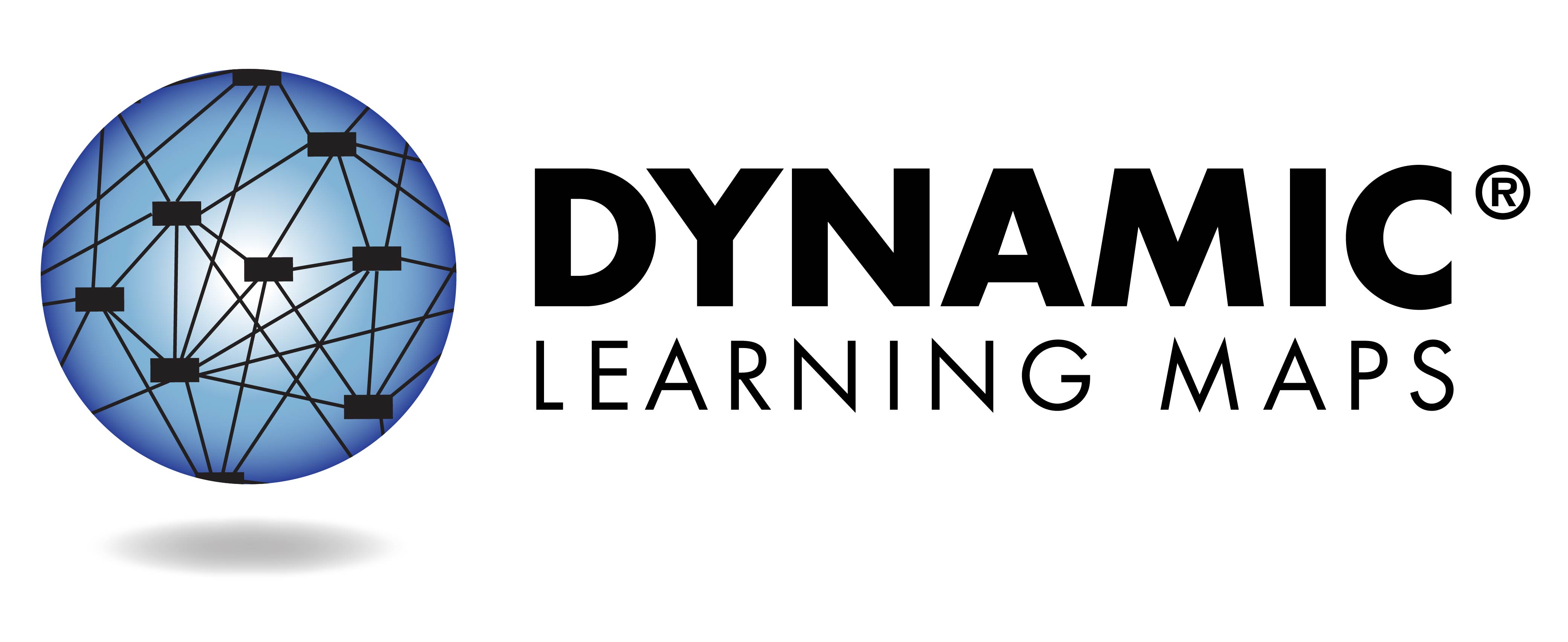

**What is the Dynamic Learning Maps Assessment?**

The Dynamic Learning Maps™ (DLM) assessment measures student performance on alternate content standards for students with the most significant cognitive disabilities—DLM Essential Elements.

Essential Elements detail what your student should know and   
be able to do at a particular   
grade level.

During spring 2016, your student took assessments in English language arts and math. This report describes how your student performed on the assessments.

**Colorado Department of Education**

**Assessment Unit**

Mindy Roden

[Roden_m@cde.state.co.us](mailto:Roden_m@cde.state.co.us)

303-866-6709

# Understanding Students’ Performance and Learning Profiles

**2016-2017 School Year**

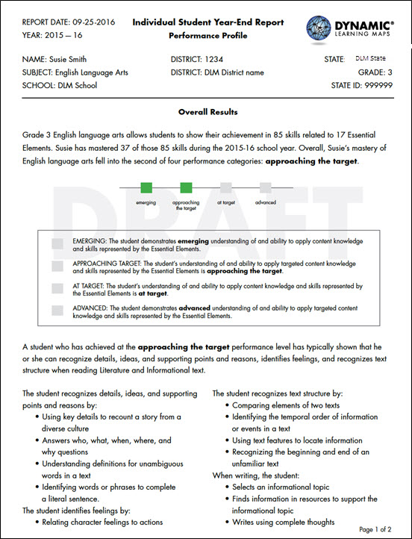

**How is the student doing?**

The **Overall Results** section describes the student’s overall performance in relation to the alternate achievement standards for English language arts or math.

**Student performance** on this assessment is categorized as Emerging, Approaching the Target, at Target, and Advanced.

**“At Target”** means that the student has met the alternate achievement standards in English language arts or math for the student’s enrolled grade level.

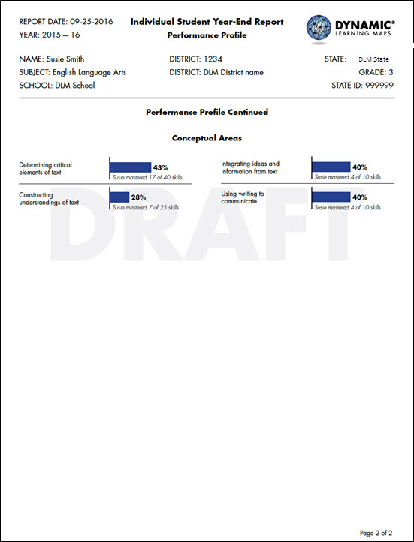

**What skills are tested at the student’s grade level?**

The **Conceptual Areas** section identifies the categories of tested skills in English language arts or math.

**Are these academic skills based on grade-level academic content?**

All reported academic skills are grade-level academic content or are leading up to grade-level content for students with the most significant cognitive disabilities.

**How is the student doing in each Conceptual Area?**

This section describes the student’s performance on academic skills in grade-level English language arts or math.