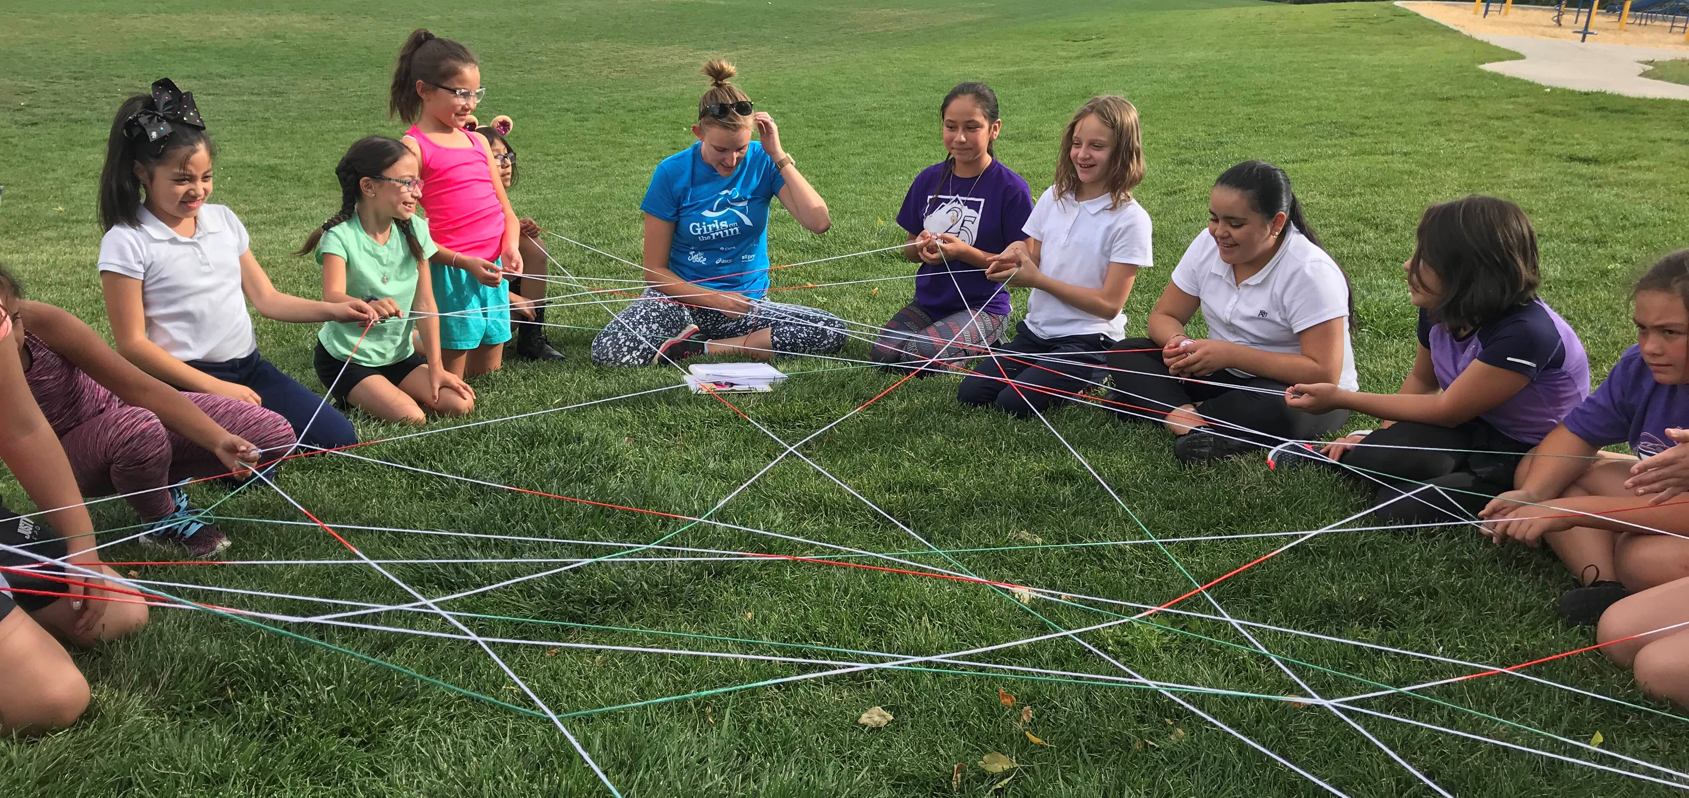

York International: 21st Century Community Learning Centers

Evaluation Report 2018-2019
Prepared By:
Oona Wellin – York International Site Coordinator
wellino@mapleton.us
(303) 853-1622

TABLE OF CONTENTS
INTRODUCTION 3
Program Description 3
Program Goals 3
EVALUATION OBJECTIVES 4
Summary of Focus 4
Purpose 4
Objectives 4
Questions to Direct Evaluation 4
DATA COLLECTION 5
Data Descriptions and Methods 5
RESULTS-ANALYSIS OF FINDINGS 6
Student Academic Progress 6
Family Needs 7
Attendance Data 8
CONCLUSION 9
Discussion of Conclusions 9
Recommendations 9

INTRODUCTION

Program Description
With great help from the 21st Century Community Learning Centers (CCLC) grant, York International provides out-of-school time academic and enrichment programs for its K-12 students and families. From family cooking classes to York Educational Support (Y.E.S.) Lab, York International continuously offers students and families a multitude of enriching opportunities that they would not otherwise receive. Enrichment activities include positive youth development, educational support, and physical activities during out-of-school hours.

Program Goals
- 21st CCLC programs will be designed based on objective data regarding the need for out-of-school time programs and activities in the schools and greater Thornton community.
- Programming utilizes performance measures which aim at providing high-quality academic enrichment opportunities
- Programs utilize evidence-based strategies and programs based on ESSA

“From family cooking classes to York Educational Support (Y.E.S.) Lab, York International continuously offers students and families a multitude of enriching opportunities that they would not otherwise receive.”

EVALUATION OBJECTIVES

Summary of Focus
This evaluation focuses on presenting evidence that York International’s 21st CCLCs provide high quality opportunities for academic enrichment and helps students meet the state and local student academic achievement standards.

Purpose
The evaluation is designed to make judgments about the York International 21st CCLC program in order to improve its effectiveness and to inform future programming decisions.

Objectives
- Assess the growth of students attending programming based on objective data
- Focus on high need areas when planning and implementing programming
- Utilize attendance data to inform program participation
- Analyze the process of implementation with a focus on utilizing evidence-based strategies and programs

Questions to Direct Evaluation
- Did the program produce or contribute to the intended outcomes over the span of one school year?
- To what extent can significant changes in data be attributed to CCLC programming?
- What role do enrichment activities play in enhancing growth in NWEA’s MAP assessment scores?

DATA COLLECTION

Data Descriptions and Methods

DESCRIPTION | METHOD | PARTICIPANTS
Student academic progress | - NWEA MAP Student Growth Reports | - All K-12 regular student  attendees in academic  enrichment programs
Family needs | - Family interviews | - 13 families attending Cooking  Matters family cooking class
Attendance data to inform programming participation | - Infinite Campus program utilized by site school | - All student participants

RESULTS-ANALYSIS OF FINDINGS

Student Academic Progress
Based on the population of 42 students who attended 30 or more days of academic programming throughout the 2018-2019 school year, 36 students showed growth in reading and 38 students showed growth in math. It should be noted that only grades 2 through 6 are represented in this data, as the Kindergarten and 1st grade classes do not take the MAP Assessments. Upon analyzing the data, it is clear to see a direct correlation between the academic programming offered and growth in NWEA MAP scores in both reading and math. Additionally, data points indicate that there is a greater need for reading support programs than math support programs.

Family Needs

Families attending the Cooking Matters family cooking class in the Fall of 2018 were surveyed, as the class directly impacted how families support their students not only at home, but also with school involvement and support. Each of the families were given a survey with questions pertaining to four greater topics: parental support, parent engagement, parent self-efficacy, and parent roles and responsibilities. These topics were chosen based on the Harvard Family Research Project’s A New Wave of Evidence: The Impact of School, Family, and Community Connections on Student Achievement findings from Dr. Henderson and Dr. Mapp which focus on the need for schools to understand the effectiveness in building parental capacity. Below are the findings from comparing the baseline surveys with the three months-post program completion surveys:
 | Parental Support | Parent Engagement | Parent Self-Efficacy | Parent Roles & Responsibilities | Average Percentage
Increased Capacity | 85% | 93% | 69% | 93% | 85%
No Change | 14% | 7% | 31% | 7% | 15%
Decreased Capacity | 1% | 0% | 0% | 0% | <0%

Though the great majority of families experienced an increased capacity to support their children overall, many families did not feel a large change in parent self-efficacy or parent support. As a result, the priority for the 2019-2020 school year is to utilize programs that promote both larger topics more explicitly.

Henderson, Anne T, and Karen L Mapp. “A New Wave of Evidence The Impact of School, Family, and Community Connections on Student Achievement.” SEDL – Advancing Research, Improving Education, 2002.

Attendance Data
The population of students who attended one or more days of programming was narrowed down for this analysis to students who came into programming with a school day attendance rate of 95% or lower. Using Infinite Campus programming, students’ school day attendance rates were compared when they started coming to out-of-school time programming with their final school day attendance rate at the end of the school year.

CONCLUSION

Discussion of Conclusions
Evaluating programming from a larger scale, rather than the normal day-to-day observations provided a great input as to what needs improving, what has gone well, and what needs to be further evaluated. Based on the analyses, it is clear that data must drive all decisions made for York International’s 21st Century Community Learning Centers. Furthermore, when proactively planning programming, each of the components outlined in this report must be heavily considered.

Recommendations
Based on the evaluation findings, three large action steps need to be taken for FY19-20:
- Upon analyzing the results from the family surveys given at the Cooking Matters Family Cooking Course, it became apparent that parent self-efficacy and parent support are amongst the two greatest areas of improvement. Programming needs to directly correlate with these needs.
- Moving forward, a greater effort must be put forth to be more intentional about attendance guiding program recruitment and retention.
- When considering family surveys, a broader sample size would be beneficial to representing the school as a whole. Rather than just giving the survey to families attending a particular program, it would be extremely helpful to extend the survey to other participating family members.

